COMMUNITY RESOURCE EXCHANGE (SWAPIFINE)

A Capstone Project Presented to

The Faculty of the Computer Studies

CORDOVA PUBLIC COLLEGE

Gabi, Cordova, Cebu

In Partial Fulfillment of the Requirements for Degree

Bachelor of Science in Information Technology (BSIT)

By

CapstoneForDaFuture

Ariel Batoon

John Zhenlly Alvarez

Javy Macabudbud

**December 2023**



| **Approval Sheet** | |
| --- | --- |
| **Title of Project**  **Community Resource Exchange(Swapifine)** | **Date Submitted**  **April 26, 2023** |
| **Name of Proponent : Ariel Batoon, John Zhenlly Alvarez, Javy Macabudbud** | |
| **Brief Description of the Project**  A progressive web application platform that connects individuals and organizations in a local community to share different types of resources. This platform is to facilitate the sharing of resources within a local community, whether it be tools, equipment, or other items that people have available to share. By encouraging the sharing of resources, the platform aims to promote sustainability, reduce waste, and foster stronger connections between community members.  **Main goal of the system is to:**  Provide a valuable service to local communities, helping to reduce waste and build stronger connections between neighbors.  **Specific objectives of the system are as follows:**   * **Promote sustainability**: The platform would aim to promote sustainable practices by encouraging the sharing and reuse of resources, reducing waste, and promoting more responsible consumption patterns. * **Foster community building**: By connecting individuals and organizations in a local community, the platform would aim to foster stronger connections and build a sense of community. * **Facilitate resource sharing**: The platform would aim to make it easy and convenient for users to share and access resources, thereby increasing efficiency and reducing the barriers to resource sharing. * **Encourage skill sharing**: The platform would aim to encourage skill sharing among users, allowing individuals and organizations to showcase their skills and expertise and share them with others. * **Improve access to resource**s: The platform would aim to improve access to resources by allowing individuals and organizations to acquire resources they might not have been able to afford or access otherwise. | |
| **APPROVED BY:**  **Jade Marthy Tulda**  **Adviser**  **Jade Marthy Tulda Jonus Berdon Mat Mitcheil Ando**  **Panel Member Panel Member Panel Member**  P | |

**ACKNOWLEDGEMENT**

We would like to express our special thanks to our instructor Mr. Nicasio Amoin who gave us the opportunity to do this project Community Resource Exchange (Swapifine), which also guides us as we go through this project.

Secondly, we'd like to extend our appreciation to Mr. Jade Marthy Tulda, our project adviser. Thank you for your guidance and support throughout our capstone project. Additionally, we're grateful for your contributions and ideas that helped improve the system until the project's completion.

Lastly, we want to express our gratitude for the support and understanding of our parents. Without their permission to go out, we wouldn't have been able to meet and barely complete this project.

We dedicate this study to our dear alma mater, Cordova Public College, for playing a significant role in shaping us into the best versions of ourselves. All the glory and honor belong to our Almighty Father.

**TABLE OF CONTENTS**

Title Page.......................................................................................................................1

Approval Page.......................................................................................................2

Acknowledgement………………………………………………………………………4

Project Proposal Approval Sheet...........................................................................v

SPMP ....................................................................................................................7

SRS......................................................................................................................34

SDD.....................................................................................................................96

STD ...................................................................................................................143

User Manual.......................................................................................................177

Curriculum Vitae.................................................................................................177



**CORDOVA PUBLIC COLLEGE**

GABI, CORDOVA, CEBU, PHILIPPINES

COLLEGE OF COMPUTER STUDIES

**Software Project Management Plan**

*for*

Community Resource Exchange (Swapifine)

CPC-BSIT-CAPSTONE-SPMP-1st SEM 2022-2023-SWAPIFINE

Documents for IT Project

Of

Ariel Batoon

John Zhenlly Alvarez

Javy Macabudbud

**Change History**

| Version | Changes Made | Editor and Date |
| --- | --- | --- |
| Version 1 | Change the Internal Structure | Javy Macabudbud  December 20,2023 |

**Preface**

The Community Resource Exchange(Swapifine) is a web-based application designed to connect people within a specific community to exchange resources and information. This platform has a user-friendly interface created to make it easier for individuals and organizations to share various assets, including tools, equipment, knowledge, and other items that are accessible for sharing.

The developers set out the creation of the user interface with a consideration of user satisfaction and retention. A pleasing and well-organized system where users can easily navigate the application's features. While users can post, discover, and trade items, the admin manages the users' transactions, accounts, and overall performance of the system. It is responsible for data management and security measures.

Generally, this application’s design focuses on providing users with a responsive design that ensures that the system interface can adapt to different screen sizes and devices. Also, implement a clear and intuitive navigation for user efficiency and satisfying user experience.

**Table of Content**

**Change History 3**

**Preface 4**

**Table of Contents 5**

**List of Figures 7**

**List of Tables 8**

**1. Overview 9**

1.1. Project Summary 9

*1.1.1. Purpose, scope, and objectives 9*

*1.1.2. Assumptions and constraints 9*

*1.1.3. Project Deliverables 9*

*1.1.4. Schedule and budget summary 10*

1.2. Evolution of Plan 11

**2. References 12**

**3. Definitions 13**

**4. Project organization 14**

4.1. Internal structure 14

4.2. Roles and Responsibilities 14

**5. Managerial process plans 16**

5.1. Start-up plan 16

*5.1.1. Estimation plan 16*

*5.1.2. Staffing plan 16*

*5.1.3. Resource Acquisition Plan 17*

*5.1.4. Project Staff Training Plan 17*

5.2. Work Plan 18

*5.2.1. Work activities 18*

*5.2.2. Schedule allocation 19*

*5.2.3. Resource allocation 19*

*5.2.4. Budget allocation 19*

5.3. Control plan 20

*5.3.1. Requirements Control Plan 20*

*5.3.2. Schedule control plan 20*

*5.3.3. Budget Control Plan 20*

*5.3.4. Quality Control Plan 20*

*5.3.5. Reporting Plan 20*

*5.3.6. Metrics Collection Plan 20*

*5.3.7 Risk Management Plan 20*

*5.3.8 Project Closeout Plan 21*

**6. Technical process plans 22**

6.1 Process Model 22

6.2 Methods, tools, and techniques 23

6.3 Infrastructure Plan 24

6.3 Product Acceptance Plan 24

**7. Supporting process plans 25**

7.1. Configuration Management Plan 25

7.2. Verification and validation plan 25

7.3. Documentation Plan 25

7.4. Quality Assurance Plan 25

7.5. Reviews and audits 26

7.6. Problem Resolution Plan 26

7.7. Process Improvement Plan 26

**List of Figures**

Figure 1. Internal Structure

Figure 2. Agile Methodology

**List of Tables**

Table 1.1.4 Schedule

Table 1.1.5 Budget Summary

Table 1.2.1 Evolution Plan

Table 4.3.1 Roles and Responsibilities

Table 4.3.2 Role Allocation

Table 5.1.2 Staff Plan

Table 5.2.1 Activities

# **Overview**

## ***Project Summary***

### ***1.1.1. Purpose, scope, and objectives***

The Community Resource Exchange (Swapifine) platform emphasizes the importance of swap marketplaces in the current digital era, highlighting the benefits and convenience of providing people with an easy-to-use platform for swapping or buy-and-sell. Furthermore, it tries to raise awareness of the adverse effects that may impact users' experiences by acknowledging the potential hazards and difficulties linked to these platforms. This description's scope includes markets as online venues for buying, selling, and bartering commodities. These venues use desktop computers and mobile devices to make it easy for users to browse and find specific items, with seller's handling shipping to purchasers.

The general objectives of the system specification are as follows:

* The primary goal of Swapifine is to offer a secure and user-friendly platform for buy-and-sell or swapping items within the marketplace.
* To encourage sustainable behaviors, such as mending and reusing objects instead of throwing them away and purchasing new ones.
* To provide an efficient platform for promoting local businesses and individuals interested in selling or reselling their items.
* Swapifine is a Progressive Web Application (PWA) that ensures a seamless and user-friendly experience for users, allowing them to access the platform from both desktop and mobile devices conveniently.

### ***1.1.2. Assumptions and constraints:***

The project is expected to be completed by December 2023, coinciding with the end of the first semester of the Bachelor of Science in Information Technology (BSIT) degree. To meet the project deadline, the web application must be fully functional and in production. The web application development will utilize Laravel API for the business logic and VueJS for the User Interface. It is important to note that the web application may not support legacy browsers. Additionally, an internet or data connection is required to access the platform.

### ***1.1.3. Project deliverables***

As part of the project, the Community Resource Exchange (Swapifine) team will deliver the following artifacts:

* Create the Swapifine application platform to provide a unified user interface for desktop and mobile platforms.
* Develop an Admin Dashboard that enables application monitoring and provides statistical insights.
* Swapifine Deployment to Live Production
* Systems Requirement Specification (SRS) document (including a list of features within the scope of the project) and the Quality Assurance requirements.
* Project Management Artifacts such as the Software Project Management Plan (SPMP).
* Software Test Document (STD).
* Software Design Description (SDD).
* All other artifacts that the team might have generated that add value to the final deliverable

### ***1.1.4. Schedule and budget summary***

Community Resource Exchange (Swapifine) – Milestone

| **Key Milestone** | **Estimated Completion**  **Date (Initiation / Completion)** |
| --- | --- |
| Project Initiation | April 2023 (Initiation) |
| Project Proposal | April 26, 2023 (completion) |
| Software Requirements Specifications (SRS) | May 31, 2023 (completion) |
| Software Project Management Plan (SPMP) | May 31, 2023 (completion) |
| Software Design Description | August 31, 2023 (completion) |
| Software Test Documents | September 9, 2023 (completion) |
| Swapifine Admin Application | October 10, 2023 (completion) |
| Swapifine User Application | October 28, 2023 (completion) |
| Swapifine Overall Application Testing | November 5, 2023 (completion) |

*[Table 1.1.4] Schedule*

Community Resource Exchange (Swapifine) – Budget

| **Item** | **Description** | **Price** |
| --- | --- | --- |
| Cloud Hosting: Hostinger | Cloud Hosting (Server, Domain, and Professional Email) | P 1, 800.00 |
| **TOTAL BUDGET** | | **P 1,800.00** |

*[Table 1.1.5] Budget Summary*

## ***Evolution of plan***

This SPMP subclause must outline the procedures for producing both scheduled and unforeseen upgrades. It is required to specify the distribution channels for the updates. The techniques used to manage subsequent changes to the SPMP and to submit the initial version of the SPMP to configuration management must also be described in this subclause.

| **Version** | **Primary Author(s)** | **Description of Version** | **Date Expected** |
| --- | --- | --- | --- |
| Designing | Ariel Batoon  John Zhenlly Alvarez | Final Design Mockup for User Interface and User Experience. | August 7, 2023 |
| Documentation | Javy Macabudbud | Compilation of all documents such as SRS, SPMP, SDD, and STD | September 9, 2023 |
| Swapifine User Application | Ariel Batoon  John Zhenlly Alvarez | Developing the user's main application | October 28, 2023 |
| Swapifine Admin Application | John Zhenlly Alvarez  Javy Macabudbud | Developing the admin monitoring system | October 10, 2023 |
| Deployment | Ariel Batoon  John Zhenlly Alvarez  Javy Macabudbud | Deploy the application in the live production | November 1, 2023 |
| QA Testing | Javy Macabudbud | Quality Assurance Testing for each feature. | November 5, 2023 |
| Features Fixes | Ariel Batoon  John Zhenlly Alvarez | An extended time to fix generated and unforeseen bugs during testing. |  |

*[Table 1.2.1] Evolution Plan*

# **References**

*1+ IEEE Std 1058-1998 IEEE standard for software project management plans

# **Definitions**

This SPMP clause must describe all acronyms and terminology that are necessary to comprehend it correctly, or it must give links to papers that do so.

* **CPC** – Cordova Public College
* **Swapifine** – Swap and Refine
* **API** – Application Programming Interface
* **QA** – Quality Assurance
* **PWA** – Progressive Web Application
* **SRS** – Software Requirements Specification
* **SDD** – Software Design Description
* **STD** – Software Test Document

# **Project organization**

This clause of the SPMP shall identify interfaces to external organizational entities, describe the project’s internal organizational structure, and define roles and responsibilities for the project.

## ***Internal structure***

*Figure 1. Internal Structure*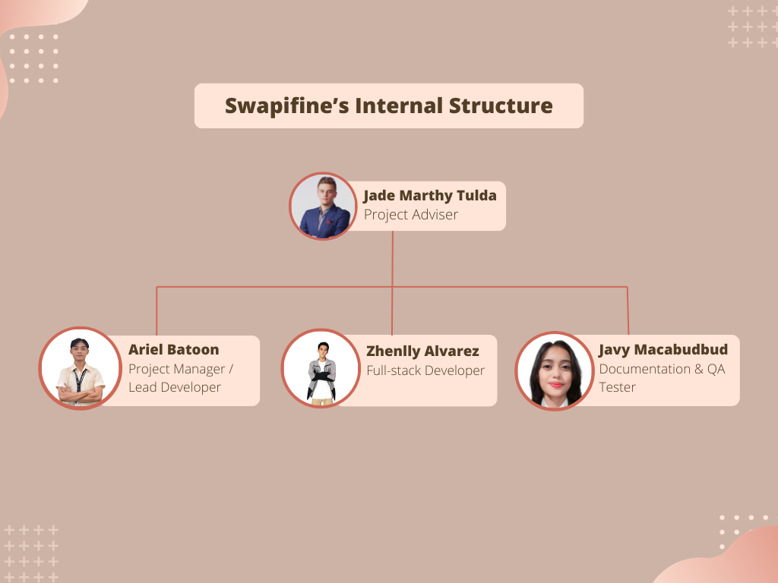

## ***Roles and responsibilities***

| **Role** | **Responsibilities** |
| --- | --- |
| Adviser/Handler | * Advises on what suits the system. * Suggest additional & changed features of the system. * Able to guide the members for the system project if necessary. |
| Project Manager / Team Lead | * Software project planning and monitoring. * Milestone and schedule planning and monitoring. * Set and communicate the team meeting agendas. |
| UI/UX | * Responsible for building UI Mockup. * Responsible for designing better User Experience. * The responsibility for ensuring design compatibility lies with the devices compatible with different systems, platforms, or technologies. |
| Developer | * Responsible for coding, debugging, and testing the system. * Assist with design, analysis, maintenance, documentation, and testing of the system matter. * Creating a library, class, and functions in logical terms. |
| Lead Developer | * Setting up the development environment. * Assisting any developer inquiries * Leading Development, either Frontend or Backend |
| QA Tester and Documentation Specialist | * Responsible for testing the system functionalities. * Responsible for testing the application. * Responsible for working on the documentation of the application. |

*[Table 4.3.1] Roles and Responsibilities*

| **Role** | **Peron’s Responsible** |
| --- | --- |
| Project Manager / Team Lead | Ariel Batoon |
| UI/UX | Ariel Batoon  John Zhenlly Alvarez |
| Lead Developer | Ariel Batoon |
| Developer | Ariel Batoon  John Zhenlly Alvarez  Javy Macabudbud |
| QA Tester and Documentation Specialist | Javy Macabudbud |

*[Table 4.3.2] Role Allocation*

# **Managerial process plans**

This clause of the SPMP shall specify the software project's work activities, schedule, resources, and budget details for the software project.

## ***Start-up plan***

The Swapifine team has already commenced the planning phase, utilizing the vacation period as a starting point to work on crucial aspects such as the Estimation Plan, Project Scope, and Software Dependencies. During this time, the team is focusing on establishing a solid foundation by estimating the effort, time, and resources required for the project, defining the project scope to outline its boundaries and deliverables, and identifying any software dependencies that may impact the project's implementation and integration. This proactive approach taken by the team at the outset sets a robust framework for successful project execution.

### ***Estimation plan***

The team members have been assigned specific tasks to focus on during the Software Project Management Planning. The project has been divided into modules per feature.

To ensure smooth task synchronization, the team will employ Trello, a drag-and-drop management tool that facilitates efficient task management.

### ***Staffing plan***

Table 5.1.2 shows the primary individuals involved in the Swapifine Project and their availability.

| Name | Affiliation to project | Semestral Break Availability | Semester Started Availability |
| --- | --- | --- | --- |
| Ariel Batoon | Project Manager/Team Lead and Lead Developer | Full Time | Full Time |
| John Zhenlly | Backend Developer | Part-Time | Full Time |
| Javy Macabudbud | QA Tester | Part-Time | Full Time |
| Jade Marthy Tulda | Adviser/Handler | N/A | N/A |

*[Table 5.1.2]: Staff Plan*

### ***5.1.3. Resource acquisition plan***

The Swapifine Team has the resources to develop and complete the system. However, as the scheme progresses, we may explore the possibility of acquiring additional help if needed.

### ***5.1.4. Project staff training plan:***

The Swapifine team is improving their skills based on the project requirements through online free course platforms.

## ***Work plan***

This clause of the SPMP shall specify the software project's work activities, schedule, resources, and budget details.

### ***Work activities:***

The numerous work activities to be carried out on the software project must be specified in this sub clause of the SPMP. To illustrate the work tasks and their connections, a work breakdown structure must be used. The level at which work activities are broken down should expose all project risk elements and enable precise estimation of resource needs and schedule duration for each work activity. It is recommended to utilize work packages to detail each work activity's prerequisites, projected time, work products to be created, work product acceptance standards, and predecessor and successor work activities. Depending on elements like the quality of the work breakdown structure, the level of decomposition for various work tasks may vary.

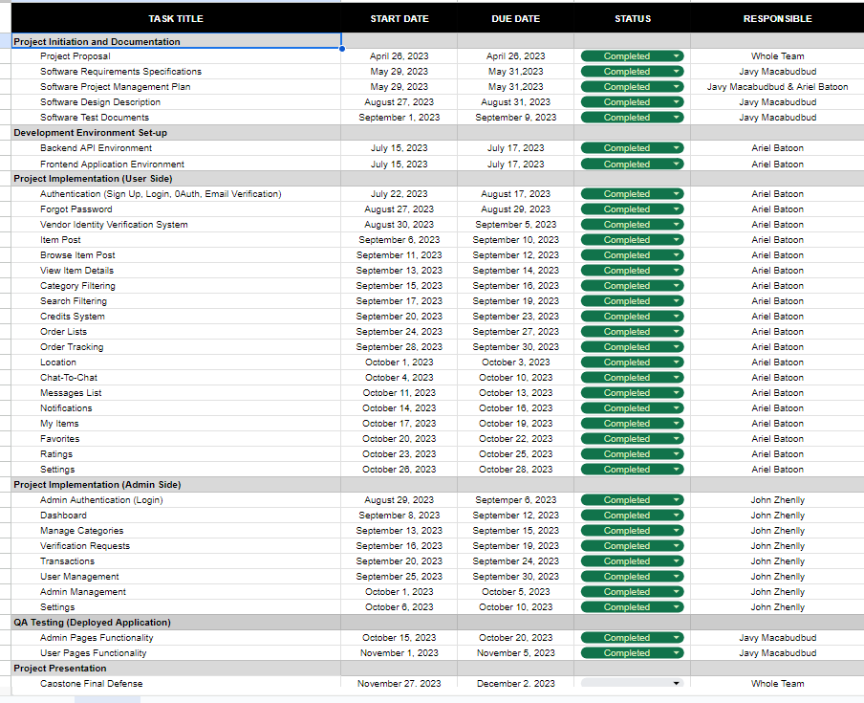

*[Table 5.2.1]: Activities*

### ***Schedule allocation:***

The project has a one-semester time limit and must finish the final product by December 23, 2023. The schedule will be managed accordingly.

### ***5.2.3. Resource allocation***

During the designated semester break, some developers will embark on the project to proactively advance its progress.

The team members are flexible to operate from various locations, including their residences, due to their possession of individual resources necessary to commence development. However, we must adhere strictly to consistent technical sync-ups upon completing modules or when encountering significant impediments. Furthermore, scheduled meet-ups will facilitate discussions surrounding pivotal matters, such as document preparation, soliciting advice from advisors, and addressing any unresolved challenges faced during the development process.

Depending on availability, each team member must commit at least 4-5 hours daily to the project to ensure adequate contribution. Rigorous progress monitoring approaches become essential for simply tracking the project's changing crucial.

### ***5.2.4. Budget allocation***

The budget details are in Table 1.1.5 - Budget Summary. Our team is committed to diligently adhering to the allocated funds and striving to minimize additional expenses throughout the project. We understand the importance of prudent financial management and will take proactive measures to avoid exceeding the designated budgetary constraints. By maintaining a focused approach towards cost control, we aim to optimize resource allocation and ensure efficient utilization of funds.

## ***5.3. Control plan***

This subclause of the SPMP shall specify the metrics, reporting mechanisms, and control procedures necessary to measure, report, and control the product requirements, the project schedule, budget, and resources, and the quality of work processes and work products. All control plan elements should be consistent with the organization’s standards, policies, and procedures for project control and with any contractual agreements for project control.

### ***5.3.1. Requirements control plan***

Requirements will be managed and updated in the SRS's use case descriptions. Any changes to the conditions will be communicated to the advisor and documented in the version change logs.

### ***5.3.2. Schedule control plan***

The Swapifine team's project manager will oversee the project schedule's maintenance within a dedicated project document. Their responsibilities include compiling individual tasks for each team member and generating status reports. If the schedule deviates from the planned track, the Swapifine team will conduct scheduled control meetings as part of their pre-planning process. The deplaning process of the Swapifine team, which is outlined in a separate document, will also be carefully maintained.

### ***5.3.3. Budget control plan***

The project does not entail additional costs besides the Cloud Hosting expenses.

### ***5.3.4. Quality control plan***

The Swapifine team follows the Agile Scrum methodology, which involves dividing the project into modules or sprints. Each sprint undergoes a testing process before the final product testing to ensure the quality of functionality in every sprint.

### ***5.3.5. Reporting plan***

The Swapifine team adheres to rigorous guidelines for conducting technical sync-ups, which serve as a platform to discuss project progress, blockers, unforeseen changes, and personal issues. This proactive approach enables the team to assist, address challenges promptly, and mitigate any potential project progress setbacks.

### ***5.3.6. Metrics collection plan:***

The team utilizes a Trello board as a project management tool to track progress efficiently. By categorizing tasks into various statuses such as "Ongoing," "50% Finished," "75% Finished," "Completed," or "Blocked," the team can easily monitor the status of each task and gain a comprehensive view of the overall project advancement. This systematic approach facilitates effective task management and promotes transparency within the team.

### ***5.3.7 Risk Management Plan***

At the onset of each project sprint, risks will be systematically identified, and the team lead will compile them into a prioritized list. This list will be available on the team's designated project management website for easy access and reference. During the weekly status meeting, team members can raise potential risks and reassess the prioritized list, making any necessary revisions. The Swapifine team employs a "Risk Statement" approach to articulate identified risks clearly.

The team members will develop mitigation plans for all identified risks and associated tasks to ensure proactive risk management. These risks and tasks will be allocated as actionable items, enabling the team to address and mitigate potential issues actively. Monitoring of high-priority risks will be discussed every week. The team will maintain comprehensive documentation of all identified risks to facilitate transparency and provide a historical record for future analysis and reference.

### ***5.3.8 Project Closeout Plan***

The Swapifine team is committed to executing a thorough and well-structured closeout process at the end of the semester. This closeout phase encompasses various activities aimed at compiling and organizing all relevant project documentation and deliverables. The team will meticulously review and verify the completeness and accuracy of the compiled materials, ensuring that all project requirements and objectives have been met satisfactorily.

**6. Technical process plans**

This clause of the SPMP shall specify the development process model, the technical methods, tools, and techniques to develop the various work products, plans for establishing and maintaining the project infrastructure, and the product acceptance plan.

## ***6.1 Process Model***

This sub-clause of the SPMP shall define the relationships among major project work activities and supporting processes by specifying the flow of information and work products among activities and functions, the timing of work products to be generated, reviews to be conducted, major milestones to be achieved, baselines to be established, project deliverables to be completed, and required approvals that span the duration of the project. The process model for the project shall include project initiation and project termination activities. A combination of graphical and textual notations may be used to describe the process model.

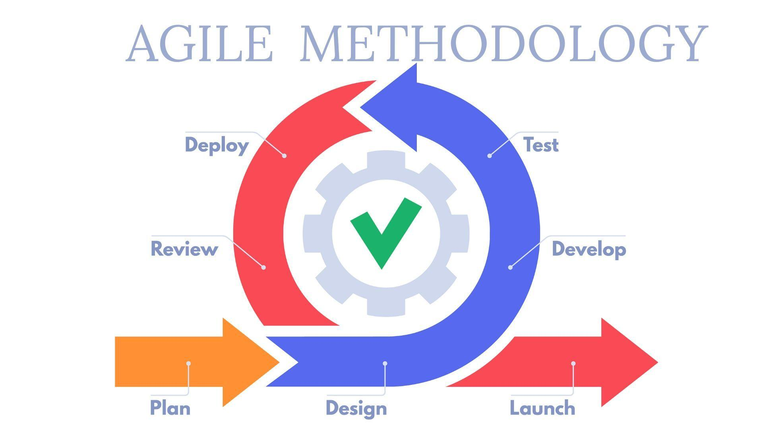

*Figure 2. Agile Methodology*

**OVERVIEW OF PHASES**

1. **Plan** – The System Requirements Specification (SRS) and System Project Management Plan (SPMP) are implemented now. The project needs must be identified and defined, and the strategy for achieving them must be laid out during this phase. The SRS is a thorough document detailing the system's functional and non-functional needs. At the same time, the SPMP outlines the strategies and methodologies to be employed for effective project management. These documents provide a solid foundation for understanding the project's scope, objectives, and deliverables and the processes and procedures to be followed throughout its execution.
2. **Design** – This pivotal stage involves the creation of the system's architecture, encompassing the design of the user interface (UI), user experience (UX), and the formulation of the Entity Relationship Diagram (ERD). In the Design Phase, careful attention is given to crafting an intuitive and visually appealing UI that enhances user interactions. Simultaneously, the UX design is tailored to optimize user satisfaction and streamline the user journey. The Entity Relationship Diagram is also constructed to establish the relationships between various data entities, ensuring the integrity and coherence of the system's data model. The Design Phase is instrumental in laying the foundation for the system's aesthetic appeal, usability, and efficient data management.
3. **Develop** – The Development Phase constitutes the implementation stage, during which the team of developers endeavors to achieve the required functionality specified in the project requirements. This crucial phase involves the coding and programming activities necessary to bring the envisioned system to life. The development team will use their knowledge and technical prowess by converting the design criteria into features and functional components.
4. **Test** – The Testing Phase is a critical stage where dedicated testers meticulously assess the quality of each functionality to ensure its seamless operation and identify any potential issues. The testers will rigorously validate the system against the specified requirements through a comprehensive range of testing methodologies, evaluating its performance, reliability, and usability. This phase aims to identify and rectify any defects or inconsistencies hindering the system's optimal functioning.
5. **Deploy** – The Deployment Phase is a critical stage where the developed system transitions from the local development environment to the live production environment. It involves implementing the system on designated production servers, configuring databases and servers, and addressing security measures. Thorough testing and validation are conducted to ensure the system's functionality, compatibility, and readiness for end-user access. This phase marks the culmination of the development process, making the system available for use in the live production environment.
6. **Review** – This phase involves conducting additional testing and reviewing the live production environment to address any remaining issues or backlog. The QA testers and developers collaborate to ensure optimal system performance before making it accessible to casual users.
7. **Launch** – In this final phase, the project is publicly deployed and accessible to casual users.

## ***6.2 Methods, Tools, and Techniques***

The project development study employed a systematic methodology to devise a system prototype. The proponents followed a structured approach involving planning, analysis, design, assembly, and testing/evaluation phases. The team diligently executed the necessary steps through these stages to conceptualize, develop, and assess the prototype device.

The project utilizes Virtual Studio Code IDE as the primary development tool. The system is designed as a Progressive Web Application (PWA), which enables it to function as a native mobile application when installed by the user, depending on the device used. The implementation approach involves first building the API using the Laravel API framework, followed by its utilization on the front end using VueJS. The project also utilizes MySQL as the database. This technique ensures efficient communication and interaction between the backend and frontend components of the system, enabling seamless data flow and optimal user experience.

## ***6.3 Infrastructure Plan***

The Swapifine project will be hosted on the live server, specifically on Hostinger, ensuring its availability to users. Swapifine is projected to operate for at least one year, possibly extending if user usage experiences significant growth. It is worth noting that even after the project compilation, the Swapifine team will continue to manage and oversee its operations to ensure ongoing maintenance, updates, and support. This commitment reflects the team's dedication to sustaining the project's functionality and meeting the evolving needs of its users beyond the initial implementation phase.

## ***6.4 Product Acceptance Plan***

The Swapifine project is mandatory for successfully completing the Capstone 2 project. However, to be deemed complete, the project must meet specific criteria and fulfill the necessary requirements. It should be noted that even after the initial delivery of the system, ongoing improvements and enhancements will be undertaken, as the project will be deployed publicly, and further refinement may be required based on user feedback and experience. This iterative process reflects the project's commitment to continuous improvement and responsiveness to user needs.

**7. Supporting process plans**

This section of the SPMP will include the plans for the supporting functions that are part of the software project. These include a configuration management plan, software document, quality assurance, and process improvement plan.

## ***7.1. Configuration management plan***

The Swapifine team's configuration management plan is documented separately and will be diligently upheld.

## ***7.2. Verification and validation plan***

Continual activities include a variety of tasks that cut across distinct life cycle phases. These activities, which include traceability analysis, assessment, interface analysis, and testing, are crucial parts of the process as a whole. They serve as horizontal threads connecting the actions of the succeeding phases, permitting more efficient verification. Assuring coherence, traceability, and general quality throughout the project's life cycle depends on these tasks.

## ***7.3. Documentation plan***

Throughout the project's lifespan, a number of documents will be created. The members of the project team are in charge of all papers. The documents that will be developed and updated using version control are:

* Statement of Work (SOW)
* Software Project Management Plan (SPMP) – defines the project management plan.
* Software Requirements Specification (SRS) – defines the functionality that the customer requires.
* Supplementary Specification (SS) - defines the non-functionality that the customer requires.
* Architecture
* Architecture Tradeoff Analysis Model (ATAM)
* Mini-Software Risk Evaluation (SRE) – evaluate software risks.
* System Integration Plan
* Status Report
* Management Statement – defines risks and each mitigation plan.

## ***7.4. Quality assurance plan***

This is described and managed in a separate document named Web Application Quality Assurance Plan.

## ***7.5. Reviews and audits***

This is described and managed in a separate document named Web Application Quality Assurance Plan.

## ***7.6. Problem resolution plan***

This is described and managed in a separate document named Web Application Quality Assurance Plan.

## ***7.7. Process improvement plan***

Process improvement activities will be conducted as an integral part of the final project evaluation. A process improvement plan will be developed and implemented during this stage to enhance the project's overall effectiveness and efficiency. The process improvement plan is documented and maintained in the Point Process Improvement Plan (PIP) document. This document outlines the strategies, methodologies, and actions to identify and address improvement areas within the project's processes. The project team aims to optimize performance, mitigate risks, and enhance future project outcomes by incorporating continuous improvement practices.



**CORDOVA PUBLIC COLLEGE**

GABI, CORDOVA, CEBU, PHILIPPINES

COLLEGE OF COMPUTER STUDIES

**Software Requirements Specifications**

*for*

Community Resource Exchange (Swapifine)

CPC-BSIT-CAPSTONE-SRS-1st SEM 2022-2023-SWAPIFINE

Documents for IT Project

Of

Ariel Batoon

John Zhenlly Alvarez

Javy Macabudbud

**Change History**

| Version | Changes Made | Editor and Date |
| --- | --- | --- |
| Version 1 | Changed Logo and Web Application name | Ariel Batoon  July 07, 2023 |
| Version 2 | Removing Social Login/Authentication for the registration and login process for users | Javy Macabudbud  September 03, 2023 |
| Version 3 | Changing all use cases | Javy Macabudbud  September 16, 2023 |
| Version 4 | Adding the following additional modules:   1. Admin: Reported User 2. Withdrawal 3. Admin: Withdrawal Request | Javy Macabudbud  December 01, 2023 |
| Version 5 | Organizing the List of Figures | Javy Macabudbud  December 02, 2023 |

**Preface**

The Community Resource Exchange(Swapifine) is a web-based application designed to connect people within a specific community to exchange resources and information. This platform has a user-friendly interface created to make it easier for individuals and organizations to share various assets, including tools, equipment, knowledge, and other items that are accessible for sharing.

The developers set out the creation of the user interface with a consideration of user satisfaction and retention. A pleasing and well-organized system where users can easily navigate the application's features. While users can post, discover, communicate, and trade items, the admin manages the users' transactions, accounts, and overall performance of the system. It is responsible for data management and security measures.

Generally, this application’s design focuses on providing users with a responsive design that ensures that the system interface can adapt to different screen sizes and devices. Also, implement a clear and intuitive navigation for user efficiency and satisfying user experience.

**Table of Contents**

**Change History** [**3**](https://docs.google.com/document/d/1FzzXDdk0cj8oLebDXpaVfwuK_mfUCm0F/edit#heading=h.3j2qqm3)

**Preface** [**4**](https://docs.google.com/document/d/1FzzXDdk0cj8oLebDXpaVfwuK_mfUCm0F/edit#heading=h.1y810tw)

**Table of Contents 5**

**List of Figures** [**6**](https://docs.google.com/document/d/1FzzXDdk0cj8oLebDXpaVfwuK_mfUCm0F/edit#heading=h.2bn6wsx)

**List of Tables 8**

**1.** **Introduction 9**

1.1. Purpose 9

1.2. Scope 9

1.3. Product Overview 9

*1.3.1 Product Perspective 10*

*1.3.2 Product Functions 10*

*1.3.3 User Characteristics 11*

*1.3.4 Limitations 11*

1.4. Definitions 11

**2.** **References 12**

**3.** **Specific Requirements 13**

3.1. External Interfaces 13

3.2. Functions 45

3.3. Usability Requirements 59

3.4. Performance Requirements 59

3.5. Logical Database Requirements 60

3.6. Design constraints 60

3.7 Software system attributes 60

**4.** **Verification 61**

**5.** **Appendices 62**

**List of Figures**

Figure no. 1. Authentication: Welcome Page, Login, and Register UI

Figure no. 2. Forgot Password User Interface

Figure no. 3. Browse User Interface

Figure no. 4. Post Item User Interface

Figure no. 5. Item Details User Interface

Figure no. 6. Credits System User Interface

Figure no. 7. Order Lists User Interface

Figure no. 8. Order Tracking User Interface

Figure no. 9. Location User Interface

Figure no. 10. Category User Interface

Figure no. 11. Search User Interface

Figure no. 12. Notifications User Interface

Figure no. 13. Messages List User Interface

Figure no. 14. Chat-To-Chat User Interface

Figure no. 15. My Items User Interface

Figure no. 16. Wishlist User Interface

Figure no. 17. Rating User Interface

Figure no. 18. Verification User Interface

Figure no. 19. Withdraw User Interface

Figure no. 20. Settings User Interface

Figure no. 21. Admin - Login User Interface

Figure no. 22. Admin - Dashboard User Interface

Figure no. 23. Admin - Categories User Interface

Figure no. 24. Admin - Verification Request User Interface

Figure no. 25. Admin - Withdrawal Request User Interface

Figure no. 26. Admin - User Transaction User Interface

Figure no. 27. Admin - Our Revenue User Interface

Figure no. 28. Admin - Reported User User Interface

Figure no. 29. Admin - User Management User Interface

Figure no. 30. Admin Management User Interface

Figure no. 31. Admin - Settings User Interface

Figure no. 32 Authentication Register Use Case

Figure no. 33. Authentication: Login Use Case

Figure no. 34. Forgot Password Use Case

Figure no. 35. Browse Use Case

Figure no. 36. Post Item Use Case

Figure no. 37. Item Details Use Case

Figure no. 38. Credits System Use Case

Figure no. 39. Order Lists Use Case

Figure no. 40. Order Tracking Use Case

Figure no. 41. Location Use Case

Figure no. 42. Category Use Case

Figure no. 43. Search Use Case

Figure no. 44. Notification Use Case

Figure no. 45. Messages List Use Case

Figure no. 46. Chat-to-Chat Use Case

Figure no. 47. View Store Use Case

Figure no. 48. Verification Use Case

Figure no. 49. Withdrawal Use Case

Figure no. 50. Settings Use Case

Figure no. 51. Admin- Login Use Case

Figure no. 52. Admin- Dashboard Use Case

Figure no. 53. Admin - Categories Use Case

Figure no. 54. Admin - Verification Request Use Case

Figure no. 55. Admin - Withdrawal Request Use Case

Figure no. 56. Admin - User Transaction Use Case

Figure no. 57. Admin- Reported Users Use Case

Figure no. 58. Admin - User Management Use Case

Figure no. 59. Admin- Admin Management Use Case

Figure no. 60. Admin - Settings Use Case

Figure no. 61. Logical Database Requirements

# **Introduction**

In the present generation, individuals extensively rely on their computing devices, including desktop computers and mobile devices, to access the internet and engage in various online activities. It encompasses utilizing online services such as buying, selling, and trading goods through e-commerce marketplaces. This digital platform facilitates convenient browsing for specific items, with sellers shipping the products to buyers or swappers, offering a more streamlined alternative to traditional physical shopping. Nevertheless, it is crucial to acknowledge that along with the benefits provided by this platform, there are inherent risks, including fraud, scams, and other adverse outcomes that can adversely affect individuals' experiences and potentially discourage them from further engaging with such platforms.

## ***Purpose***

This Software Requirements Specification (SRS) aims to clearly define the functional and non-functional requirements of the Swapifine's system. It aims to provide a comprehensive understanding of the system's capabilities, features, and performance expectations to the development team involved in the project. This document plays a vital role by establishing a solid foundation for system development and guiding subsequent stages of the software development lifecycle.

## ***1.2 Scope***

This project's scope entails the development of a marketplace platform that utilizes internet or mobile connections. The software product will enable users to discover and swap goods, providing features such as a user-friendly interface for browsing and searching items, secure transaction management, user account management, withdrawal, communication capabilities between seller and buyer, and order management. Bear in mind that this software will not support shipment logistics, as it is an aspect that may involve third-party integrations.

The application of this software lies in offering a centralized marketplace where users can conveniently engage in browsing products, allowing them to buy and sell or swap items remotely while providing sellers with increased business reach. The primary objectives include facilitating a seamless marketplace experience, enabling effective communication between sellers and buyers, and enhancing the accessibility and convenience of e-commerce through Internet or mobile connections. This scope will maintain consistency with higher-level specifications, ensuring alignment with the overall system requirements while providing a more detailed understanding of the marketplace software's specific functionality and application.

## ***Product Overview***

### ***1.3.1 Product Perspective***

The system platform comprises various components, such as user authentication, inventory management, payment processing,withdrawal, and order fulfillment. The marketplace software interacts with these components to facilitate seamless buy-and-sell or swapping of goods and services.

### ***1.3.2 Product Functions***

Swapifine functions are the following:

**User Features**

* Authentication: Sign Up and Log In to Your Account through Manual Credentials.
* Forgot Password: Password recovery is feasible as long as access to the linked email is accessible.
* Browse: Explore Posted Items.
* Post Item: Able to post items
* Item Details: Access Information About Posted Items and Send Offers.
* Credits System: Purchase Platform Credits for Sellers to Utilize When Adding Items.
* Order Lists: To View the List of Orders
* Order Tracking: To Monitor Completion Status (Completed, In-Progress, Failed).
* Location: Set the User's Current Location and Use it to Determine Distances to Other Users.
* Category Filtering: Item Categorization and Filtering.
* Search Filtering: Locate Specific Item Posts.
* Notifications: Receive Alerts for New Activities.
* Messages List: View all the messages.
* Chat-To-Chat: Engage in Real-Time Chats with Other Users.
* My Items: List of All Posted Items.
* Wishlist: List of liked Posts.
* Ratings: Ratings Provided by the buyers.
* Verification: Vendors Must Verify Their Identification.
* Withdrawal: Users withdraw funds from their account.
* Settings: View and Update Personal Information.

**Admin Features**

* Admin Authentication: Admins Must Provide Credentials to Access the Dashboard.
* Dashboard: Provides an Overview of All Information.
* Categories: Manage Adding, Updating, and Viewing Item Categories.
* Verification Requests: Displayed Verification Requests for Sellers.
* Withdrawal Request: Displayed Withdrawal Request for Users.
* Transactions: User Transactions and Platform Revenue (in Credits).
* Reported User : Can report user via Message feature
* User Management: Administering User Data.
* Admin Management: Accessible to Super Admins, Enabling Oversight of Listed Admins and Addition of New Ones.
* Settings: View and Modify Personal Information.

### ***1.3.3 User Characteristics***

Users have the flexibility to engage in multiple actions within the Swapifine platform, including posting listings and sending offers. They can list both brand-new and second-hand items, either for direct sale or to accept bids from other users. This feature empowers users to actively participate in the marketplace, providing them with choices to effectively trade their items based on their preferences and desired transaction methods.

### ***1.3.4 Limitations***

* Users must read and agree to Swapifine 's Terms and Conditions and Policies to prevent account termination.
* Users must have an active internet or mobile connection to access and utilize the platform.
* Mobile users are encouraged to add the web application to their home screen or install it if their operating system supports Progressive Web Application (PWA) functionality for easy accessibility.
* Account verification is required for users to create listings on the platform.
* The admins can only access the Admin Dashboard if their IP is listed on the server network.

## ***Definitions***

This clause of the SRS shall define or provide references to documents containing the definition of all terms and acronyms required to understand the SRS properly.

* **CPC** – Cordova Public College
* **Swapifine** – Swap and Refine
* **API** – Application Programming Interface
* **PWA** – Progressive Web Application
* **SRS** – Software Requirements Specification
* **UI** – User Interface
* **IP** - Internet Protocol

# **References**

IEEE. *IEEE Std 830-1998 IEEE Recommended Practice for Software Requirements Specifications.* IEEE Computer Society, 1998.

# **Specific Requirements**

## ***External interfaces***

1. ***3.1.1. User interfaces***
2. Authentication: Welcome Page, Login, and Register User Interface

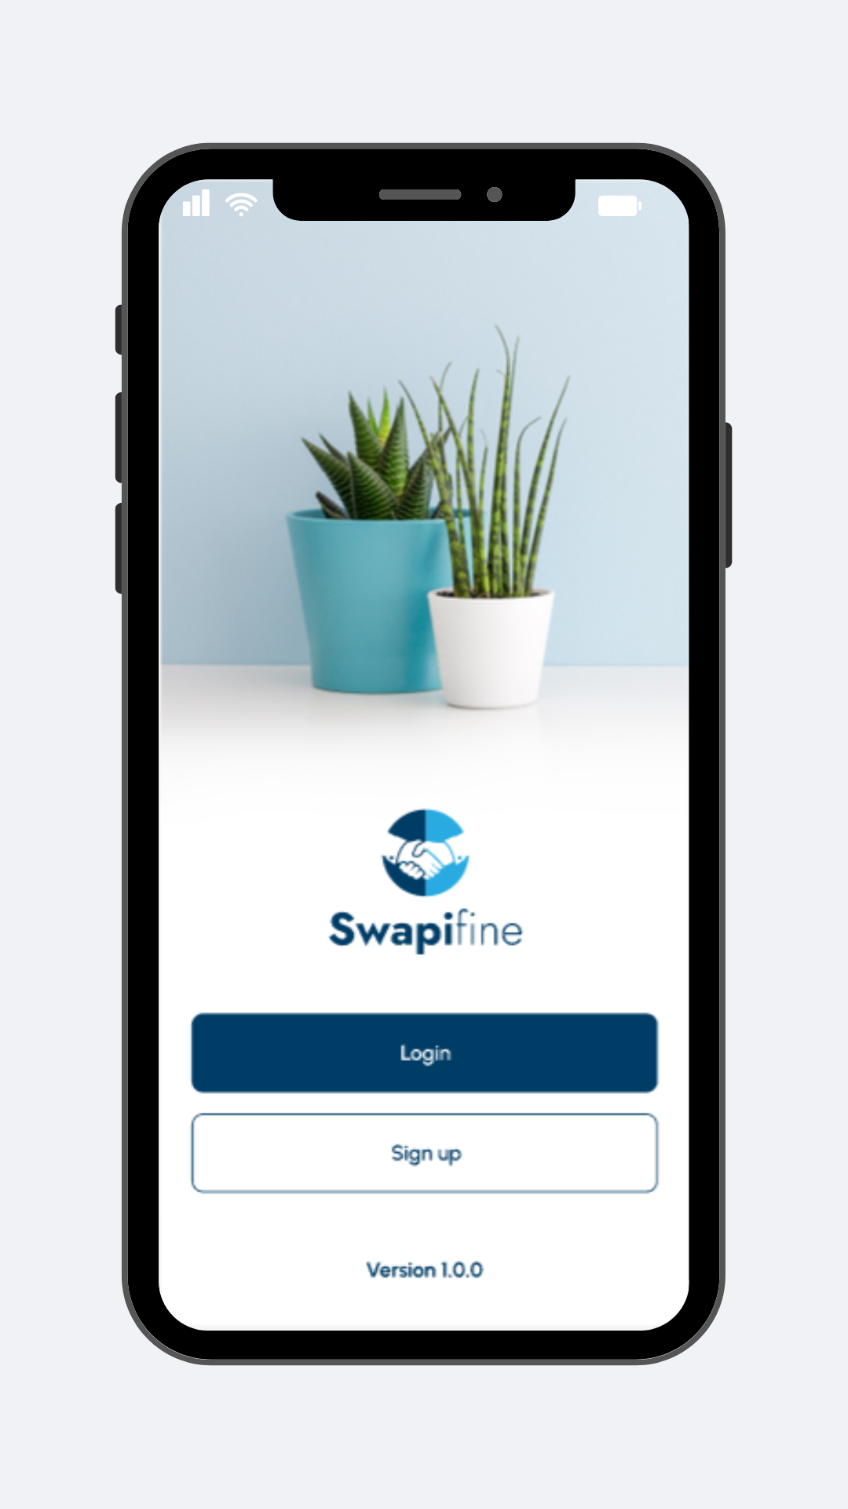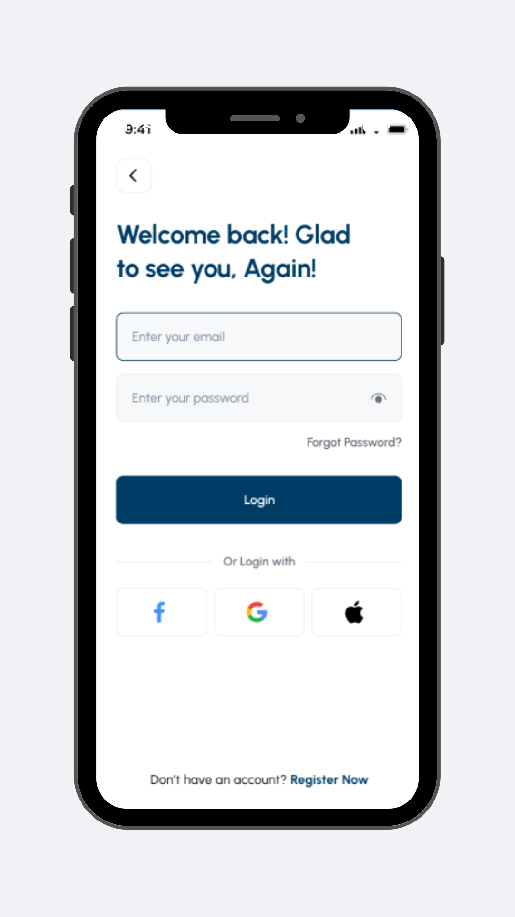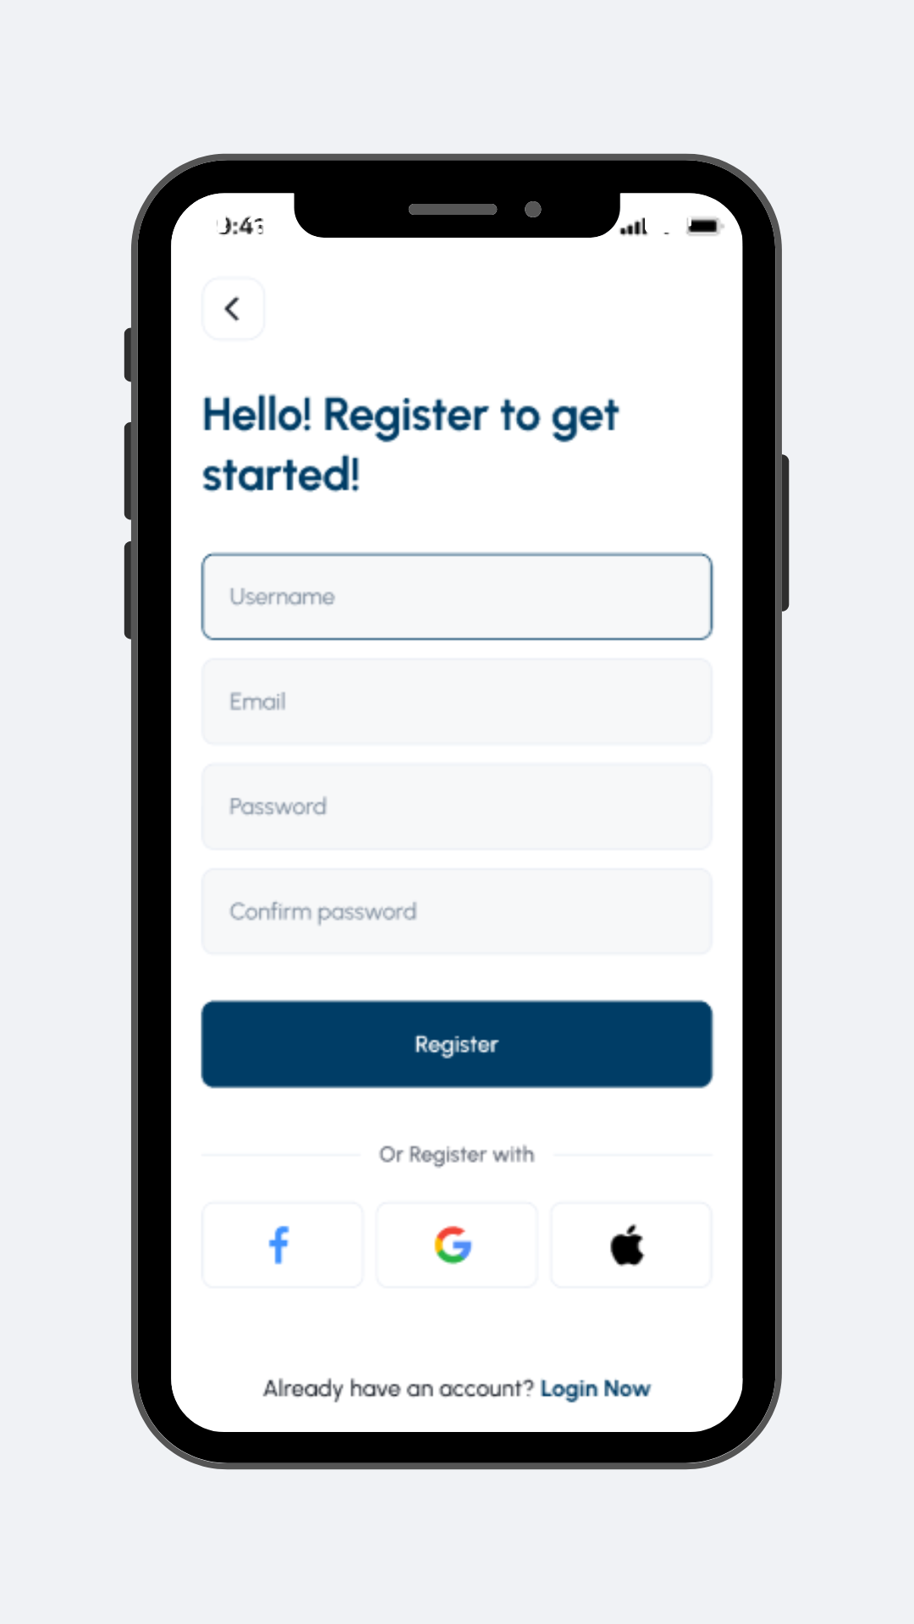

*Figure 1*

The Welcome Page is the user's initial interface upon entering the platform. The platform prompts users to fill out the required fields for logging in. Users must provide a valid email address, as the platform utilizes it for account verification.

1. Forgot Password User Interface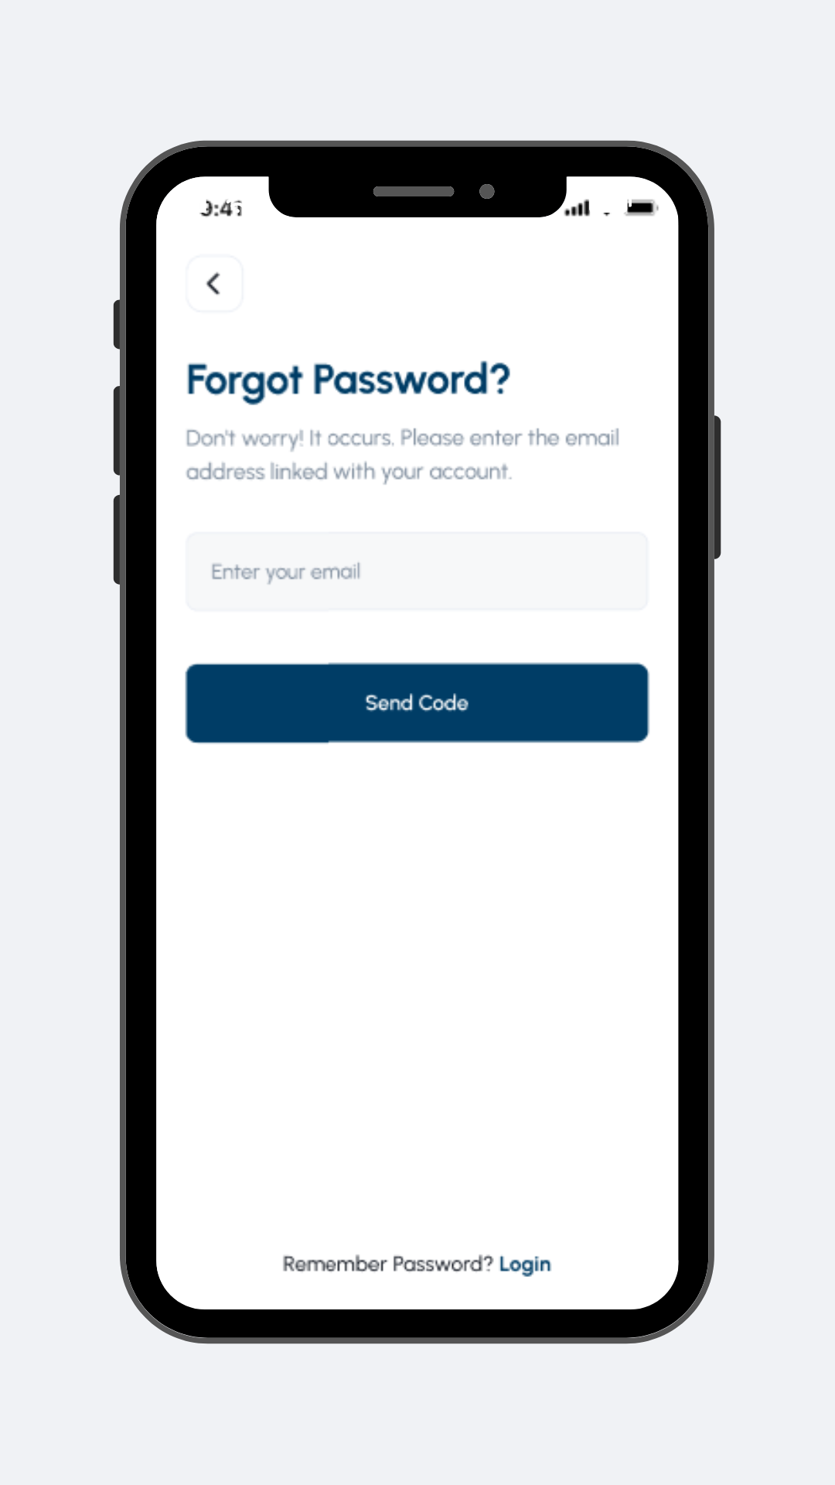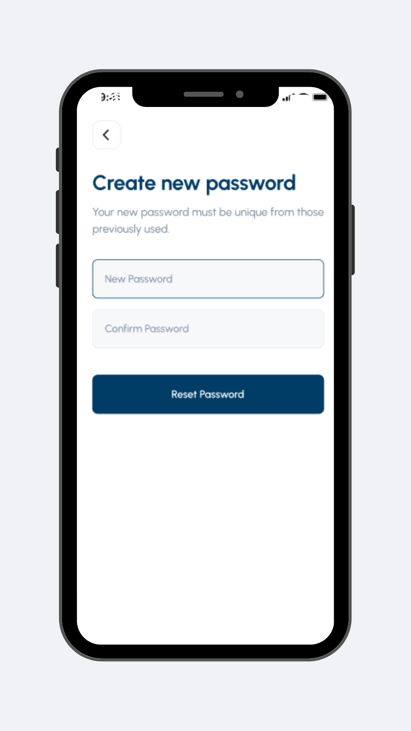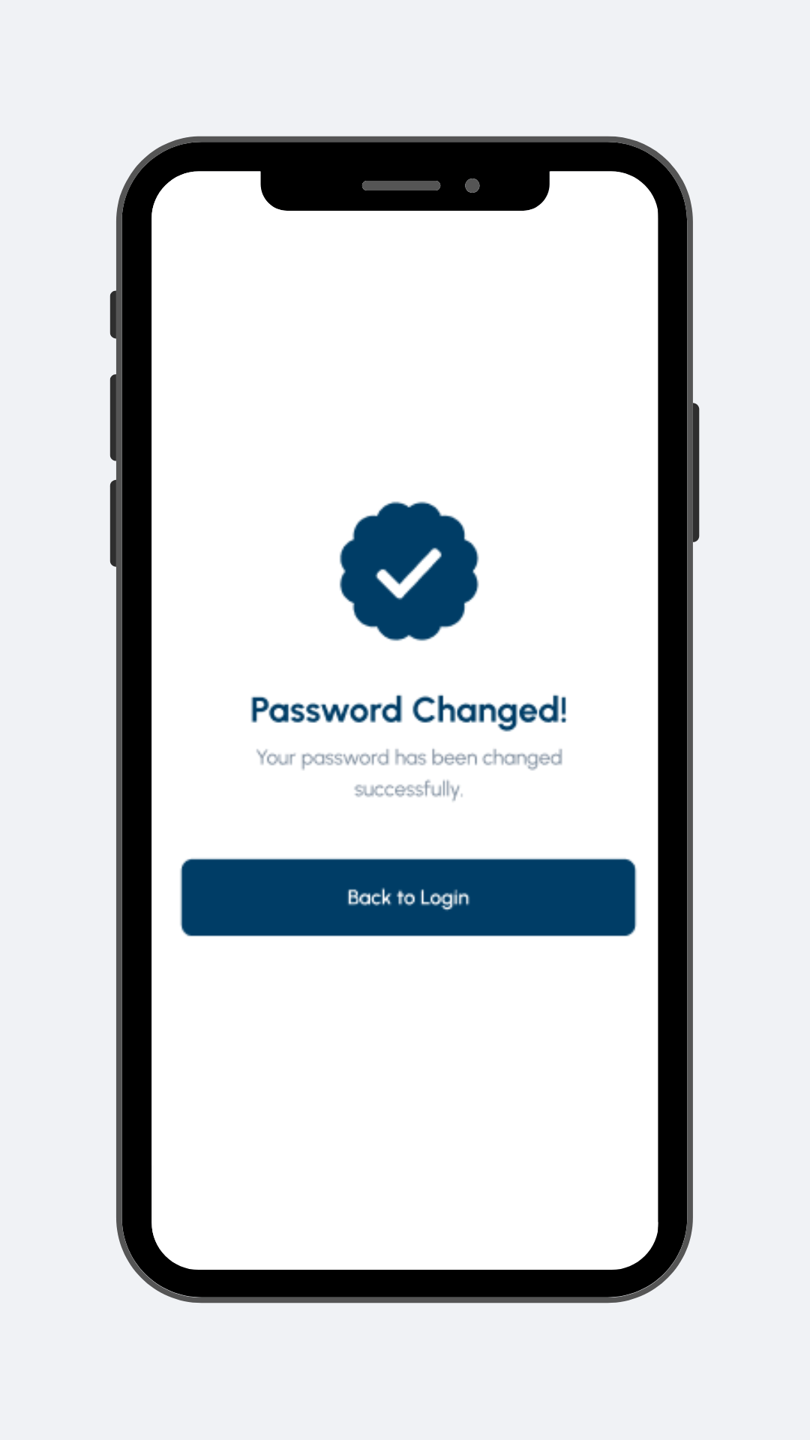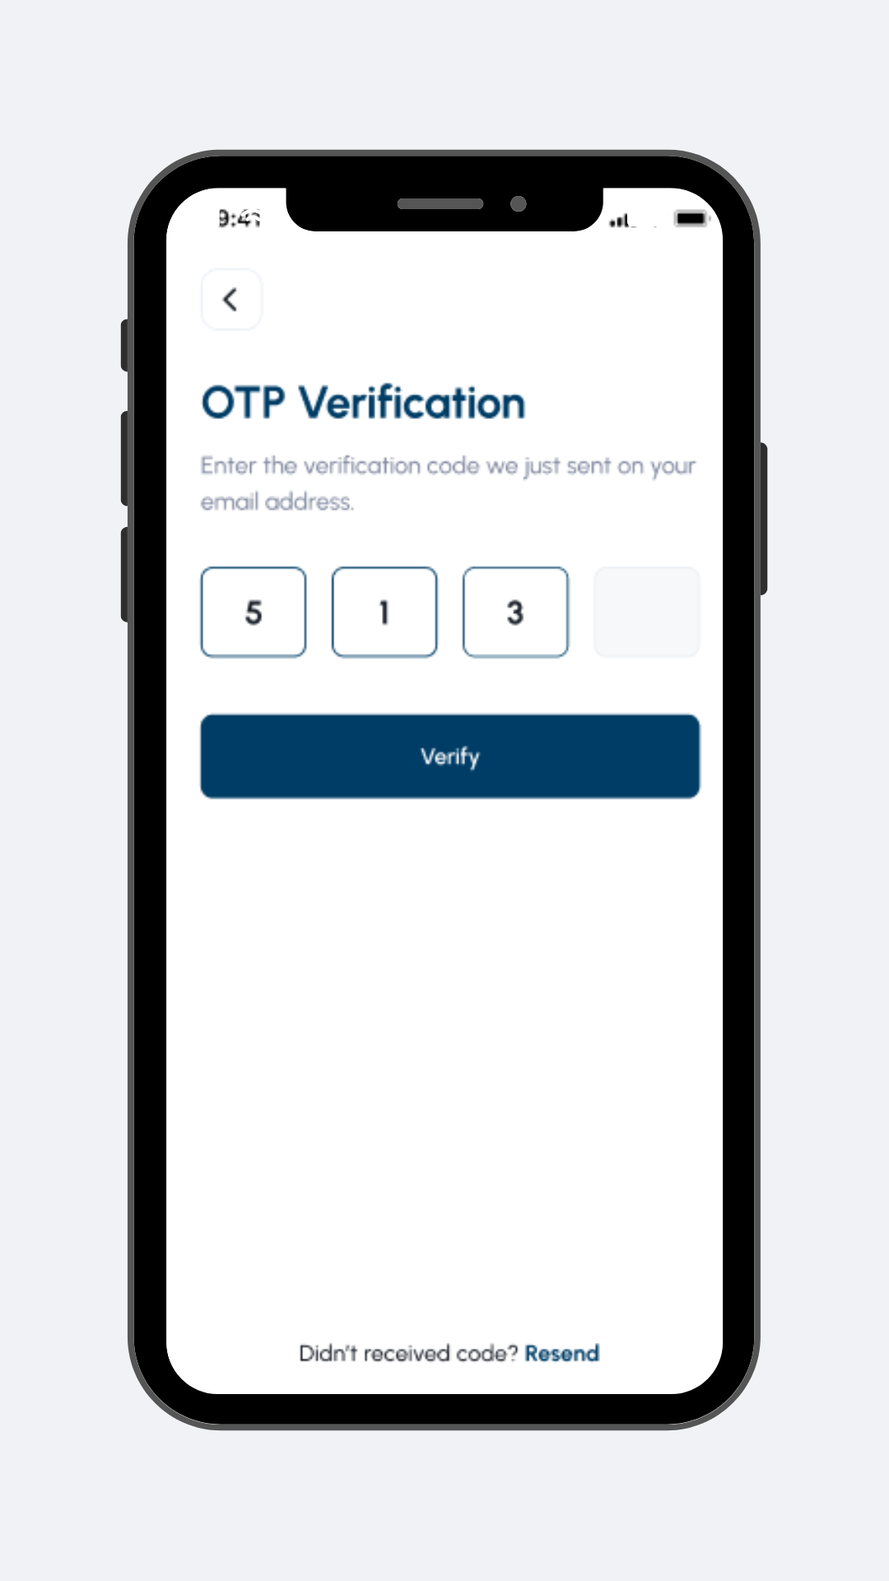

*Figure 2*

The "Forgot Password" User Interface empowers users to restore their account access via a Gmail account. Within this process, users receive a verification code, enabling them to update their password to a distinct one subsequently. This guarantees that only authorized users can successfully restore access to their accounts.

1. Browse User Interface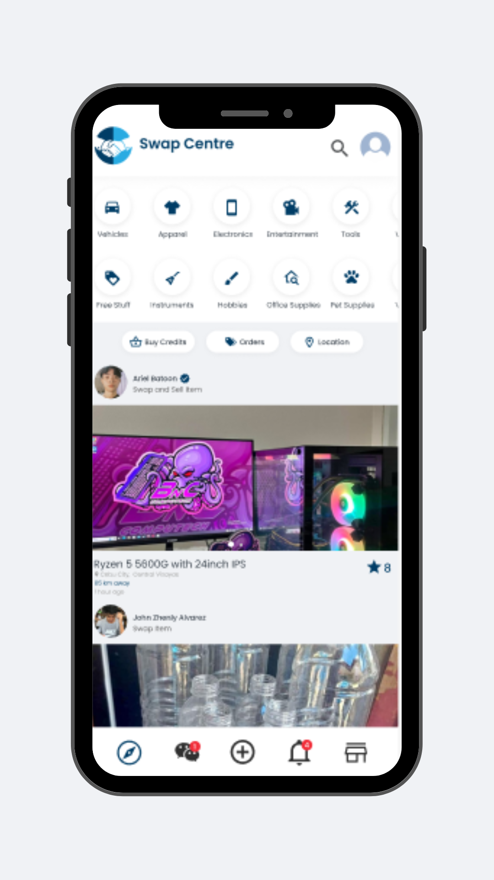

*Figure 3*

Upon clicking the login button in this User Interface, the system will automatically redirect users to the home page. The user can search, discover item categories, and engage with the items of their interest.

1. Post Item User Interface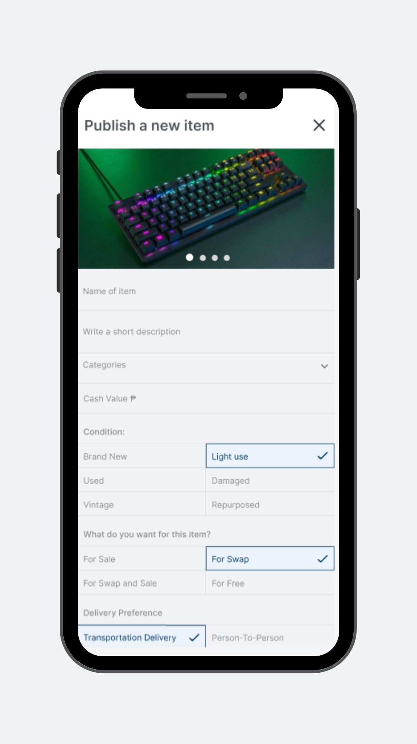

*Figure 4*

The user triggers this process by selecting the "New Post Item" button. Users must input the necessary information into the required fields to proceed with item publication. Furthermore, users can enhance the reliability of the item or service by adding images. The user interface conveniently offers a checkbox and dropdown menu for this selection.

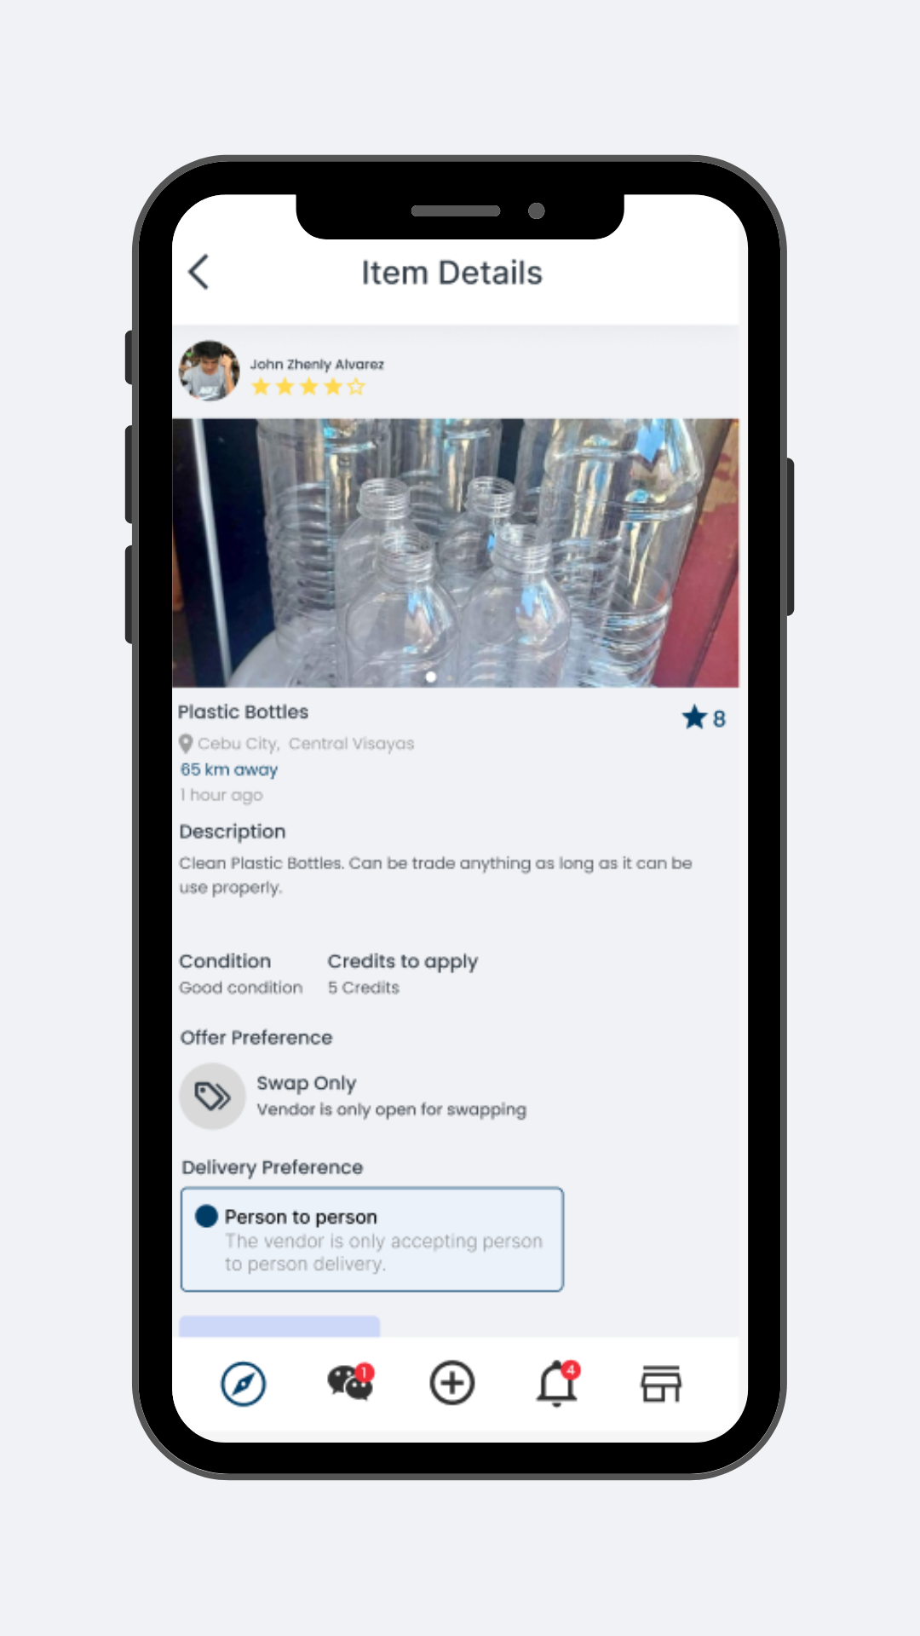

1. Item Details

*Figure 5*

This UI presents the offer preference of an item. The user can choose between swapping or buying the item through cash. Users can also select their delivery preferences and view the value of the things they are interested in.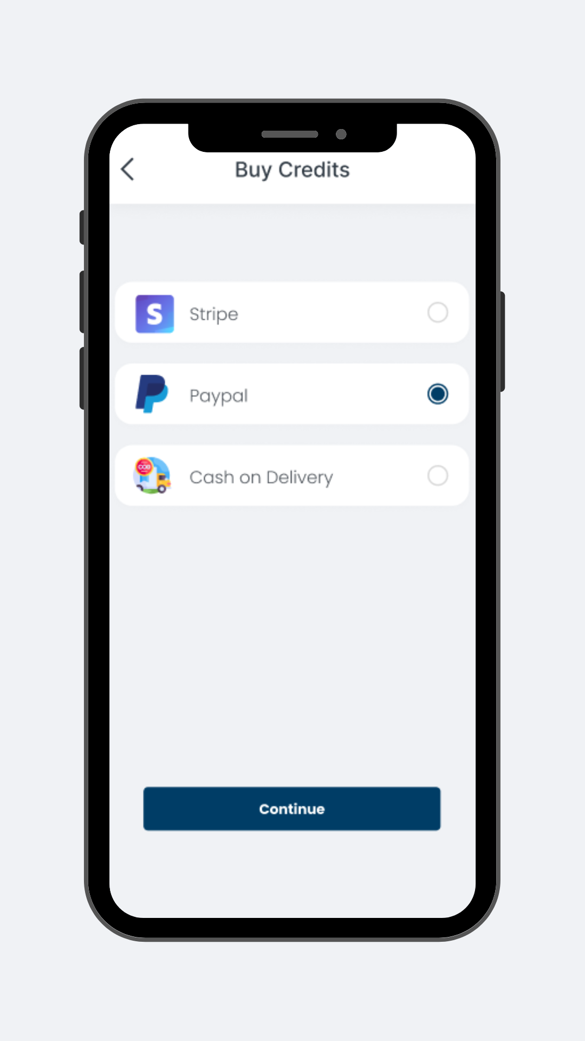

1. Credits System

*Figure 6*

This user interface is for purchasing credits. It showcases the process of purchasing credits that users can use to add items.

1. Order Lists User Interface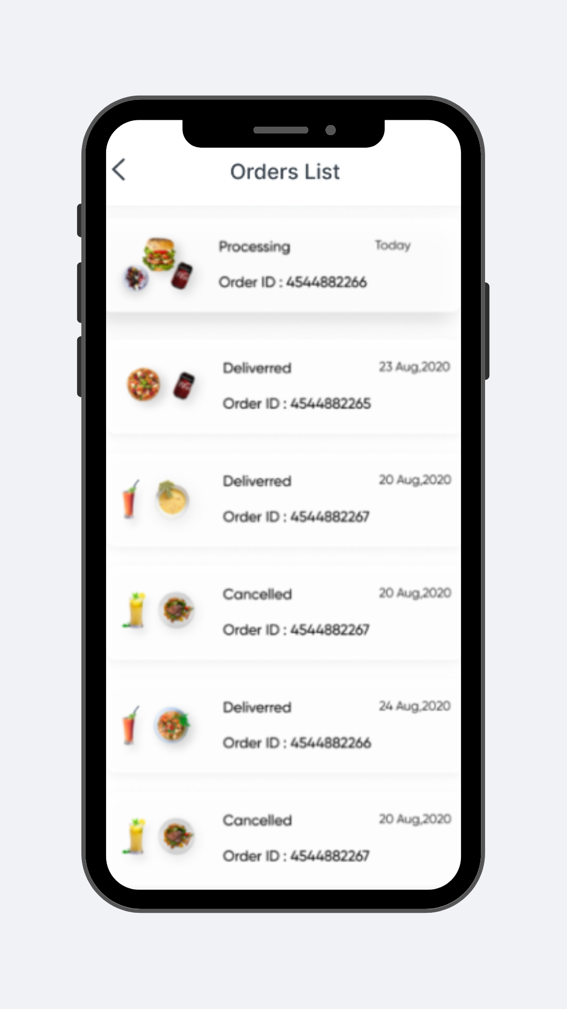

*Figure 7*

This user interface allows users to view their order list in a user-friendly design. It shows the user's order details.

1. Order Tracking User Interface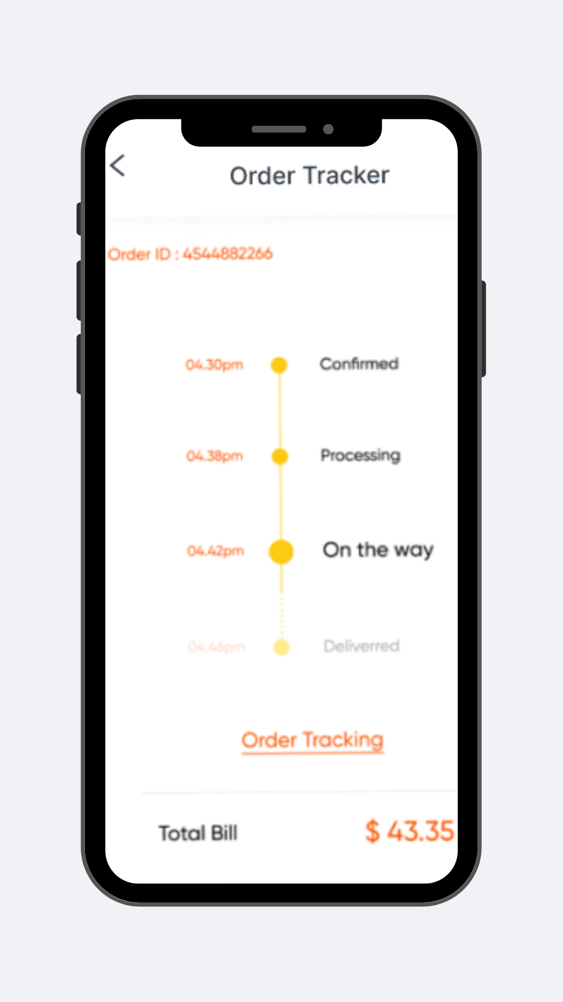

*Figure 8*

The Order Tracking User Interface gives users information about their orders' status. It assists users in staying updated and informed about the exact day their delivery will be made.

1. Location User Interface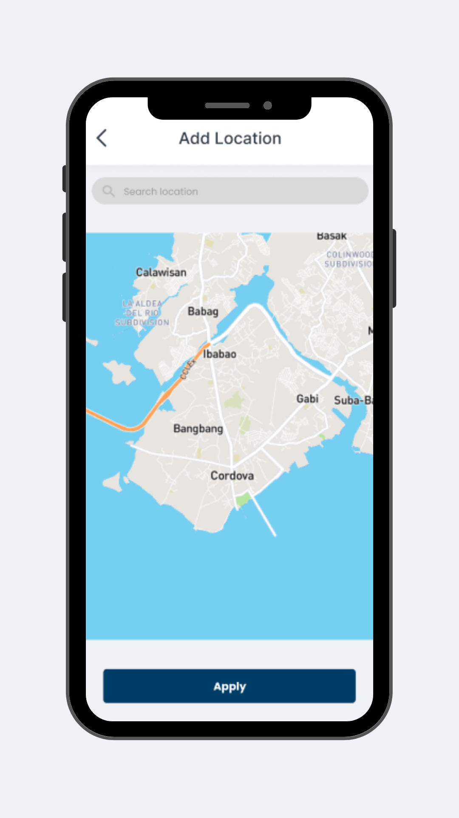

*Figure 9*

The User Interface of location visually illustrates a particular geographic location. These include a search bar or filtering options to help users find specific areas.

1. Category User Interface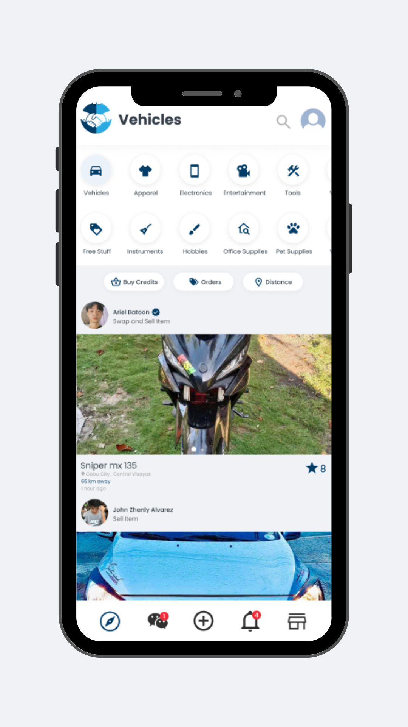

*Figure 10*

The user interface for item categories features functional icons, enabling users to filter displayed items within each category, thus facilitating exploration and discovery across various types.

1. Search User Interface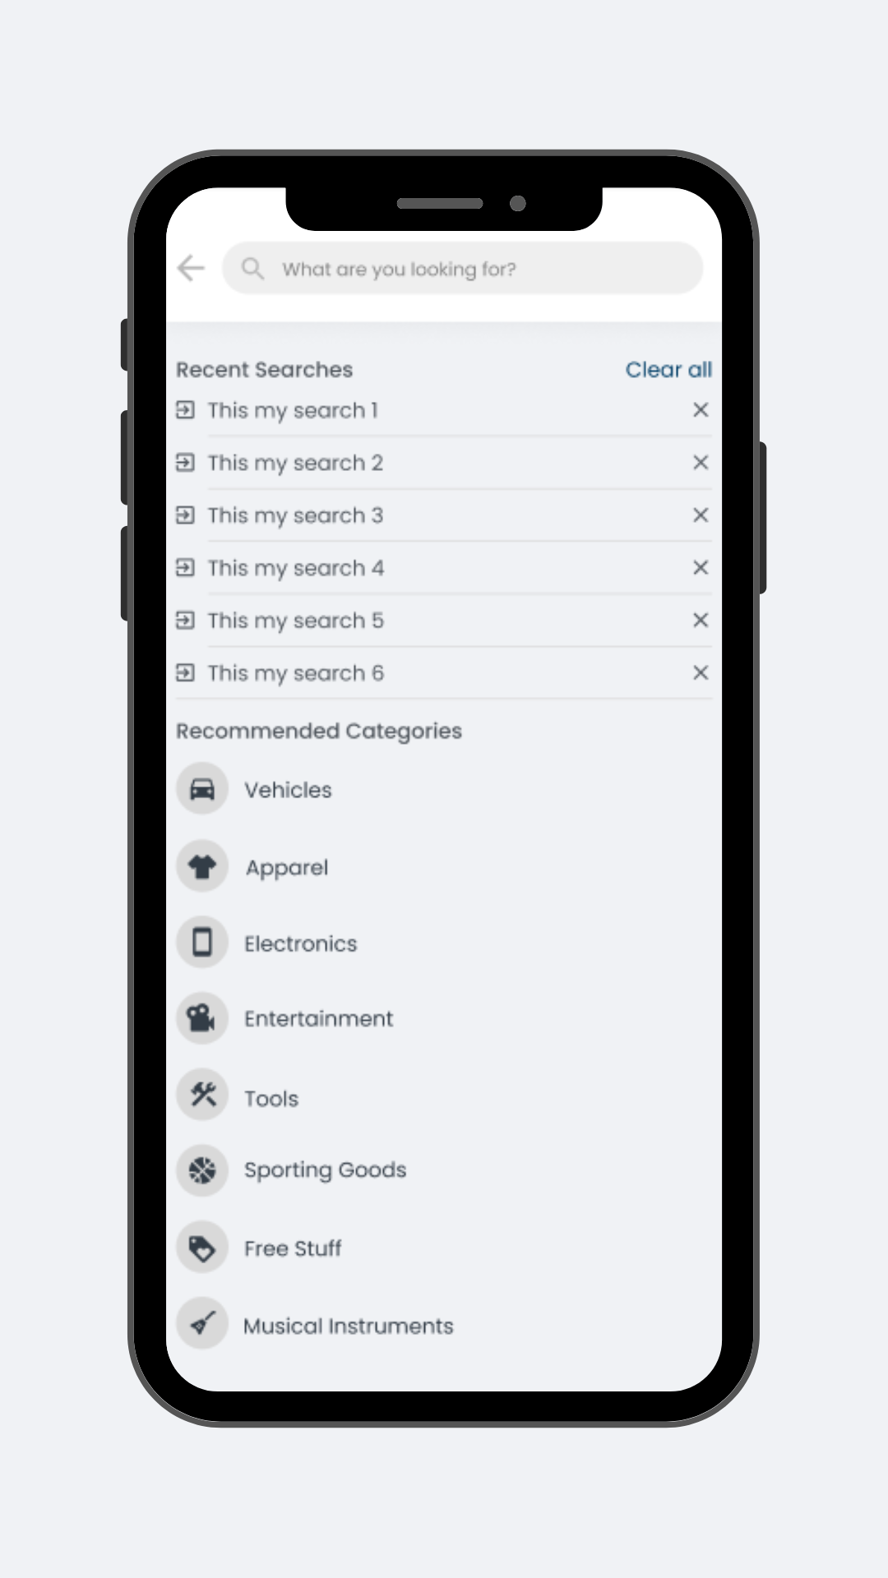

*Figure 11*

It gives users a specific search interface for particular items within the platform. It includes option fields, buttons, and text fields.

1. Notifications User Interface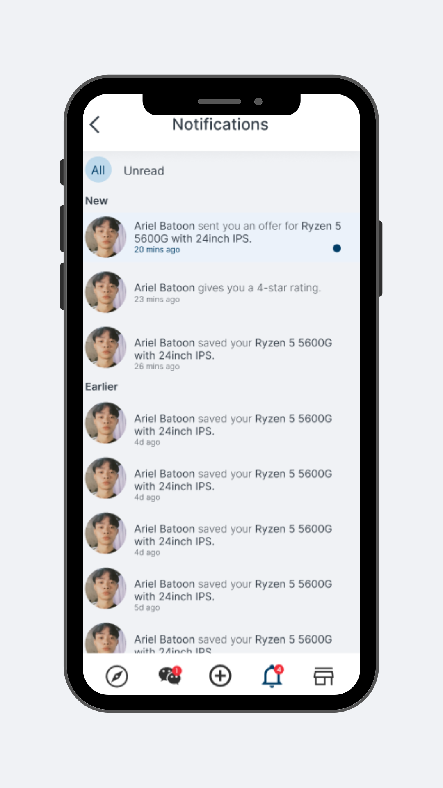

*Figure 12*

This user interface displays a banner message to the user to provide the user with meaningful messages that the user needs to know, such as if someone sends them an offer with their item, if some user gives them reviews and ratings, or if someone likes their things posted.

1. Messages List User Interface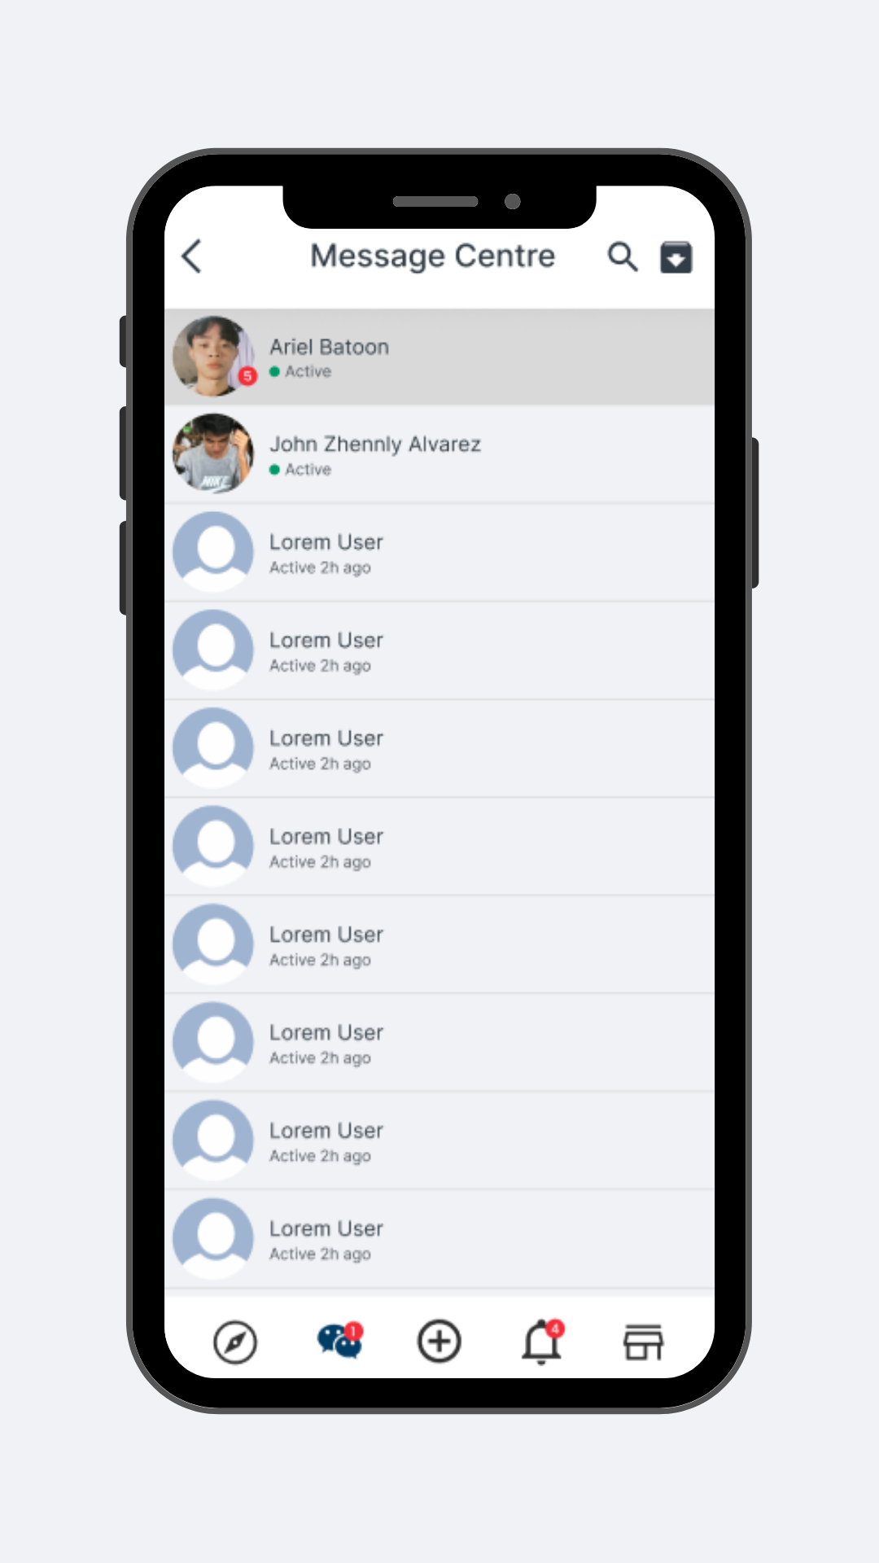

*Figure 13*

Users can access this User Interface by clicking the message icon on the upper bar. It allows users to view all the messages they have received.

1. Chat-To-Chat User Interface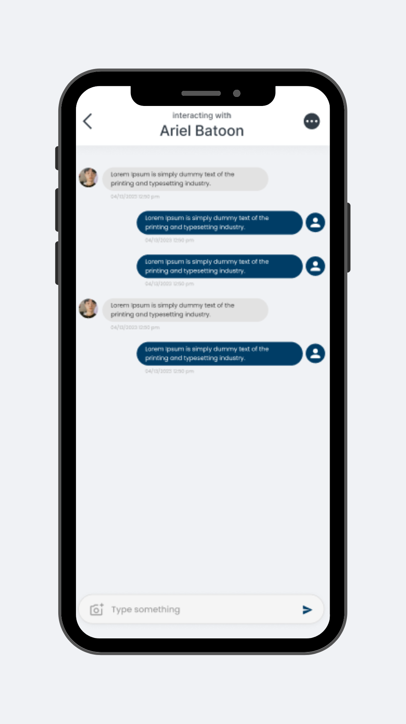

*Figure 14*

In this User Interface, buyers can interact with the vendor in terms of negotiating about the items they want to buy or swap. Buyers can message the sellers on this platform to inquire and make transactions.

1. My Items User Interface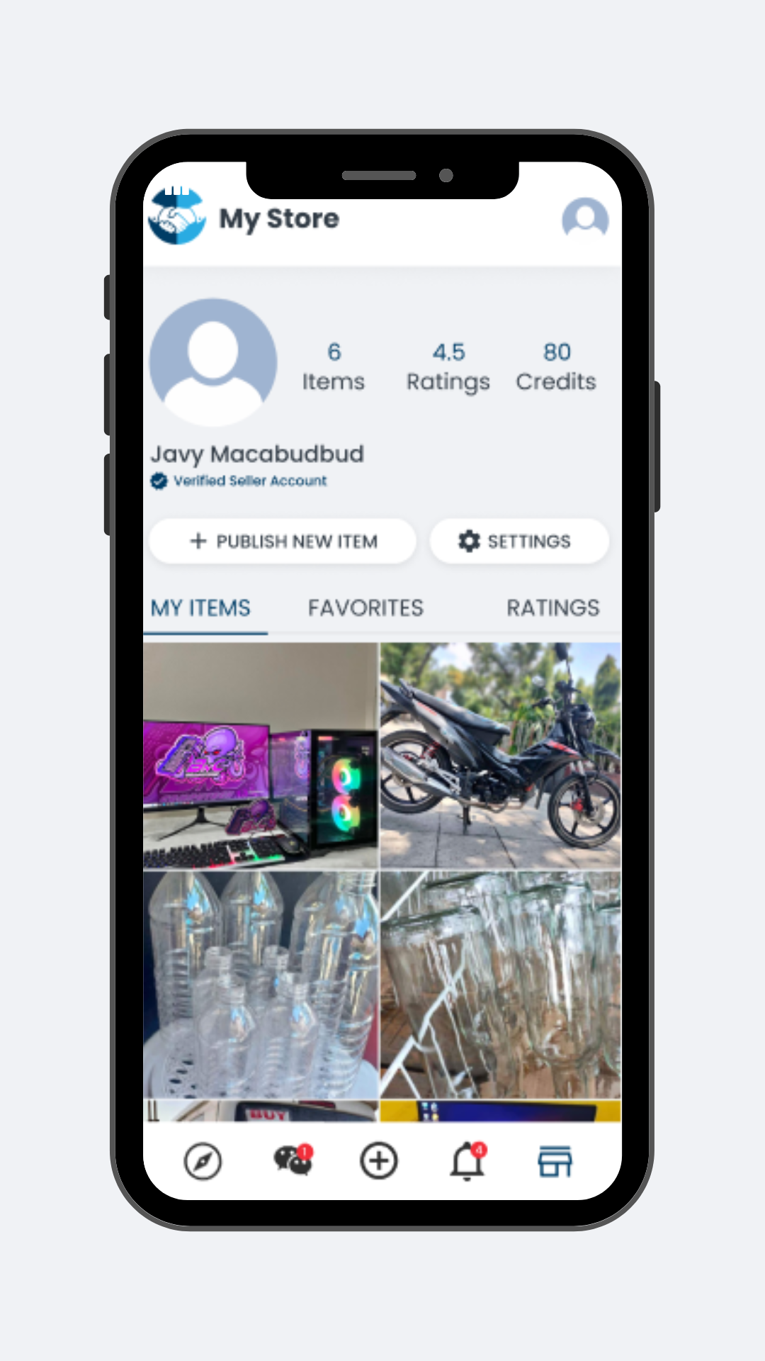

*Figure 15*

Users can easily observe and navigate through their item listings within this section. Additionally, they can publish new items by completing the necessary fields.

1. Wishlist User Interface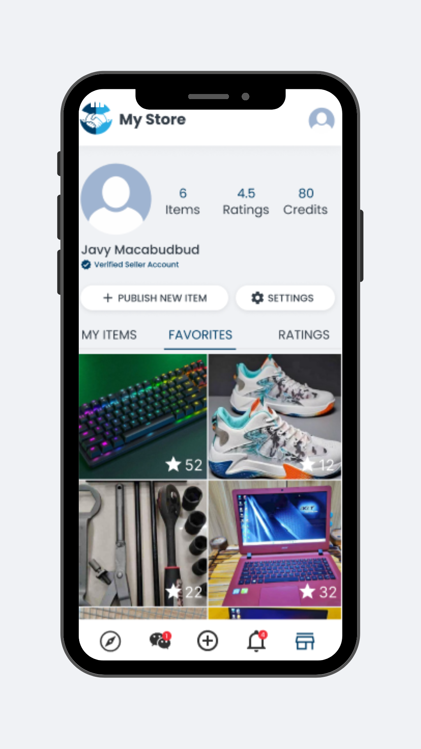

*Figure 16*

This user interface lets users view all the items they like or are interested in. It will occur when the user clicks the heart icon, and each instance of doing so leads to the system saving it within this section.

1. Rating User Interface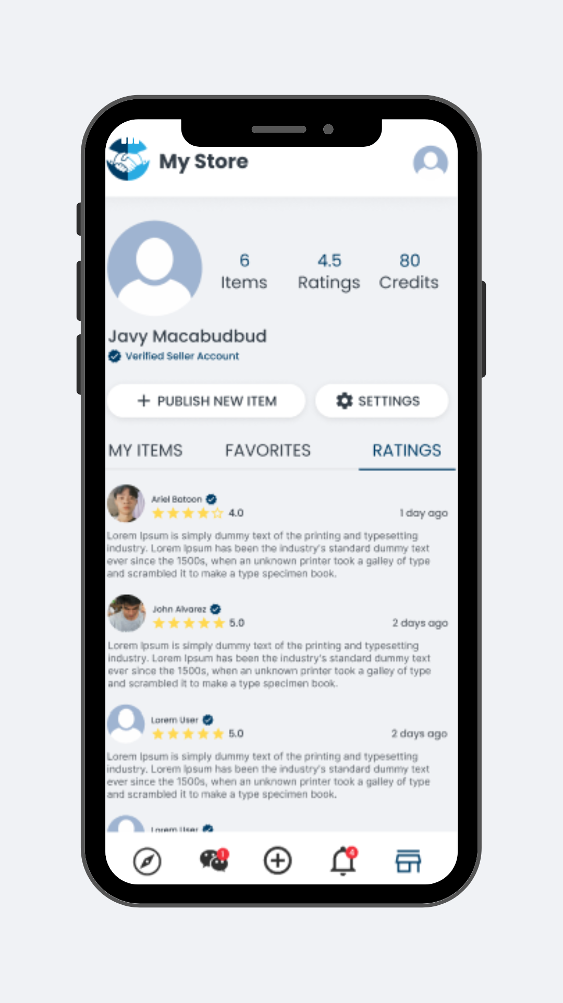

*Figure 17*

This UI presents the feedback and ratings given by other users. It shows the vendor’s credibility and how well they transact with the buyers or swappers. In this section, options like sorting ratings to aid users in their navigation. It filters by narrowing down the ratings by period.

1. Verification User Interface

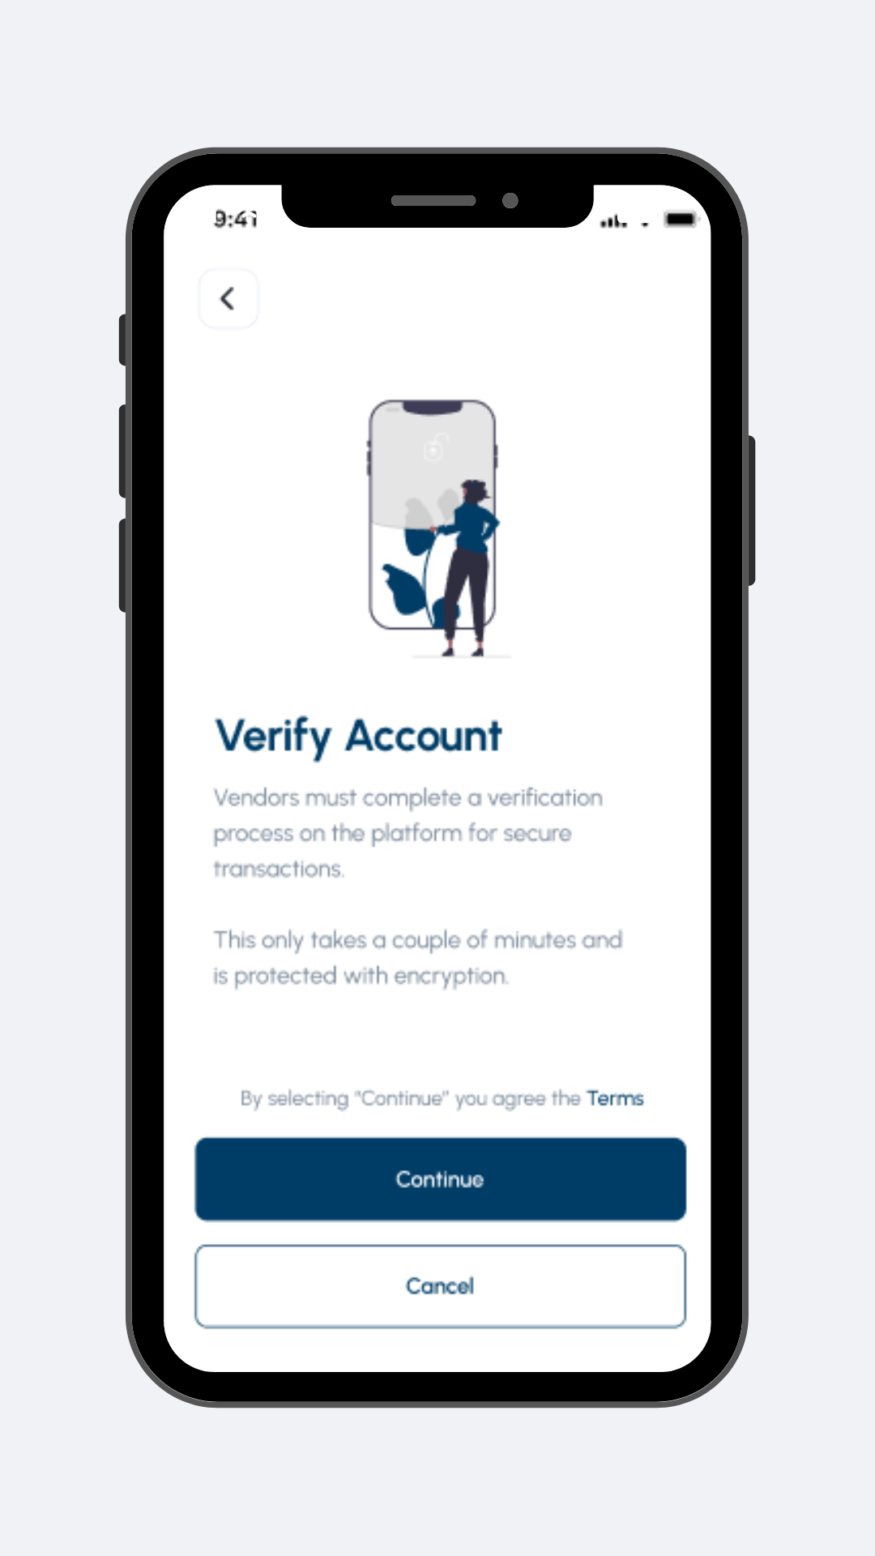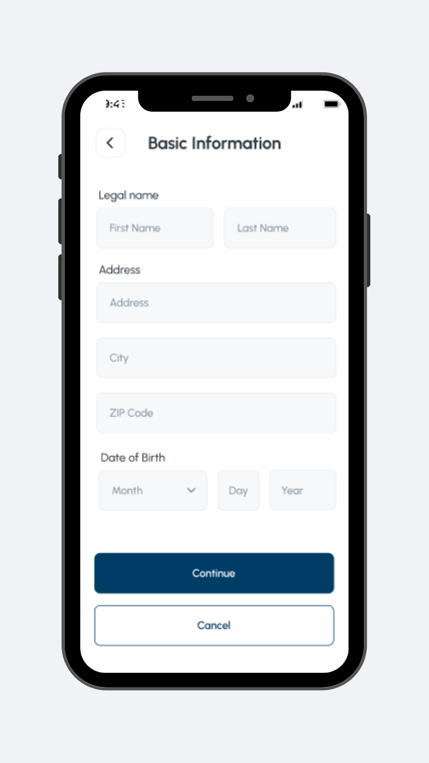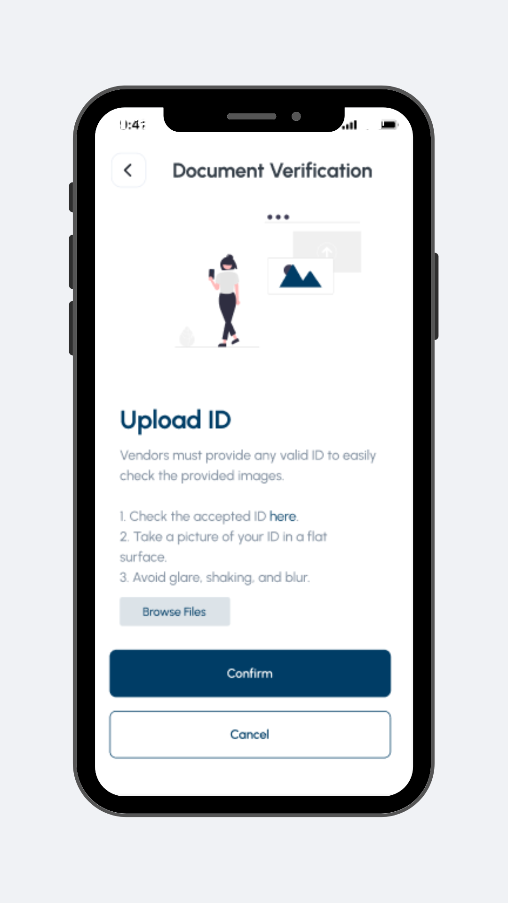

*Figure 18*

This interface makes it easier to authenticate user identities, accounts, or information within this platform. It allows users to submit necessary information, id, and details for verification purposes.

1. Withdraw User Interface

*Figure 19*

The Users can withdraw their funds safely and easily. In case of technical issues, a proper alert is given.

1. Settings User Interface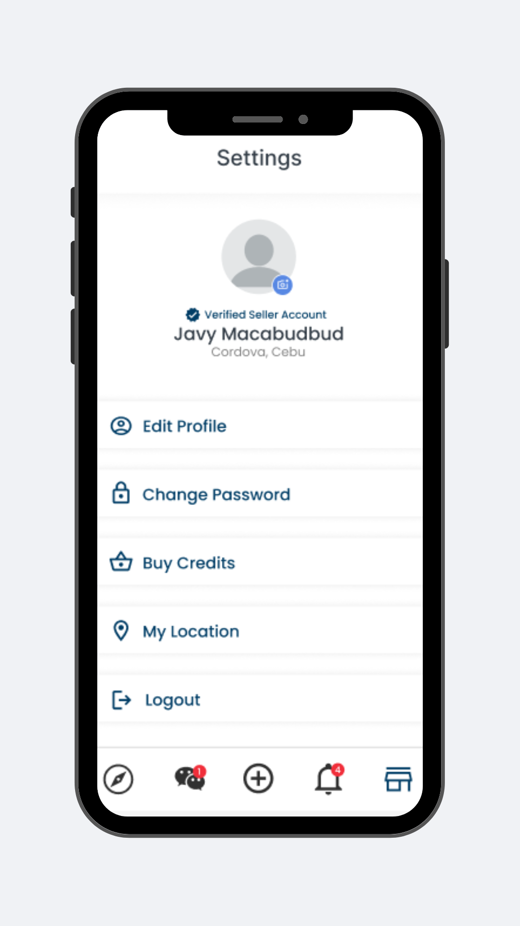

*Figure 20*

Users can modify their profiles and utilize the system's functionality according to their needs and preferences. The user can also choose ro delete their account permanently.

1. Admin - Login User Interface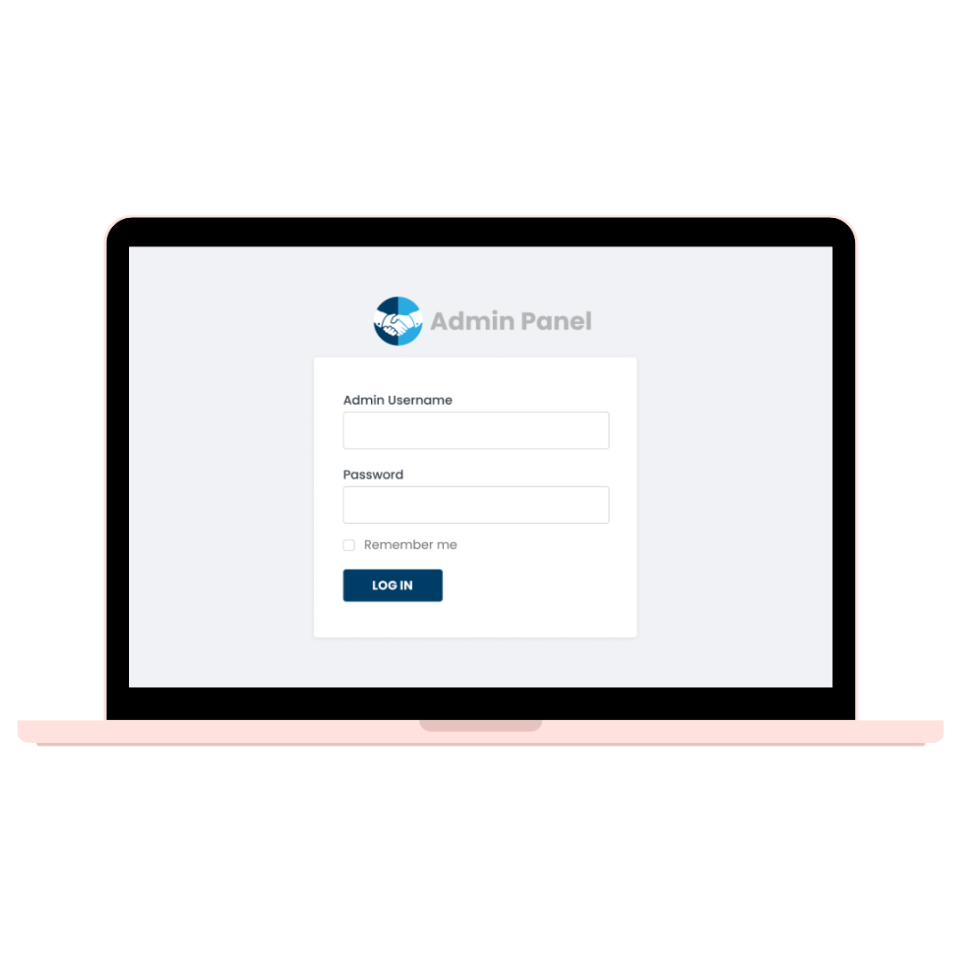

*Figure 21*

This UI presents the Admin Login interface that provides a safe way for administrators to enter the system. Ensures that only authorized personnel can use the administrative functionalities or dashboard.

1. Admin - Dashboard User Interface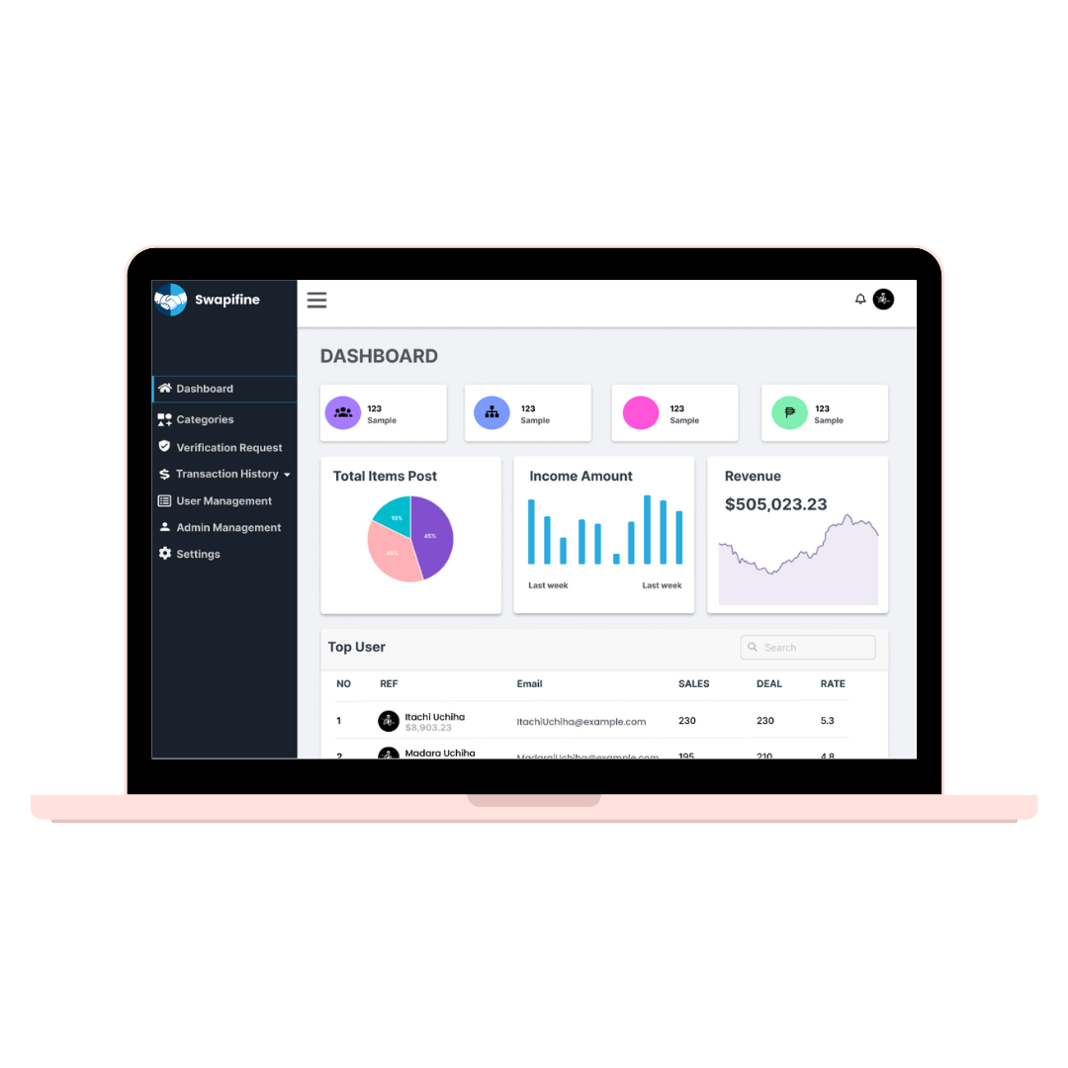

*Figure 22*

This user interface allows administrators to oversee and supervise the platform efficiently. It presents data using tables and provides essential information. It empowers administrators to take charge of different aspects of the system.

1. Admin - Categories User Interface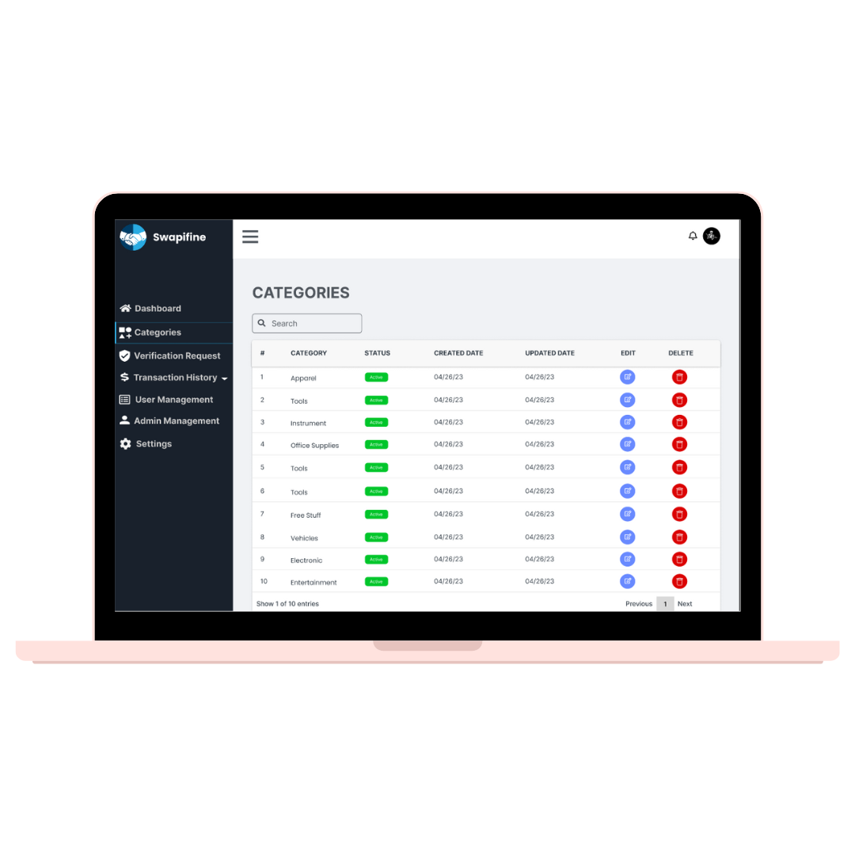

*Figure 23*

The Admin - Categories user interface enables the administrator to monitor the category list. It facilitates efficient space for edit and delete categories. There is also a search bar for filtering for a convenient way of finding the exact variety.

1. Admin - Verification Request User Interface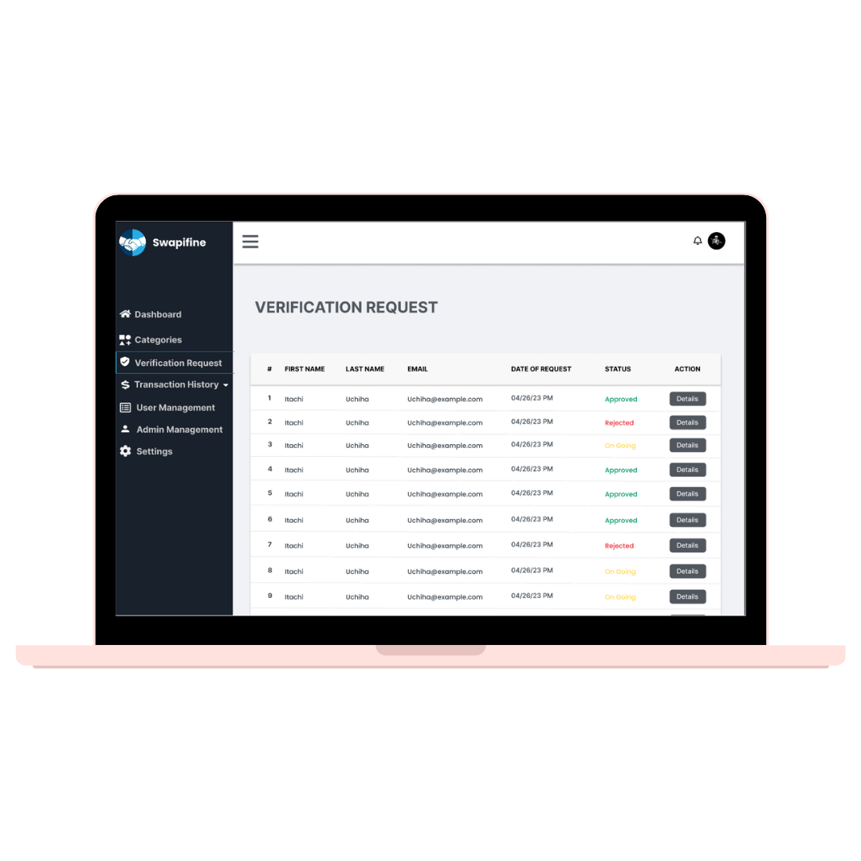

*Figure 24*

This user interface presents organized information for those users who seek verification within the platform. It allows the administrator to take action by changing the status of their request.

1. Admin - Withdrawal Request User Interface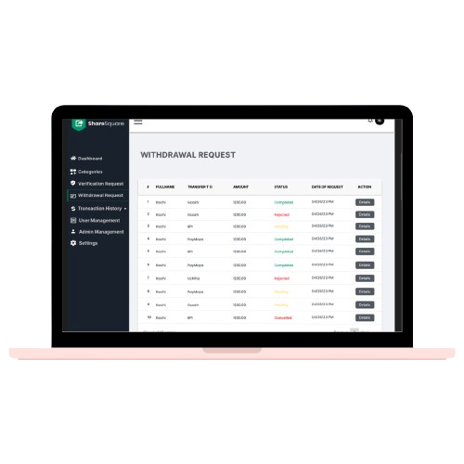

*Figure 25*

This user interface manages information for those users who seek withdrawal within the platform. The administrator can change the status of the request. It processes the transaction and updates the account balance accordingly.

1. Admin - User Transaction User Interface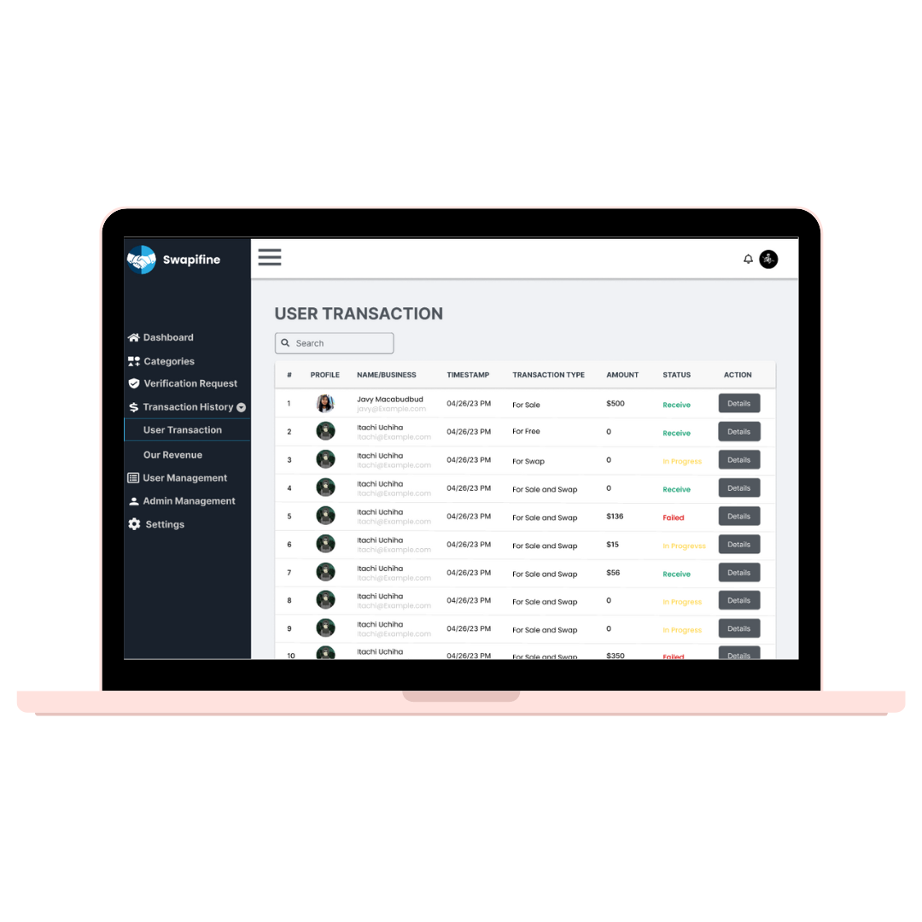

*Figure 26*

In the User Transaction, the administrator has control over this area to manage all the user transactions.

1. Admin - Our Revenue User Interface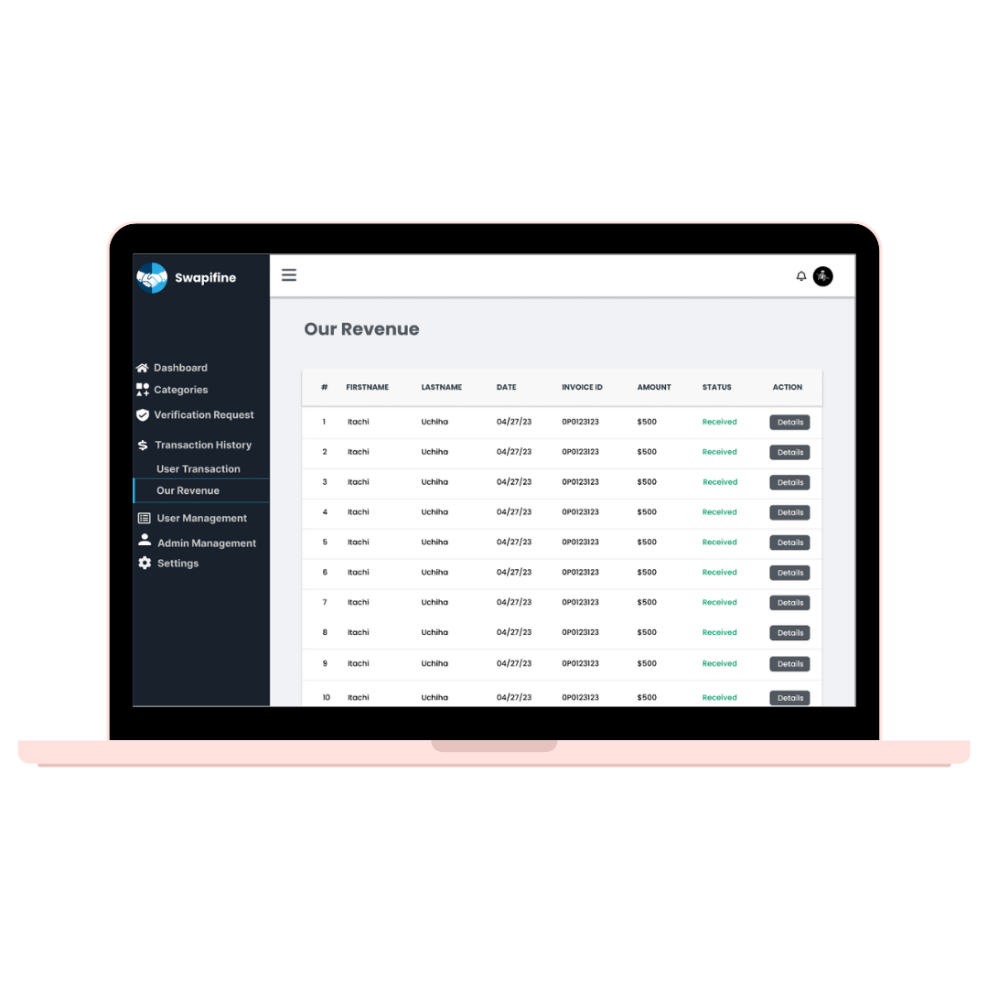

*Figure 27*

The “Our Revenue" UI is actively organized to give administrators insights into the revenue generated within the application. It takes an active role in overseeing accuracy of the received data and displays details.

1. Admin - Reported User User Interface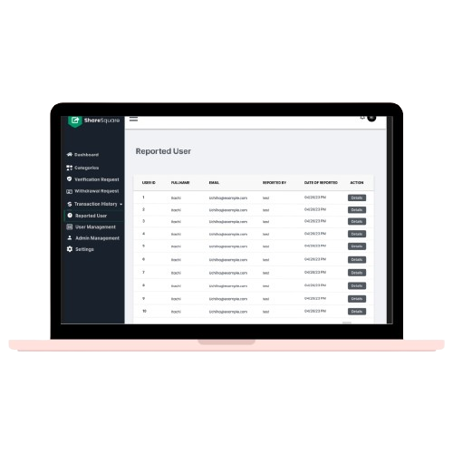

*Figure 28*

This user interface allows the administrator to monitor and manage the reported users.

1. Admin - User Management User Interface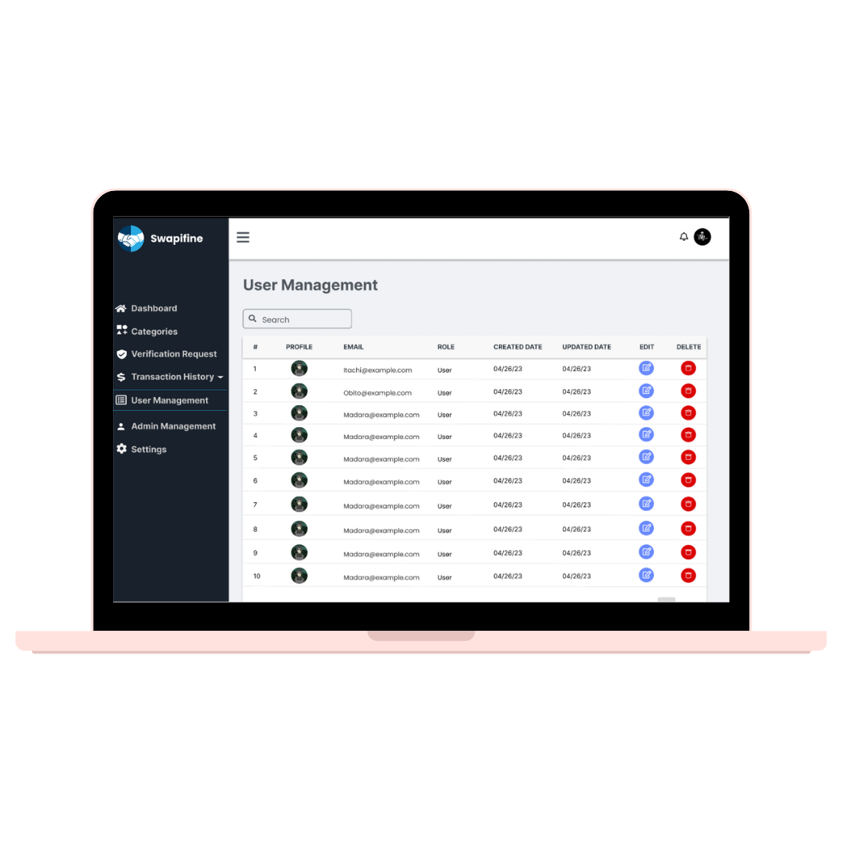

*Figure 29*

This user interface allows the administrator to monitor and manage the user accounts. The administrator has control to edit or delete the user’s account.

1. Admin Management User Interface

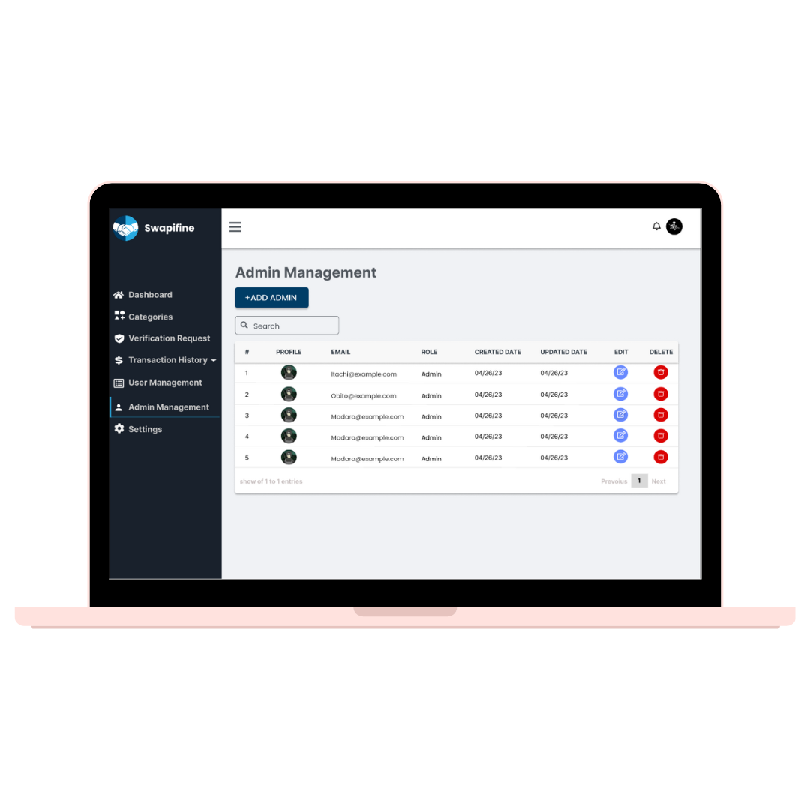

*Figure 30*

The Admin Management user interface equips administrators with the necessary tools to oversee the accounts of other administrators within the system. There is a button to add another admin and a search bar for filtering.

1. Admin - Settings User Interface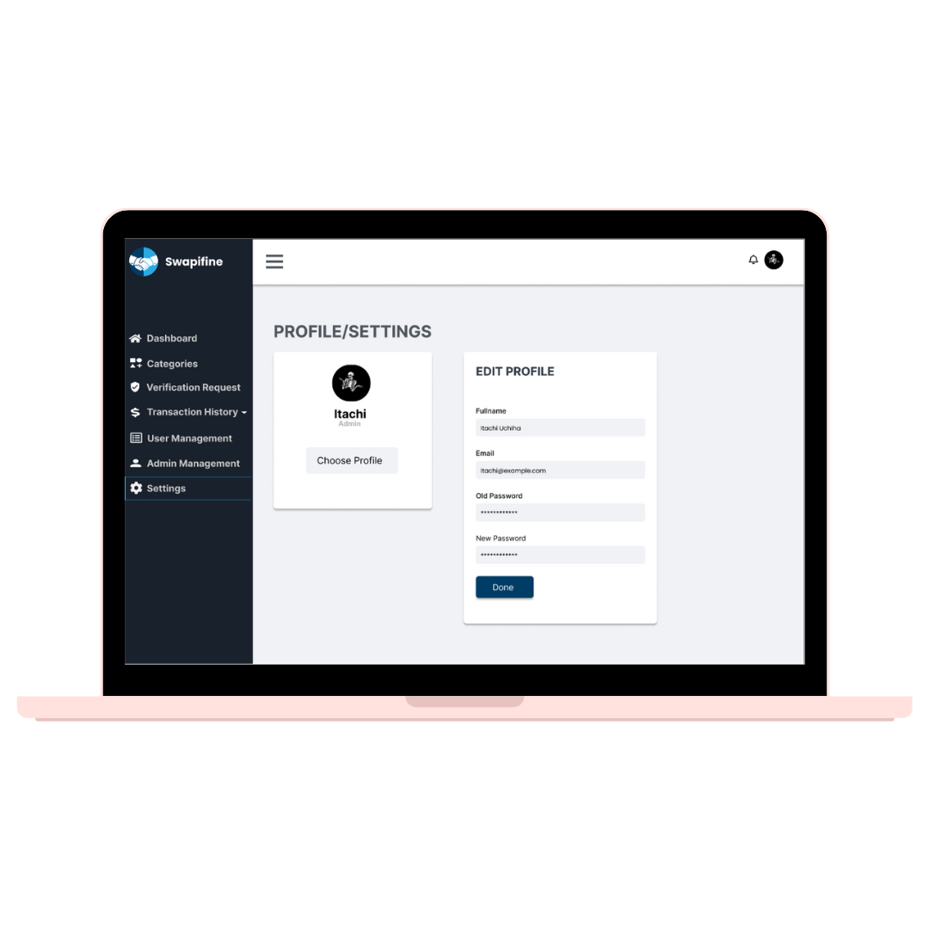

*Figure 31*

This UI presents the Admin's Settings, wherein it can change the information required for the account. For security, the administrator can change the password and their email anytime. There is an image for visualization of the owner. Also the administrator can choose to delete their account permanently.

#### ***3.1.2. Hardware interfaces***

Swapifine will require the following computer hardware to be installed:

* User: In order to utilize the application, both the buyer and the vendor must have a mobile smartphone.
* Admin: A laptop or computer is required for administration.

#### ***3.1.3. Software interfaces***

The computer has to install the following software in order for the system to function:

* Laravel Framework
* Vue CLI
* Framework 7
* Axios

#### ***3.1.4. Communication interfaces***

* + - * Users can engage in mutual communication through the platform's real-time messaging feature.

## ***Functional requirements***

***3.4.1. Authentication Register Use Case*** 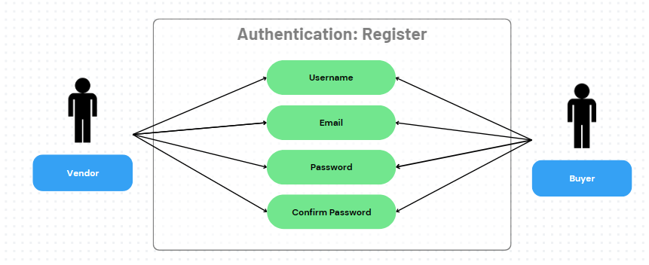

*Figure 32*

This use case diagram illustrates how users create a new account in the system. It enables users to create a unique account and input information for credibility.

***3.4.2. Authentication: Login Use Case*** 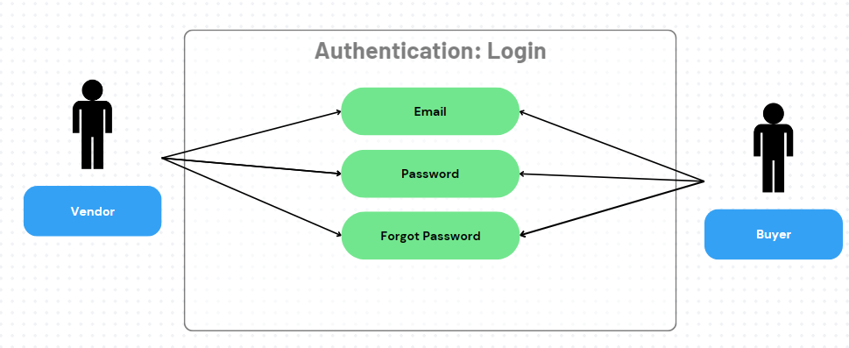

*Figure 33*

This diagram shows the process of verifying a user's identification and allowing access to the system. It enables users to access the system's functionality safely by logging in with their credentials, such as an email and password.

***3.4.3. Authentication: Forgot Password Use Case*** 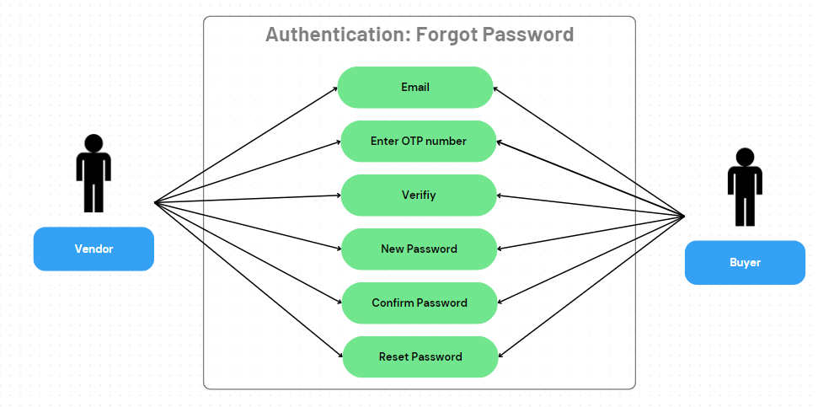

*Figure 34*

The Forgot Password Use Case Diagram depicts how users can securely recover access to their accounts. It asks for the user's email, OTP number, and a new password.

***3.4.4. Browse Use Case*** 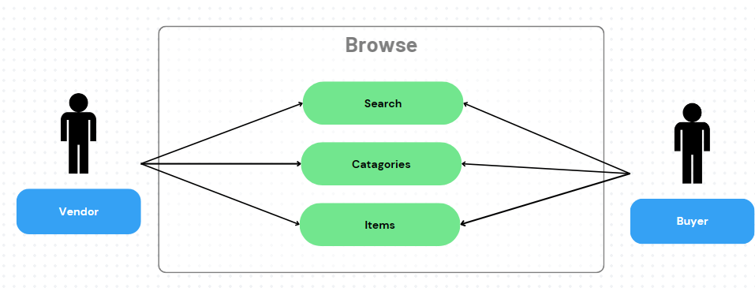

*Figure 35*

Users explore content or features in the browse use case. It includes actions like viewing, scrolling, and interacting with items, and it provides a fundamental user experience for content discovery.

***3.4.5. Post Item Use Case*** 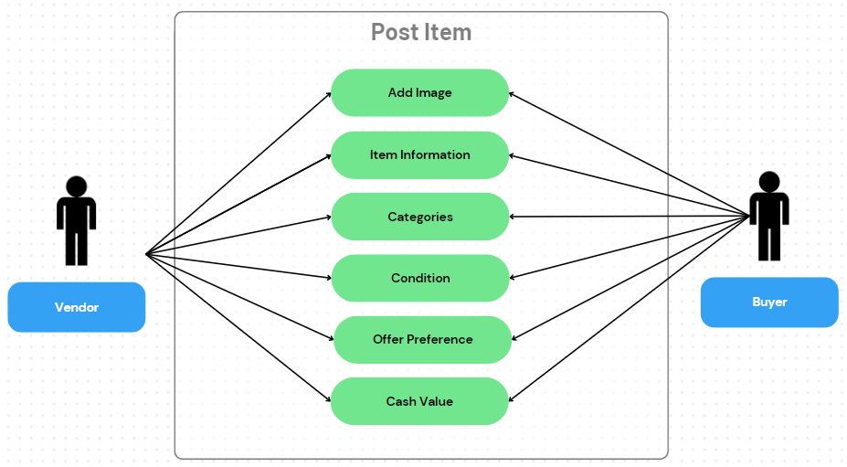

*Figure 36*

This use case diagram navigates users to the required information to input in publishing a new item.

***3.4.6. Item Details Use Case*** 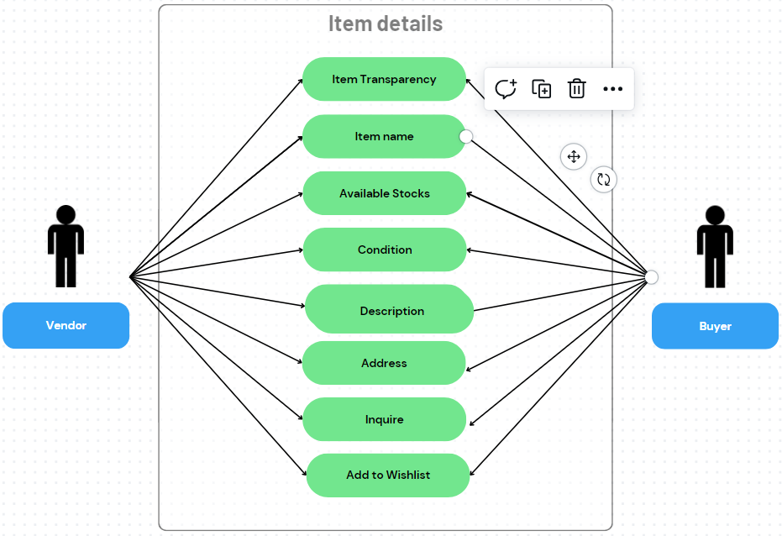

*Figure 37*

This use case diagram indicates the capability of a system to provide users access to item information. Users can obtain detailed information about the selected item.

***3.4.7. Credits System Use Case*** 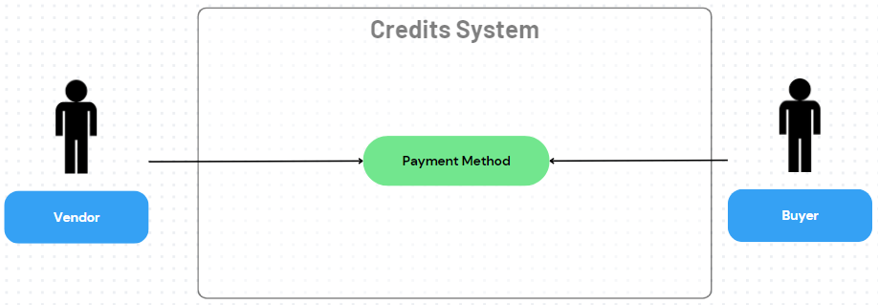

*Figure 38*

This use case diagram helps users to gain credits within the system. It allows users to select their preferred payment methods.

***3.4.8. Order Lists Use Case***

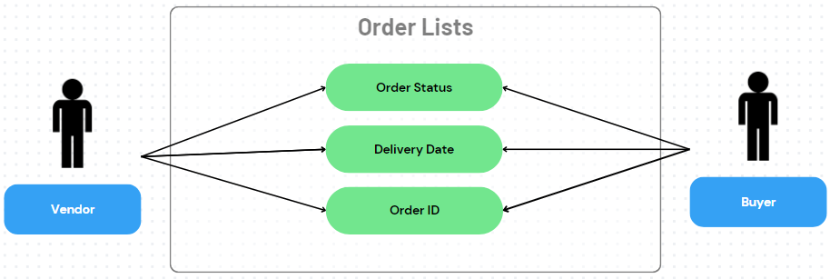

*Figure 39*

The order lists use case describes how users view and manage their sorted item lists within a system. Users are able to check their orders and track their deliveries.

***3.4.9. Order Tracking Use Case*** 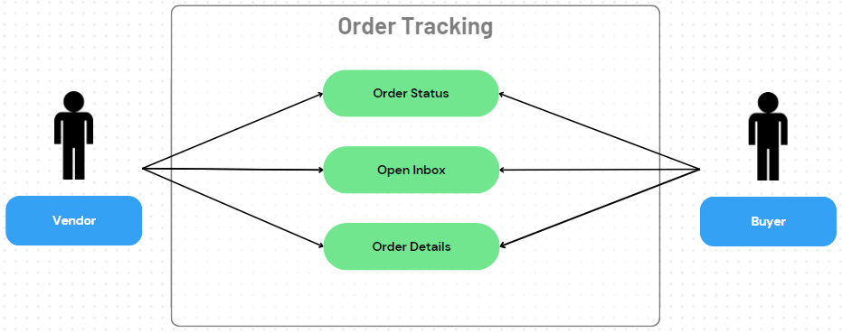

*Figure 40*

This use case provides users a real-time progress of their orders and expected delivery details of their orders. The system also displays order details and opens the inbox for messaging the vendor.

***3.4.10. Location Use Case*** 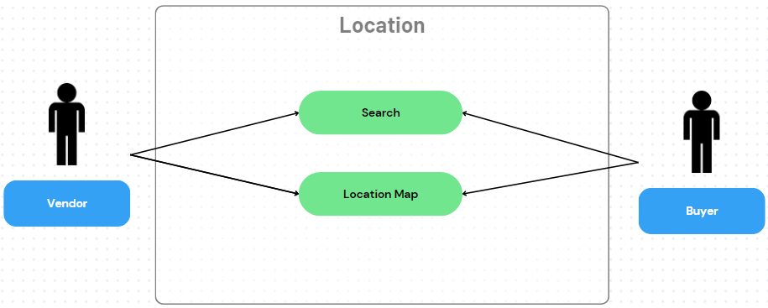

*Figure 41*

Location use case diagrams help users add their addresses for various purposes. It enables users to search for nearby items or track the location.

***3.4.11. Category Use Case*** 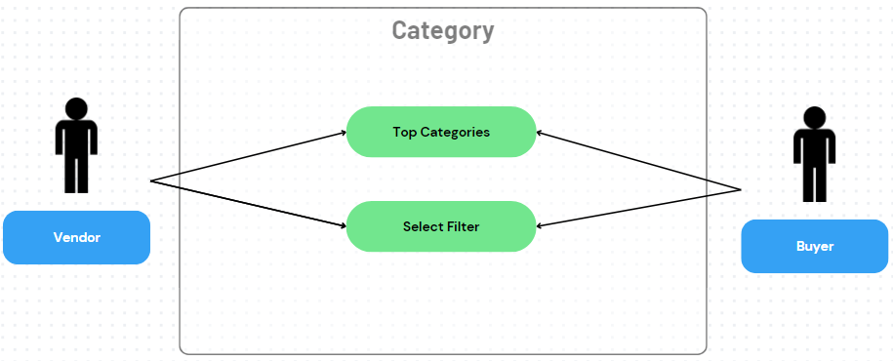

*Figure 42*

Category use case diagrams help users to organize and classify their items. It also allows users to select categories based on their interests quickly.

Additionally, it enables users to navigate and interact with the available resources by searching, filtering, and sorting them.

***3.4.12. Search Use Case*** 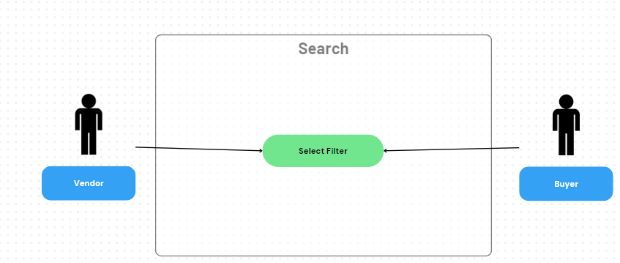

*Figure 43*

Search use case diagrams help users to easily find items of their interest.

***3.4.13. Notification Use Case*** 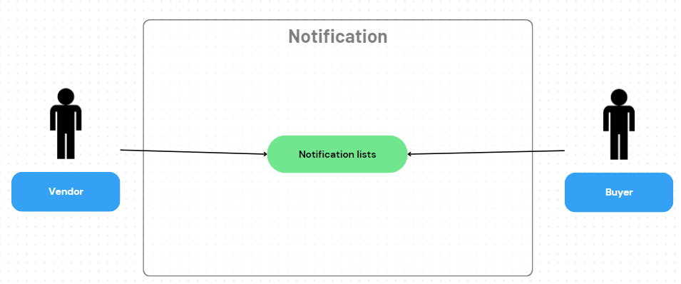

*Figure 44*

This use case diagram illustrates the essential functions associated with notification, showing how users, for example, receive notifications from the system.

***3.4.14. Messages List Use Case*** 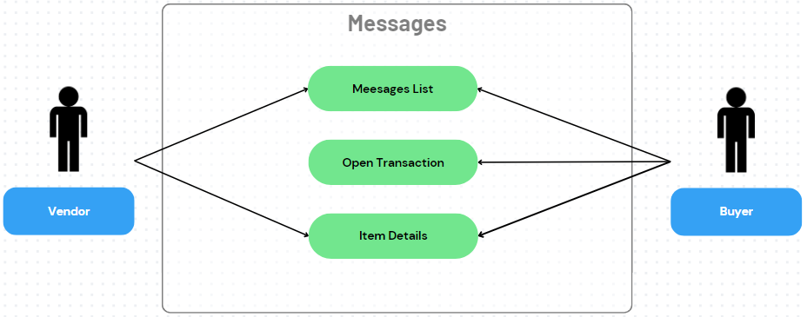

*Figure 45*

This use case diagram indicates the capability of a system to enable users to receive messages.

***3.4.15. Chat-to-Chat Use Case*** 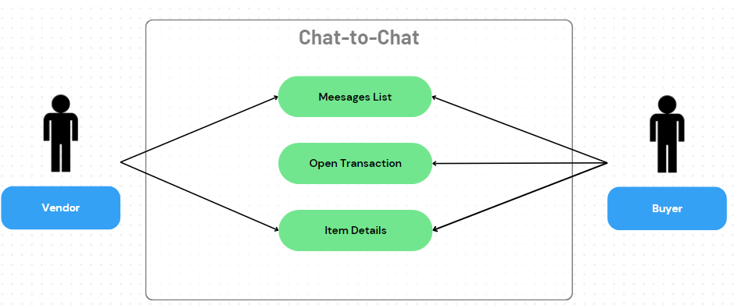

*Figure 46*

This use case diagram indicates the capability of a system to enable vendors to only view messages and item details but not open the transaction for security purposes. While buyers can navigate the messages, transaction, and item details.

***3.4.16. View Store Use Case***

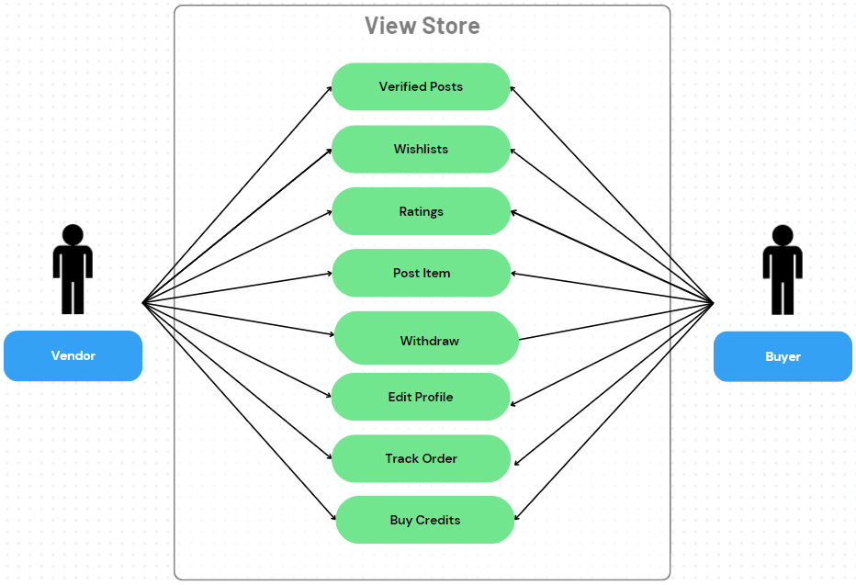

*Figure 47*

This represents the management of posted items, wishlists of users, and ratings.

***3.4.17. Verification Use Case*** 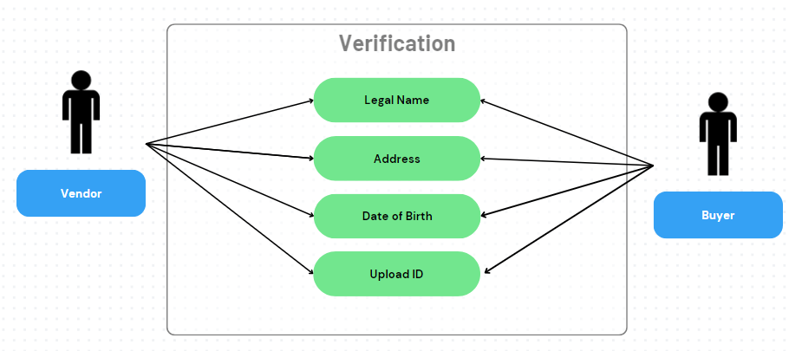

*Figure 48*

This use case diagram enables vendors to verify their account by giving their personal information.

***3.4.18. Withdrawal Use Case*** 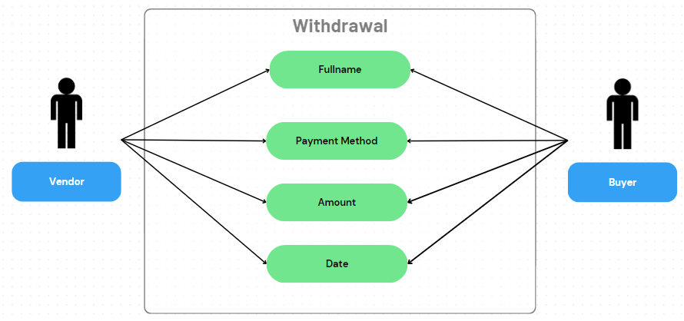

*Figure 49*

This use case diagram enables users to withdraw their money securely.

***3.4.19. Settings Use Case*** 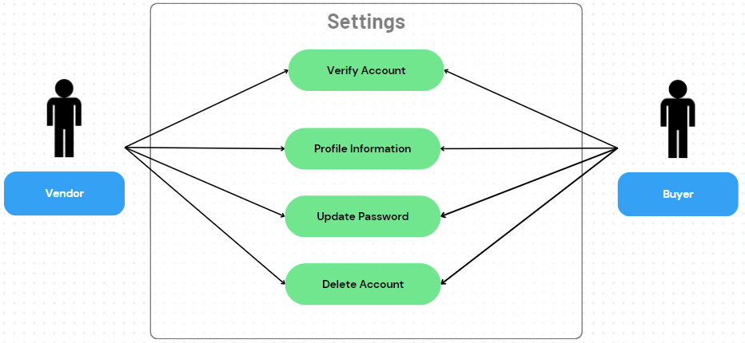

*Figure 50*

The Settings use case diagram enables users to adjust the personal preferences associated with their accounts. This involves updating personal information and managing their accounts.

***3.4.20. Admin- Login Use Case***

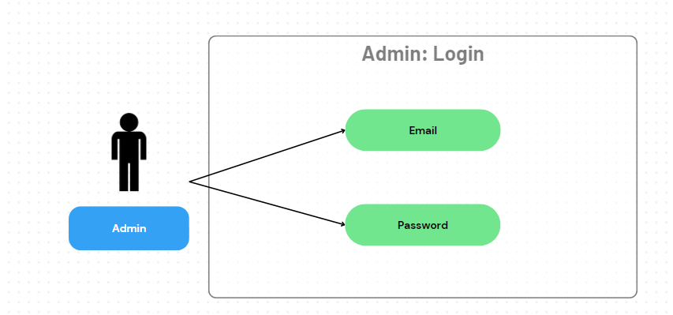

*Figure 51*

The Admin Dashboard use case diagram involves the management of the overall functionalities of the Administrator in the swapifine system. It illustrates the organizing and managing of systems data.

***3.4.21. Admin- Dashboard Use Case*** 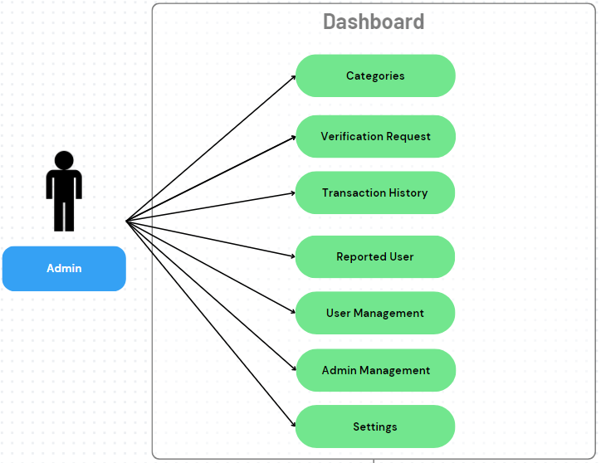

*Figure 52*

The Admin Dashboard use case diagram involves the management of the overall functionalities of the Administrator in the swapifine system. It illustrates the organizing and managing of systems data.

***3.4.22. Admin- Categories Use Case*** 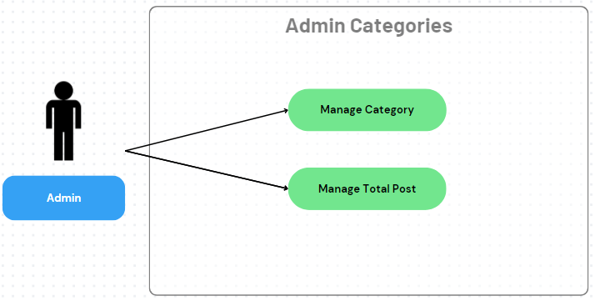

*Figure 53*

This use case diagram illustrates administrators' management of categories. Enables Admin to add, edit, and delete categories.

***3.4.23. Admin- Verification Request Use Case*** 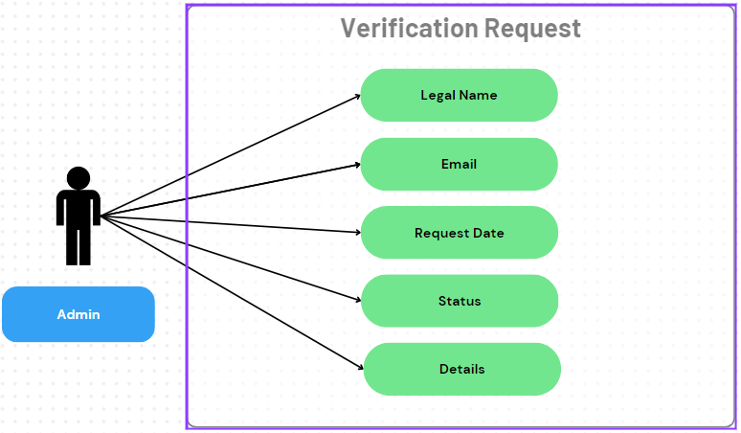

*Figure 54*

This use case diagram ensures a secure and organized management of authentication of user verification requests.

***3.4.24. Admin - Withdrawal Request Use Case*** 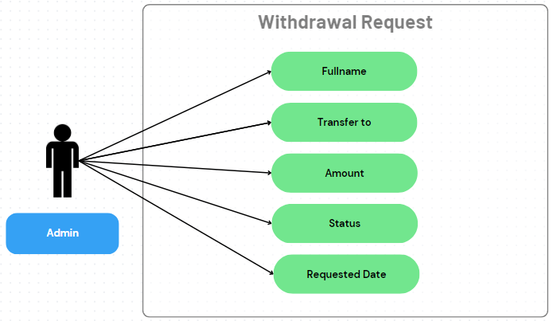

*Figure 55*

This use case diagram ensures a secure and organized management of the user's withdrawal request.

***3.4.25. Admin- Transaction History Use Case*** 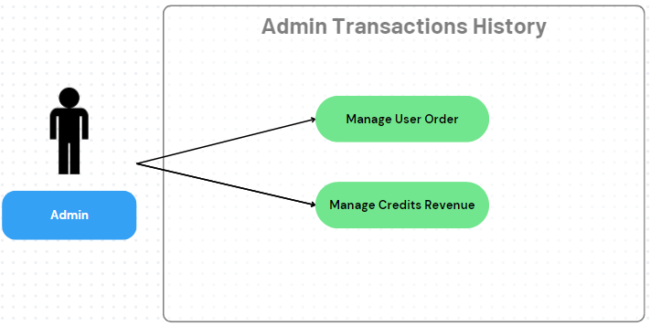

*Figure 56*

The system presents an organized and detailed transaction history. It enables admins to manage user orders and credit revenue of the application.

***3.4.26. Admin- Reported Users Use Case*** 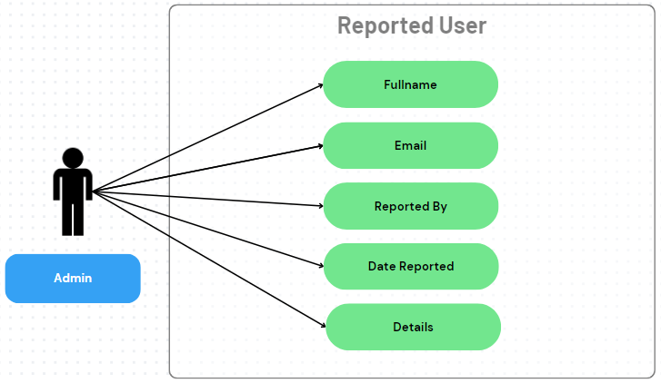

*Figure 57*

The administrator performs operations such as adding and deleting user accounts within this system under the User management use case.

***3.4.27. Admin- User Management Use Case*** 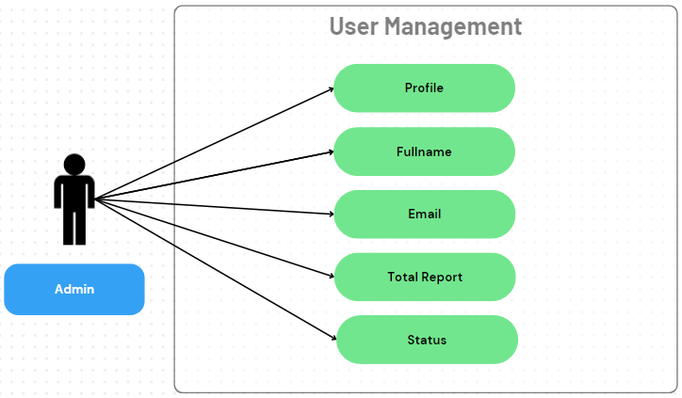

*Figure 58*

The administrator performs operations such as adding and deleting user accounts within this system under the User management use case.

***3.4.28. Admin- Admin Management Use Case*** 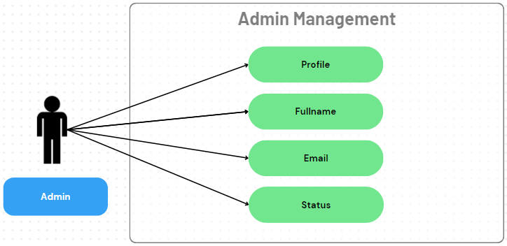

*Figure 59*

This provides an efficient management of administrator accounts. It involves actions such as adding, deleting, and updating its accounts.

***3.4.29. Admin- Settings Use Case*** 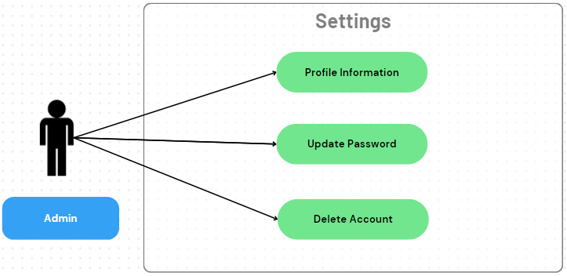

*Figure 60*

The Admin Settings use case diagram involves updating personal information and managing Admin accounts.

## ***Usability requirements***

In this platform, Users should be able to easily comprehend and interact with a user-friendly interface, straightforward navigation, and intuitive design. Users should be able to quickly find the precise materials they need using the search functionality, location, category, and other essential variables.

## ***3.4. Performance requirements***

To use the platform, the user must have an internet connection to register, log in, view the listings, upload resources, communicate with other users, and utilize other features. For unlimited user experience, one must verify their account. The platform must respond to search queries for resources within 1 second for quick and effective resource discovery.

## ***3.5. Logical database requirements***

Swapifine application is a big system that requires a big database to store all the users account information. It also stores data like purchase credits, order transaction, user favorites, admin account, vendor ratings, categories, post item and so on. Each entry shall have an ID as a primary key to easily track the table and identify the relationship between other entries.

## ***3.6. Design constraints***

The platform should maintain compatibility with various software and web browsers. Additionally, it must adhere to data protection regulations to safeguard user information and privacy.

## ***3.7. Software system attributes***

1. a)  Reliability - The platform is simple to use and navigates expectedly with minimal delays. It is responsive to any device.
2. b)  Availability -The platform will be available for every user when they need to discover and swap for items.
3. c)  Security - The system will protect user information to ensure data security and privacy. Admin will check the user's identity and has no part of the transaction that will be made between users.
4. d)  Maintainability - The platform will be maintained and handled accordingly.

# **Verification**

During registration, users should receive a verification link in their registered email, which they must click to validate their email addresses. Vendors will need to submit a valid identification document to verify their identity. Users could be requested to upload pertinent documents or photographs to verify contents' accuracy. Furthermore, users should be able to rate and provide feedback on other users based on their resource exchange experiences. Higher ratings and positive comments can indicate a higher level of trustworthiness.



**CORDOVA PUBLIC COLLEGE**

GABI, CORDOVA, CEBU, PHILIPPINES

COLLEGE OF COMPUTER STUDIES

**Software Design Description**

*for*

Community Resource Exchange (Swapifine)

CPC-BSIT-CAPSTONE-SDD-1st SEM 2022-2023-SWAPIFINE

Documents for IT Project

Of

Ariel Batoon

John Zhenlly Alvarez

Javy Macabudbud

**Change History**

| Version | Changes Made | Editor and Date |
| --- | --- | --- |
| Version 1 | Updating the ERD | Javy Macabudbud  September 08, 2023 |
| Version 2 | Updating the System Architecture and Architectural design | Javy Macabudbud  October 22, 2023 |
| Version 3 | Adding the Reported User’s description | Javy Macabudbud  November 09, 2023 |
| Version 4 | Adding the tbl_withdrawal, Withdrawal description, and Admin: Withdrawal Request description | Javy Macabudbud  December 01, 2023 |
| Version 5 | Add data description for user withdrawal and its data dictionary | Javy Macabudbud  December 02, 2023 |

**Preface**

The Community Resource Exchange(Swapifine) is a web-based application designed to connect people within a specific community to exchange resources and information. This platform has a user-friendly interface created to make it easier for individuals and organizations to share various assets, including tools, equipment, knowledge, and other items that are accessible for sharing. The system provides an architectural design that is easy to comprehend and well-structured.

The developers set out the creation of the user interface with a consideration of user satisfaction and retention. A pleasing and well-organized system where users can easily navigate the application's features. While users can post, discover, and trade items, the admin manages the users' transactions, accounts, and overall performance of the system. It is responsible for data management and security measures.

Generally, this application’s design focuses on providing users with a responsive design that ensures that the system interface can adapt to different screen sizes and devices. Also, implement a clear and intuitive navigation for user efficiency and satisfying user experience.

**Table of Contents**

**Change History 3**

**Preface** [**4**](https://docs.google.com/document/d/15ZbPmmn_dWBk_7guqc_GrSgMTrcwiHOls6nH18B_uAU/edit#heading=h.1fob9te)

**Table of Contents 5**

**List of Figures 6**

**List of Tables 7**

**1.** **Introduction 8**

1.1. Purpose 8

1.2. Scope [8](https://docs.google.com/document/d/15ZbPmmn_dWBk_7guqc_GrSgMTrcwiHOls6nH18B_uAU/edit#heading=h.4d34og8)

1.3. Reference Material 8

1.4 Definitions and Acronyms 8

**2.** **System Overview 9**

**3.** **System Architecture 10**

3.1. Architectural Design 10

3.2. Decomposition Description 11

*3.2.1.* *Module 1 Description 11*

*3.2.2.* *Module 2 Description.. 11*

3.3. Design Rationale 15

**4.** **Data Design 1**6

4.1. Data Description [1](https://docs.google.com/document/d/15ZbPmmn_dWBk_7guqc_GrSgMTrcwiHOls6nH18B_uAU/edit#heading=h.3j2qqm3)7

4.2. Data Dictionary 18

**5.** **Component Design 26**

5.1. Component Description 1 26

5.2. Component Description 2.. 26

**6.** **Human Interface Design 28**

6.1. Overview of User Interface 28

6.2. Screen Images 28

6.3 Screen Objects and Actions 31

**7.** **Requirement Matrix 44**

**List of Figures**

Figure 1: System Architecture

Figure 2: Entity Relationship Diagram

Figure 3: User Authentication

Figure 4: User View Interface

Figure 5: Admin Interface

Figure 6: View Select Filter Button

Figure 7: View Post Item Page

Figure 8: Browse Page

Figure 9: Set Location

Figure 10: View Track Orders

Figure 11: Checkout

Figure 12: Buy Credits

Figure 13: View Store

Figure 14: Edit Profile

Figure 15: Admin - Login

Figure 16: Admin - Dashboard

Figure 17: Admin - Categories

Figure 18: Admin - Verification Request

Figure 19: Admin - Transaction History - User Order

Figure 20: Admin - Credits Revenue

Figure 21: Admin - Reported User

Figure 22: Admin - User Management

Figure 23: Admin - Admin Management

Figure 24: Admin - Settings

**List of Tables**

Table 1: tbl_user

Table 2: tbl_personal_info

Table 3: tbl_post_item

Table 4: tbl_category

Table 5: tbl_user_location

Table 6: tbl_item_image

Table 7: tbl_notification

Table 8 : tbl_messages

Table 9: tbl_purchase_credits

Table 10: tbl_order_transactions

Table 11: tbl_user_ratings

Table 12: tbl_user_favorites

Table 13: tbl_withdrawal

Table 14: tbl_admin_account

Table 15: Requirement Matrix

# **Introduction**

Different e-commerce applications have been developed over the years. Wherein people sell and buy products online. Our application, The Community Resource Exchange somewhat has the same purpose as those applications, the difference is that our goal is to encourage the community to promote sustainability.

This platform aims to reduce waste as it helps users to post the resources they want to sell or swap. It's an easy way for individuals to search for things or items they need. Additionally, our application encourages resource sharing, wherein users don’t need to have money to have an item. They can make transactions with another user through swapping an item as easy and convenient as it is. The transaction is just between users, the admin of the system has no control over that. But for security, the administrator is responsible for checking the user’s credibility and reliability.

Overall, this application is user-friendly and provides valuable service to the community. Improve access to resources by allowing individuals and organizations to obtain items or services they have been looking for.

## ***Purpose***

To provide a comprehensive insight into the design features and architectural framework of the Community Resource Exchange, giving exhaustive details and descriptions for each module. This document serves as a blueprint for executing each design aspect and functions as a guiding reference for the development team, incorporating illustrative diagrams to enhance the visualization of the data structure.

## ***Scope***

The document presents the description of each module of the designs. The documents will help broaden the understanding of the application, from its architectural structure to its user interface design.

## ***Reference Material***

* SRS document
* STD document

## ***1.4 Definitions and Acronyms***

This clause of the SDD shall define, or provide references to, documents containing the definition of all terms and acronyms required to properly understand the SDD.

CPC – Cordova Public College

Swapifine – Swap and Refine

SRS – Software Requirements Specification

SDD – Software Design Description

UI – User Interface

ERD – Entity Relationship Diagram

SASS – Syntactically Awesome Style Sheets

# **System Overview**

The system platform comprises various components, such as user authentication, browse and post items, viewing item details, purchasing credits, viewing order lists, tracking orders, and setup location. explore categories, search filtering, notifications, view messages list, communicate with other users, verify user vendor account, edit user’s profile, and admin functionality that will manage and oversee data within this platform. The marketplace software interacts with these components to facilitate seamless buying, selling, and swapping of goods and services.

# **System Architecture**

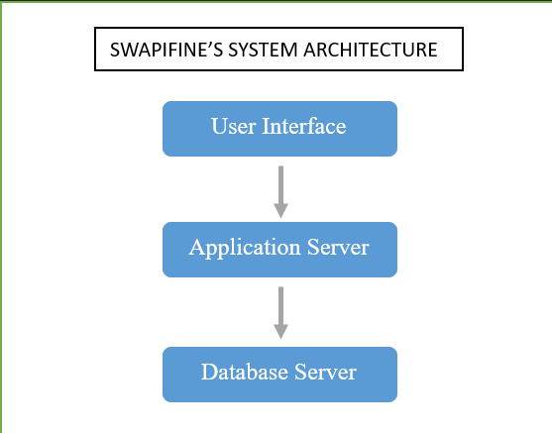

*Figure 1*

**User Interface (UI):** This is responsible for user interfaces for the users.

**Application Server:** This contains the business logic. Handles item management and order processing.

**Database Server:** This manages the storing of data. It includes user information, item categories, orders, verification requests, and transactions.

## ***Architectural Design***

**User Interface (UI):** It includes the web pages, displaying the category list, and other features that the user interacts with within the system. The developers use VUEJS, SASS, TailwindCSS, and Framework7 to build this.

**API / Business Logic:** Handles the functions that are needed for this system.

**Database Server:** Manages storing of data. It includes the user information, items, orders, transactions and so on. Developers used MySQL.

## ***Decomposition Description***

The Community Resource Exchange (Swapifine) can be decomposed into two main modules:

**User Module:** This module contains the necessary features that users may discover in using the application. It pertains to all the activities of the user and what are the functionalities they may access or control. The user module includes user authentication, forgot password, browse, post an item, view item details, credits system, order lists, order tracking, location, category filtering, search filtering, notifications, message lists, chat-to-chat, my items, favorites, ratings, withdrawal, and lastly settings.

**Admin Module:** This module is responsible for managing and manipulating various aspects of the platform, including Admin authentication, dashboard, categories, verification requests, withdrawal requests, transaction history, reported users, user management, admin management, credits revenue, and settings. The admin will have access to all user input data and monitor and enforce security measures within the system.

### ***Module 1 Description***

**Module Name:** User Authentication

**Module Description:** This module is essential for the user to access the application. It is responsible for managing the authentication process by using user credentials to ensure secure access. This module also enables users to create their own accounts within the system. Users need to provide the required information like username, email, and password.

### ***Module 2 Description***

**Module Name:** Forgot Password

**Module Description:** In this module, when a user forgets their password it enables them to access their account.

### ***Module 3 Description***

**Module Name:** Browse

**Module Description:** Users can utilize this module to explore posted items as much as they want to.

### ***Module 4 Description***

**Module Name:** Post Item

**Module Description:** In this module, the user will be able to add items to posts.

### ***Module 5 Description***

**Module Name:** Item Details

**Module Description:** Users can access item-detailed information in this module.

### ***Module 6 Description***

**Module Name:** Credits System

**Module Description:** In this module, the sellers need to buy credits to utilize for adding items. These credits can also be used for purchasing items.

### ***Module 7 Description***

**Module Name:** Order Lists

**Module Description:** The order list is a module that is designed to organize orders in a systematic manner, allowing for easy and quick access.

### ***Module 8 Description***

**Module Name:** Order Tracking

**Module Description:** In this module buyers and sellers are able to track the status of orders. Buyers can also contact sellers, enabling them to receive updates and pose inquiries regarding their orders.

### ***Module 9 Description***

**Module Name:** SetLocation

**Module Description:** In this module, users are able to input their location for order-related purposes. The inclusion of an exact geographic location is essential to ensure the accurate and timely delivery of orders.

### ***Module 10 Description***

**Module Name:** Category Filtering

**Module Description:** In this module, the system sorts categories based on their variety. Filters can be applied to categories by users, making searches easier and more efficient.

### ***Module 11 Description***

**Module Name:** Searching Filtering

**Module Description:** Users can locate items or categories by entering keywords into the search bar, allowing for a more specific and targeted search experience.

### ***Module 12 Description***

**Module Name:** Notification

**Module Description:** In this module, users receive notifications containing messages or updates within the system.

### ***Module 13 Description***

**Module Name:** Message List

**Module Description:** Within this application, users can view the messages they have received. The module also displays the user’s active duration.

### ***Module 14 Description***

**Module Name:** Chat-to-Chat

**Module Description:** In this module, users can engage in communication within the system for the purpose of inquiring about items and facilitating transactions.

### ***Module 15 Description***

**Module Name:** My Items

**Module Description:** This module presents the listed items posted by the user.

### ***Module 16 Description***

**Module Name:** Wishlists

**Module Description:** Liked posts will be put in this module, allowing users to conveniently locate and review the items they are interested in.

### ***Module 17 Description***

**Module Name:** Ratings

**Module Description:** Users have the ability to provide reviews and comments for items they have purchased. The trustworthiness of an item is reflected by the number of hearts it has received, as rated by users.

### ***Module 18 Description***

**Module Name:** Verification

**Module Description:** Vendors can verify their account for the credibility of their items.

### ***Module 19 Description***

**Module Name:** Withdrawal

**Module Description:** Users can withdraw their accounts credits or money.

### ***Module 20 Description***

**Module Name:** Settings

**Module Description:** Users can perform actions such as modifying their profile, logging out from the system, and deleting their account.

### ***Module 21 Description***

**Module Name:** Admin Authentication

**Module Description:** In this module, administrators can securely access the system by logging into their accounts.

### ***Module 22 Description***

**Module Name:** Dashboard

**Module Description:** Administrators can monitor and administer the dashboard, allowing them to keep track of and access the system's overall status.

### ***Module 23 Description***

**Module Name:** Categories

**Module Description:** Administrators can manage the categories.

### ***Module 24 Description***

**Module Name:** Verification Request

**Module Description:** Administrators can oversee the verification requests submitted by users. In this module, admins have the authority to either accept, update, or reject the requests.

### ***Module 25 Description***

**Module Name:** Withdrawal Request

**Module Description:** Administrators can oversee the verification requests submitted by users. In this module, admins have the authority to either approve or denied the user’s withdrawal request

### ***Module 26 Description***

**Module Name:** Transaction

**Module Description:** In this module, administrators are responsible for managing and organizing user orders as well as the credit revenue generated by users in the system.

### ***Module 27 Description***

**Module Name:** Reported User

**Module Description:** In this module, users who have been reported for abusive behavior are recorded and managed.

### ***Module 28 Description***

**Module Name:** User Management

**Module Description:** Administrators can monitor and manage the total reports of users in this module. They can delete the accounts of users who have been reported for abusive behavior.

### ***Module 29 Description***

**Module Name:** Admin Management

**Module Description:** In this module, The admin can add, update, and delete the administrator account.

### ***Module 30 Description***

**Module Name:** Admin Settings

**Module Description:** Administrators have the ability to update their profiles and log out from the application within this module.

## ***Design Rationale***

The design rationale for the Community Resource Exchange (Swapifine) is centered on creating a user-friendly and responsive interface to enhance the user experience. The developers have employed a mobile-first design approach to ensure that the platform is accessible and functional on both smaller mobile screens and larger desktop screens. Here's a breakdown of the key design elements and their significance:

1. **Mobile-First Design:** By prioritizing mobile devices in the design process, Swapifine aims to ensure that users can easily access and use the platform on any device. This approach recognizes the widespread use of mobile devices for online activities and aims to cater to this user base effectively.

2. **Logo Color Scheme:** The logo of Swapifine utilizes a combination of two colors - dark blue and light blue - to convey its core message effectively.

***Dark Blue:*** The left half of the logo is dark blue, symbolizing the purpose of the application. It represents the idea that people often have items in their lives that they no longer need or use. These items can be repurposed and given new life through the platform. Users can post such items and swap them for something else they need. The dark blue color reflects the transformative aspect of the application, where unused resources can find new utility.

***Light Blue:*** The light blue color in the logo signifies that there is still value in the resources and services users own but no longer need. It emphasizes that even though something may no longer be useful to one person, it can still be valuable to others within the community. This aspect of the design encourages users to share and exchange resources, recognizing the potential impact and value of such exchanges to the community.

3. **Emphasizing Important Information:** The use of colors in the logo and text to highlight key information helps draw the user's attention to the core principles and goals of the platform. This can help users quickly grasp the concept behind Swapifine and encourage them to participate in resource-sharing and swapping activities.

The use of technologies like Vue.js, SASS (Syntactically Awesome Style Sheets), Tailwind CSS, and Framework7 in the design of User and Admin modules.

In summary, Swapifine's design choices reflect its mission to facilitate resource exchange and promote community sharing. The mobile-first approach ensures accessibility, while the logo's color scheme effectively communicates the platform's purpose and values, encouraging users to participate in the exchange of resources and services.

# **Data Design**

*Figure 2*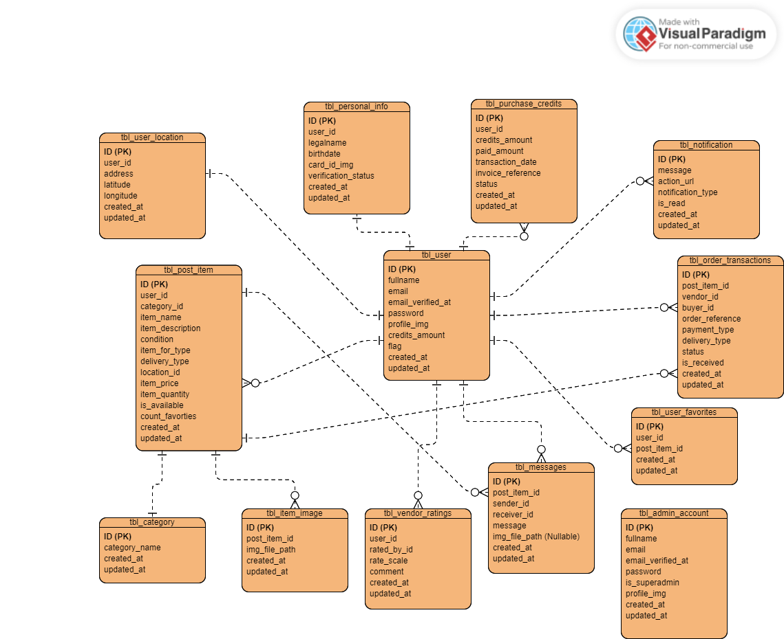

## ***Data Description***

The following is a description of each entity and its associated attributes:

**User Table**: This entity serves as a repository for user information. It has a relationship with other entities, such as one user can have one location and personal information. Also, one user can purchase many credits, receive many notifications, transactions, favorites, messages, and vendor ratings, and post as many items as they want.

**Personal Information**: As the name suggests, it stores the personal information of the user, such as their legal name, birthdate, valid card ID, the status of their verification, and the timestamp it is created and updated.

**Post Item**: This entity stores essential information about posting an Item. The user table and the category table are connected so that one user can post many items, and each item post has one category.

**Category**: The table Category consists of the id, category name, and date and time it was created and updated. It is an entity that holds data that classifies the item.

**User Location**: It consists of data about the user's specific address. This entity has attributes of id, user_id, address, latitude, longitude, and timestamp of create and update.

**Item Image**: This table holds data on the item image. It consists of ID, post item ID, image file path, and timestamp as its attributes.

**Notification**: This table keeps information about notices such as messages from other users, action_url, and the type of notification, status, and timestamp.

**Messages**: It refers to the data gathered about the content of some information, such as the post item ID, send ID, receiver ID content of the message, image file path, and timestamp.

**Purchase Credits**: Stores data about the transaction made upon purchasing a credit. It consists of attributes such as the ID, credits amount, paid amount, transaction date, invoice reference, status, and timestamp. The user table is connected to this entity, allowing one user to purchase many credits.

**Order Transaction**: E-commerce systems commonly require this entity. The Order Transaction table holds information about users’ placing orders within the application.

**User Ratings**: This table consists of the data about the rate and feedback made by the user. All information received is stored here.

**User Favorites**: The information stored in this table is about the things a user likes. It consists of attributes such as ID, user ID, post-item ID, and timestamp.

**User Withdrawal**:The information stored in this table includes the id(primary key), user_id and account_name and account_number (foreign key), amount, status, and timestamps for created and updated.

**Admin Account**: This entity contains data about the information of the admin. Has an attribute of ID, full name, email, email verified at, password, super admin, profile image, and timestamp.

## ***Data Dictionary***

Entity Name: **tbl_user**

*Table 1*

| ATTRIBUTES | DATA TYPE |
| --- | --- |
| id (Primary Key) | Integer |
| fullname | String |
| email | String |
| email_verified_at | Datetime |
| password | String |
| profile_img | String |
| credits_amount | Integer |
| flag | Integer |
| created_at | Timestamp |
| updated_at | Timestamp |

Entity Name: **tbl_personal_info**

*Table 2*

| ATTRIBUTES | DATA TYPE |
| --- | --- |
| id (Primary Key) | Integer |
| user_id (Foreign Key) | Integer |
| legalname | String |
| birthdate | Datetime |
| card_id | String |
| verification_status | Integer |
| created_at | Timestamp |
| updated_at | Timestamp |

Entity Name: **tbl_post_item**

*Table 3*

| ATTRIBUTES | DATA TYPE |
| --- | --- |
| id (Primary Key) | Integer |
| user_id (Foreign Key) | Integer |
| category_id (Foreign Key) | Integer |
| item_name | String |
| item_description | String |
| condition | String |
| item_for_type | String |
| delivery_type | String |
| location_id(Foreign Key) | Integer |
| item_price | Integer |
| item_quantity | Integer |
| is_available | Integer |
| count_favorites | Integer |
| created_at | Timestamp |
| updated_at | Timestamp |

Entity Name: **tbl_category**

*Table 4*

| ATTRIBUTES | DATA TYPE |
| --- | --- |
| id (Primary Key) | Integer |
| category_name | String |
| created_at | Timestamp |
| updated_at | Timestamp |

Entity Name: **tbl_user_location**

*Table 5*

| ATTRIBUTES | DATA TYPE |
| --- | --- |
| id (Primary Key) | Integer |
| user_id (Foreign Key) | Integer |
| address | String |
| latitude | Decimal |
| longitude | Decimal |
| created_at | Timestamp |
| updated_at | Timestamp |

Entity Name: **tbl_item_image**

*Table 6*

| ATTRIBUTES | DATA TYPE |
| --- | --- |
| id (Primary Key) | Integer |
| post_item_id(Foreign Key) | Integer |
| img_file_path | String |
| created_at | Timestamp |
| updated_at | Timestamp |

Entity Name: **tbl_notification**

*Table 7*

| ATTRIBUTES | DATA TYPE |
| --- | --- |
| id (Primary Key) | Integer |
| message | String |
| action_url | String |
| notification_type | String |
| is_read | Integer |
| created_at | Timestamp |
| updated_at | Timestamp |

Entity Name: **tbl_messages**

*Table 8*

| ATTRIBUTES | DATA TYPE |
| --- | --- |
| id (Primary Key) | Integer |
| post_item_id(Foreign Key) | Integer |
| sender_id(Foreign Key) | Integer |
| receiver_id(Foreign Key) | Integer |
| message | String |
| img_file_path(Nullable) | String |
| created_at | Timestamp |
| updated_at | Timestamp |

Entity Name: **tbl_purchase_credits**

*Table 9*

| ATTRIBUTES | DATA TYPE |
| --- | --- |
| id (Primary Key) | Integer |
| user_id(Foreign Key) | Integer |
| credits_amount | Integer |
| paid_amount | Integer |
| transaction_date | Datetime |
| invoice_reference | String |
| status | Integer |
| created_at | Timestamp |
| updated_at | Timestamp |

Entity Name: **tbl_order_transactions**

*Table 10*

| ATTRIBUTES | DATA TYPE |
| --- | --- |
| id (Primary Key) | Integer |
| post_item_id(Foreign Key) | Integer |
| vendor_id(Foreign Key) | Integer |
| buyer_id(Foreign Key) | Integer |
| order_reference | String |
| payment_type | String |
| delivery_type | String |
| status | Integer |
| is_received | Integer |
| created_at | Timestamp |
| updated_at | Timestamp |

Entity Name: **tbl_user_ratings**

*Table 11*

| ATTRIBUTES | DATA TYPE |
| --- | --- |
| id (Primary Key) | Integer |
| user_id(Foreign Key) | Integer |
| rated_by_id(Foreign Key) | Integer |
| rate_scale | Integer |
| comment | String |
| created_at | Timestamp |
| updated_at | Timestamp |

Entity Name: **tbl_user_favorites**

*Table 12*

| ATTRIBUTES | DATA TYPE |
| --- | --- |
| id (Primary Key) | Integer |
| user_id(Foreign Key) | Integer |
| post_item_id(Foreign Key) | Integer |
| created_at | Timestamp |
| updated_at | Timestamp |

Entity Name: **tbl_withdrawal**

*Table 13*

| ATTRIBUTES | DATA TYPE |
| --- | --- |
| id (Primary Key) | Integer |
| user_id(Foreign Key) | Integer |
| transfer_to | String |
| account_name(Foreign Key) | String |
| account_number(Foreign Key) | Integer |
| amount | Integer |
| status | String |
| created_at | Timestamp |
| updated_at | Timestamp |

Entity Name: **tbl_admin_account**

*Table 14*

| ATTRIBUTES | DATA TYPE |
| --- | --- |
| id (Primary Key) | Integer |
| fullname | String |
| email | String |
| email_verified_at | Datetime |
| password | String |
| is_superadmin | Integer |
| profile_img | String |
| created_at | Timestamp |
| updated_at | Timestamp |

# **Component Design**

There are 3 Component Design for Community Resource Exchange (Swapifine):

**User Interface Component**: This component provides users with interfaces which enable them to explore and navigate system features.

**Business Logic**: This component meets the system requirements . In which the administrator is able to add, read ,update, and delete.

**Data Access Component**: This component provides the access of the system’s data. These include user information, requests, revenues, and others.

## ***Component Description 1***

The **User Interface Component** is designed with a mobile-first approach in order to be compatible with different screen devices. Its purpose is to facilitate user interaction with the features within the system .

It contains the form, buttons, modals, and option fields that allow users to interact with the system's features. Buyers and vendors can utilize it to browse through items and categories, conduct searches, create posts, provide ratings, choose payment methods, and engage in conversations with other users for seamless transactional interactions. For the system administrator, it enables the admin to interact with the system such as to view total user count, category listings, user orders, transactions, and revenues.

This component is designed to be simple and responsive. Making it easy for users to navigate and browse the application's resources. The design is carefully planned to provide the end-user with a satisfactory experience.

## ***Component Description 2***

The **Business Logic** handles data transfers between a database and a user interface. It is the crucial component that ensures the system’s functionality is met and makes decisions of what actions to be made with the collected data while ensuring security.

It encompasses tasks such as handling user orders, incorporating categories, managing requests, processing user inputs, facilitating payment methods, conducting verifications, and performing other functions essential for the seamless operation of the application.

Furthermore, this component specifies what data is and is not visible to users. Include the reasoning behind data calculation processes such as purchasing credits and modifying the values of items.

## ***5.3 Component Description 3***

The **Data Access Component** is responsible for overseeing data storage. It serves as an interface between the application's business logic and the database, enabling the application to engage with stored data in a well-organized manner. It includes functions for adding, updating, retrieving, and deleting data from the database.

The Data Access Component grants access to various types of data, including user information, categories, transactions, revenues, reported users, user management, and admin accounts. It also manages data backup and recovery in case of system issues or errors. It ensures that the data are secured and protected.

# **Human Interface Design**

## ***Overview of User Interface***

The User Interface of Swapifine is well-planned and offers a user-friendly and responsive interface. It provides elements such as forms, buttons, text, images, and icons to guide users through its functions and content. The objective is to present a visually captivating and uniform appearance that mirrors the brand or purpose of the application.

For the User, it allows them to create an account, log in to the application, view and discover items, be notified of upcoming messages, post an item, interact with other users, purchase credit points, and utilize other features of the system. For the Admin, it is intended for monitoring overall aspects of the application. It controls system performance and manages data received from users.

Overall, The user interface of this application is well-organized and easy to navigate. It focuses on providing a great user experience. A system that helps users enjoy while browsing and interacting within the application.

## ***Screen Images***

**User Authentication: Welcome page, Login, & Register Interface:** This presents users the welcome page and form for both logging in and registering within the system. 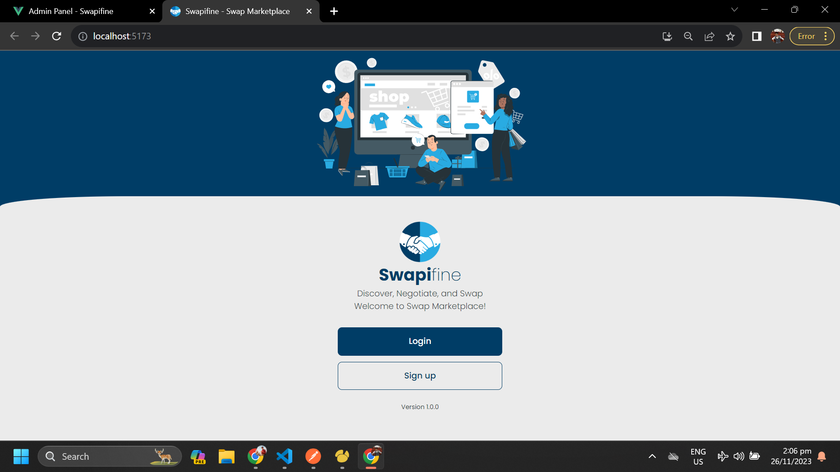

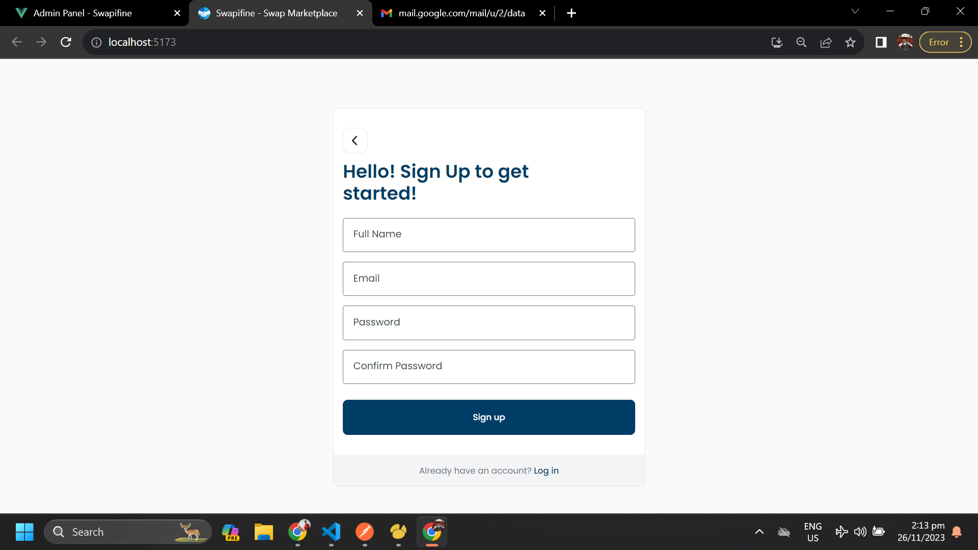

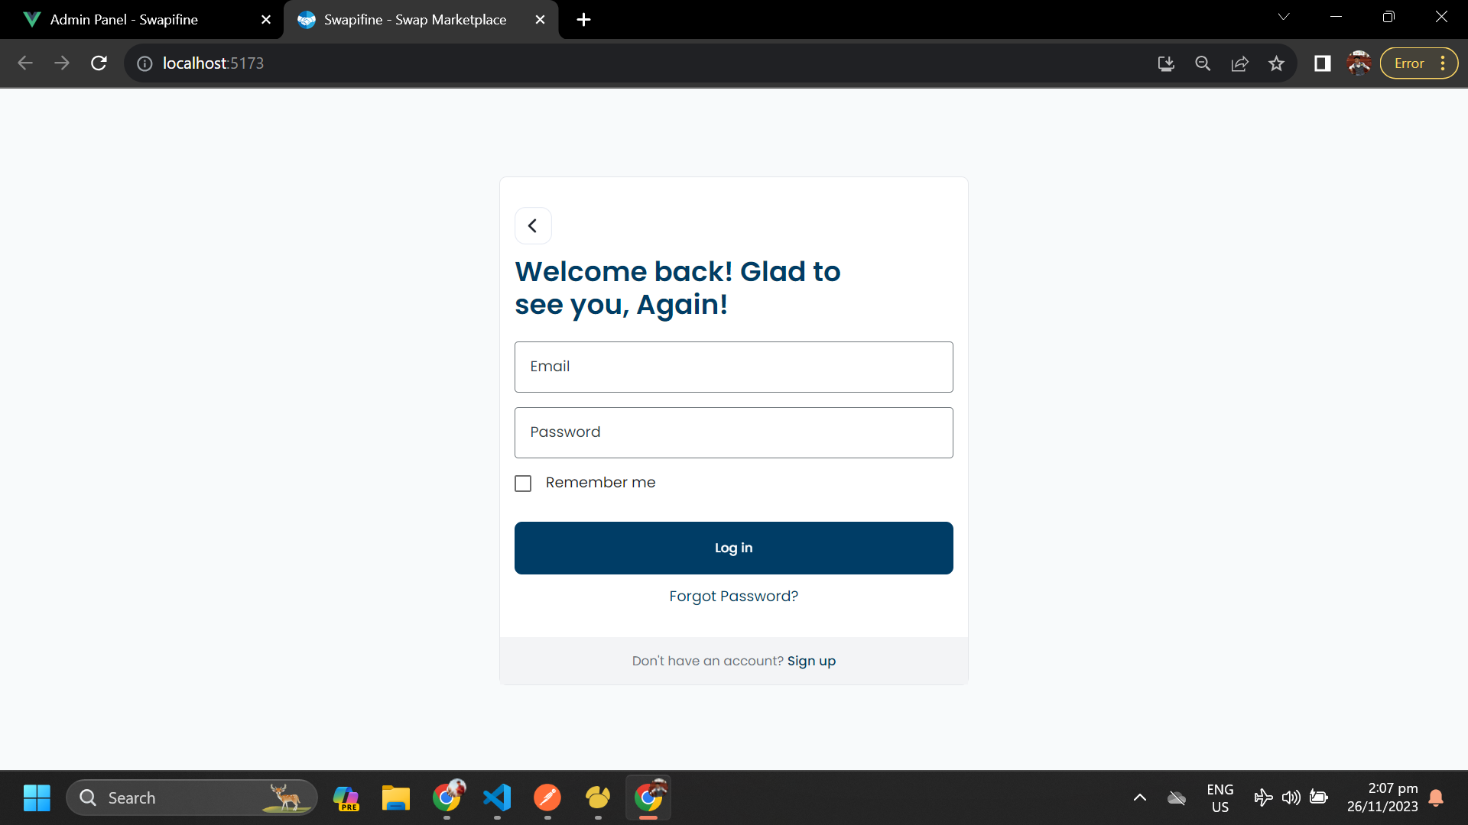

*Figure 3*

**User View Interface**: This represents the interface that a user encounters upon logging into the Swapifine Application.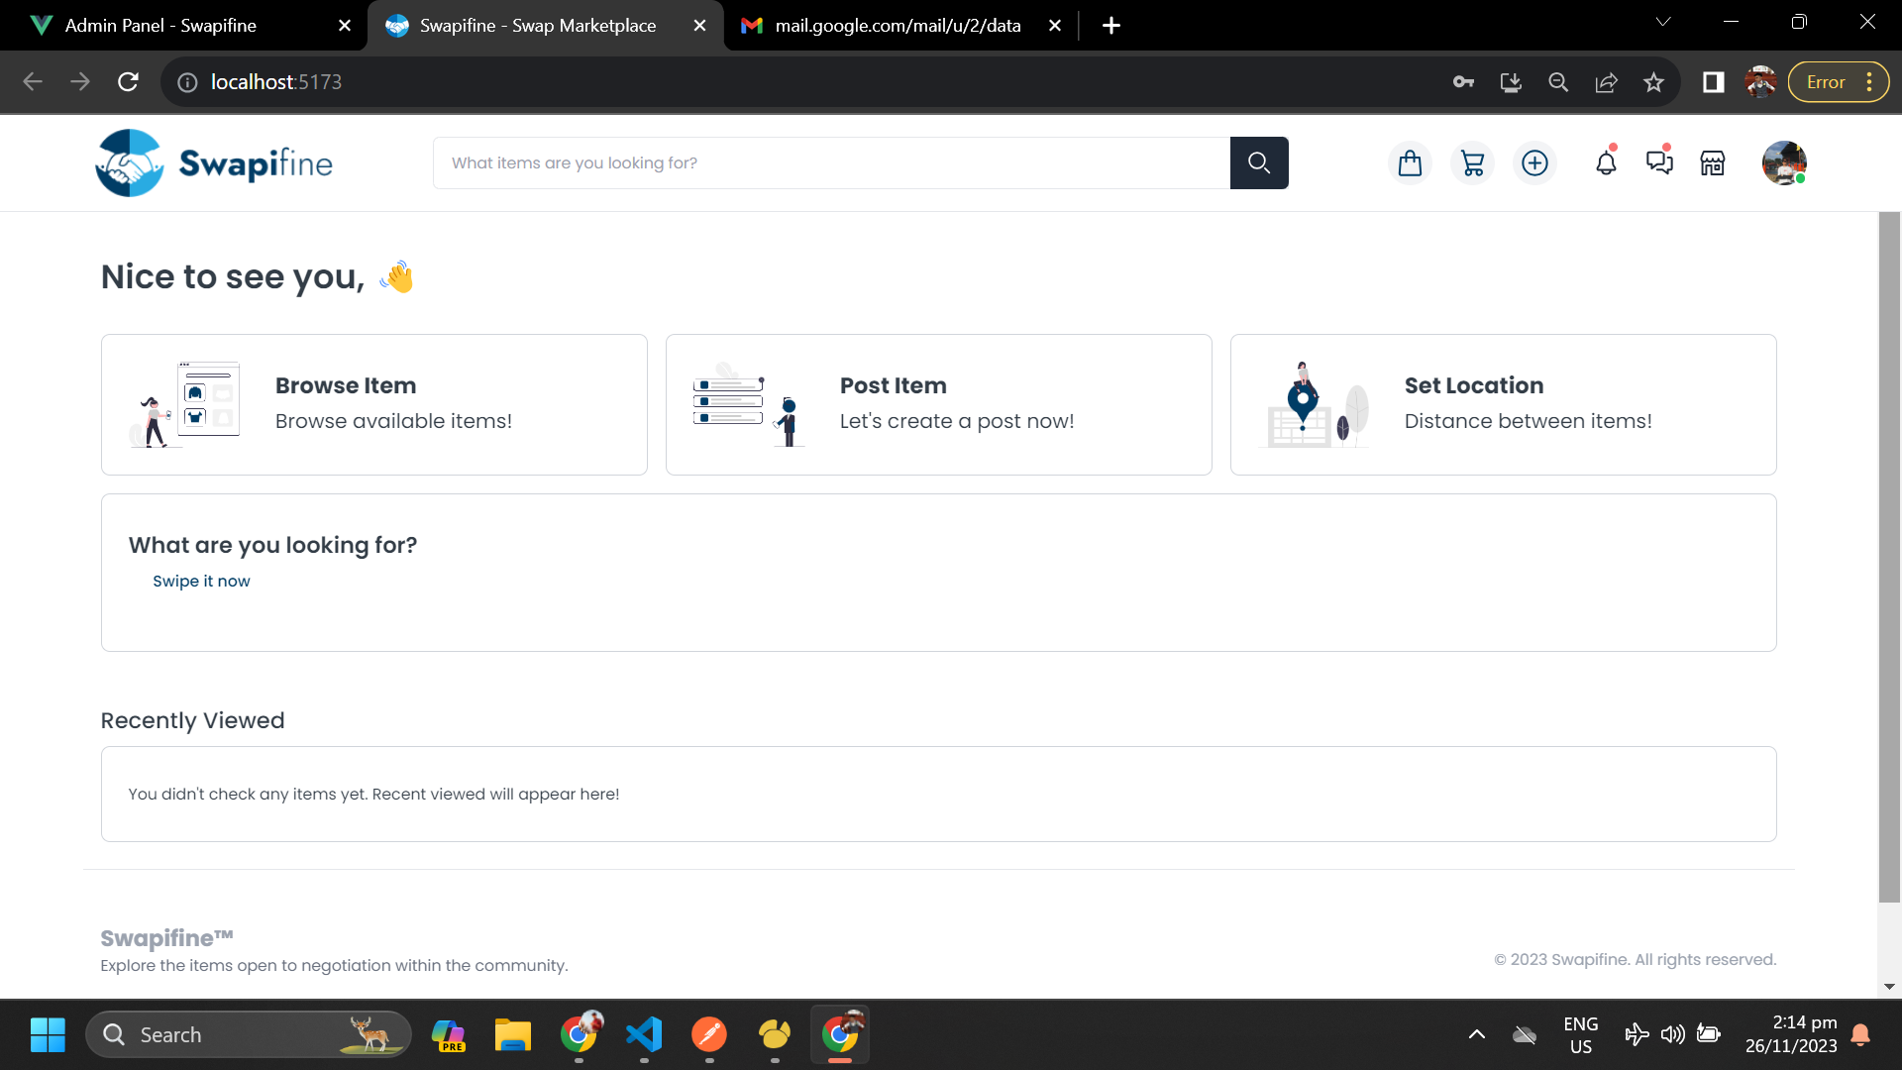

*Figure 4*

**Admin Interface**: This is the design for the Admin's dashboard, depicting the view they will see when they log in.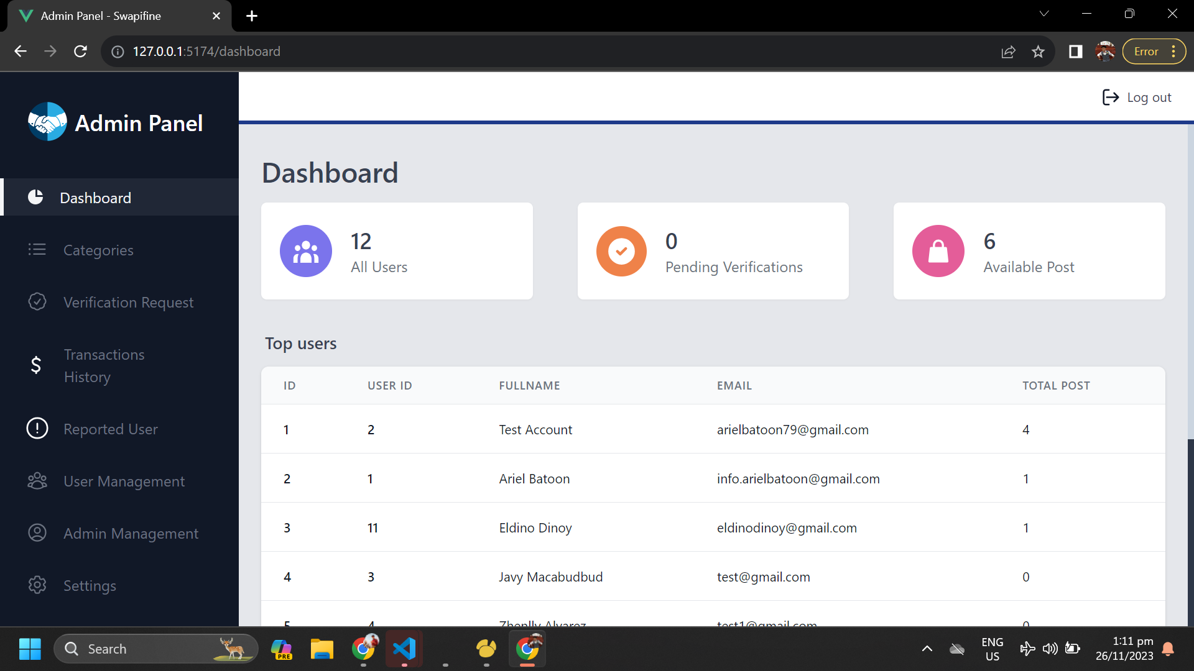

*Figure 5*

## ***6.3 Screen Objects and Actions***

**View Select Filter button**- when the user clicks the “search filter” button it will redirect to its modal

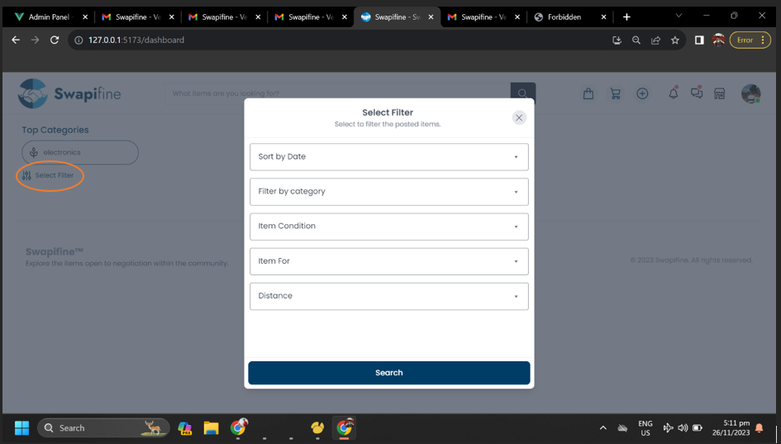

*Figure 6*

**View Post Item Page**:when user clicks it, this will navigate to the process of publishing an item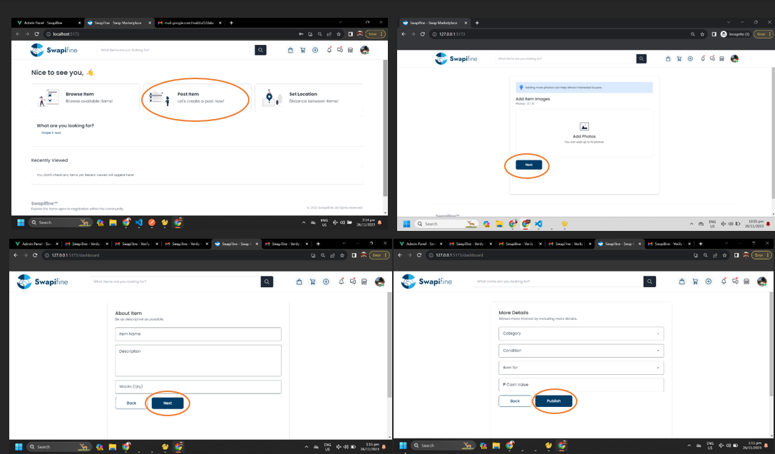

*Figure 7*

**Browse Page**: upon clicking the “Browse Item” this design will show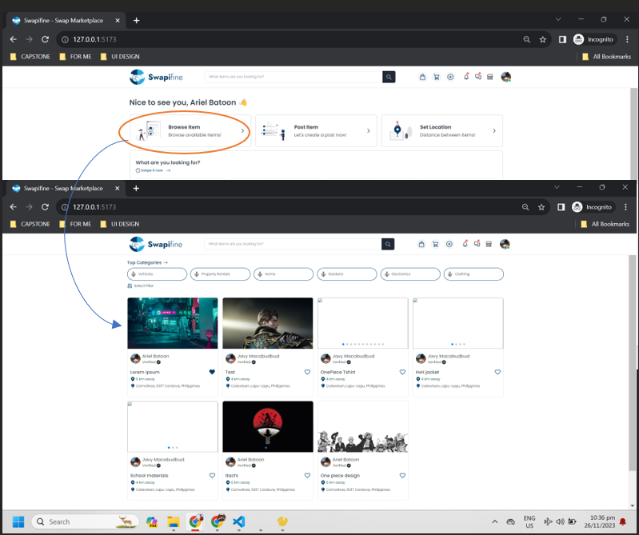

*Figure 8*

**Set Location**: this what user will view when clicking “Set Location”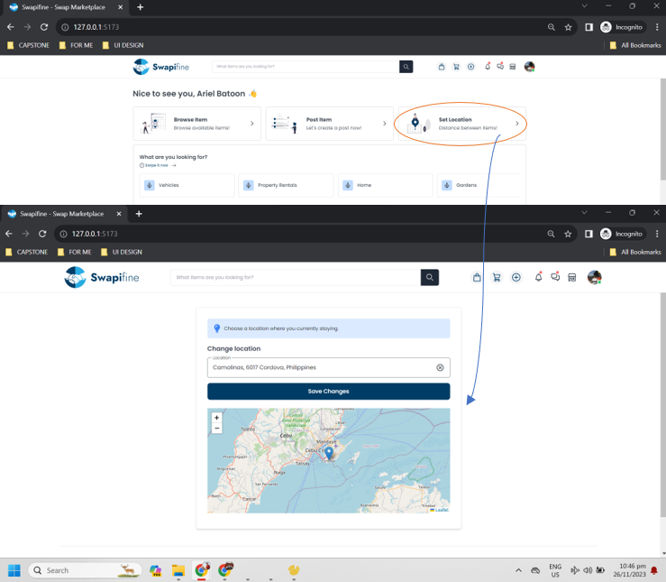

*Figure 9*

**View Track Orders**: this presents the process of tracking the orders of the user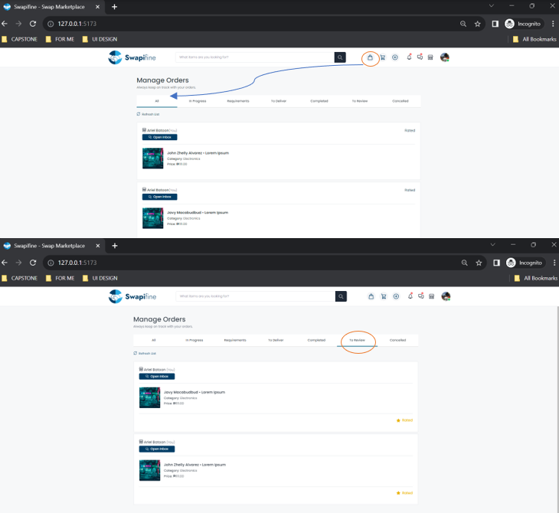

*Figure 10*

**Checkout**: when a user clicks the icon checkout this design will appear. A procedure is presented below.

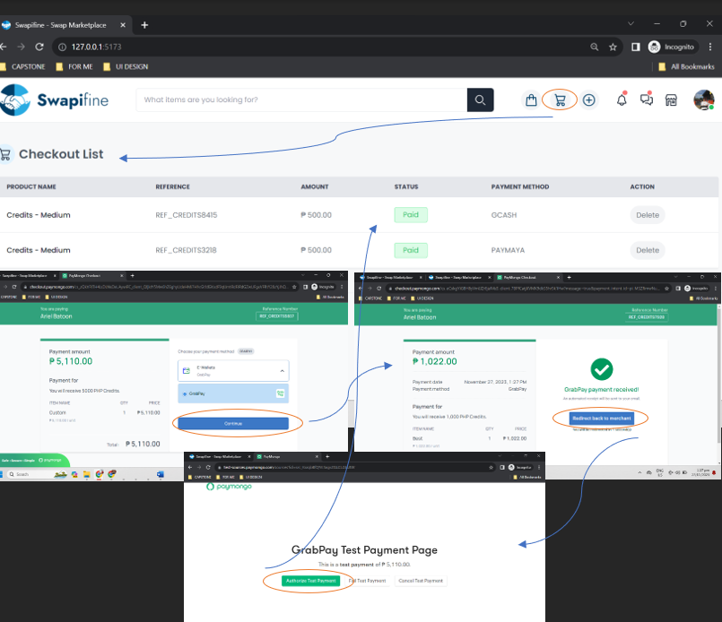

*Figure 11*

**Buy Credits**: when user clicks the buy credits button this design will appear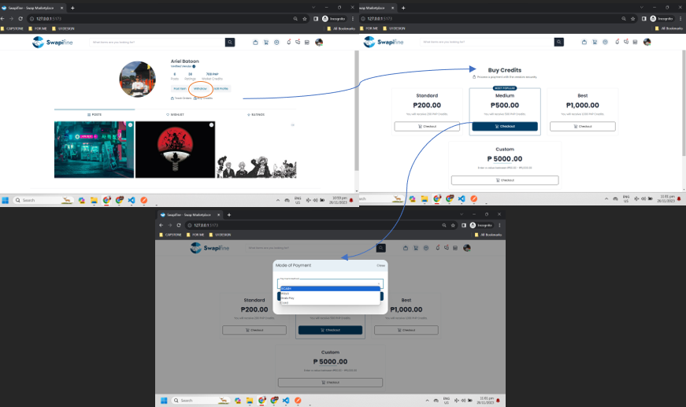

*Figure 12*

**Withdraw**: when user clicks the withdraw button a design like this will appear

*Figure 13*

**View Store**: when user click the icon store this design will appear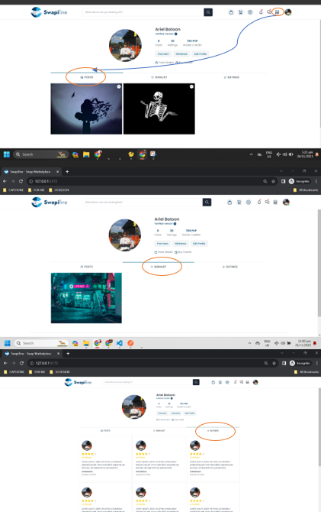

*Figure 14*

**Edit Profile**: when a user clicks the “edit profile” it will redirect to its page. This shows the UI for verifying accounts for vendors.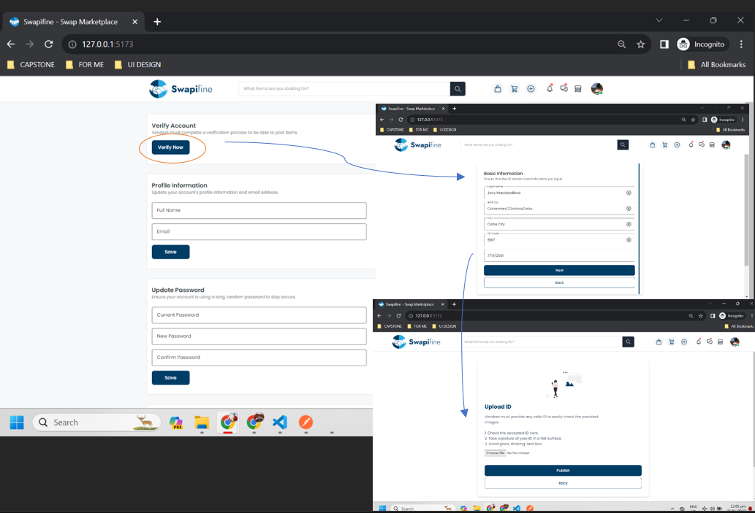

*Figure 15*

**Admin - Login:** Ensures that only authorized personnel can use the administrative functionalities or dashboard.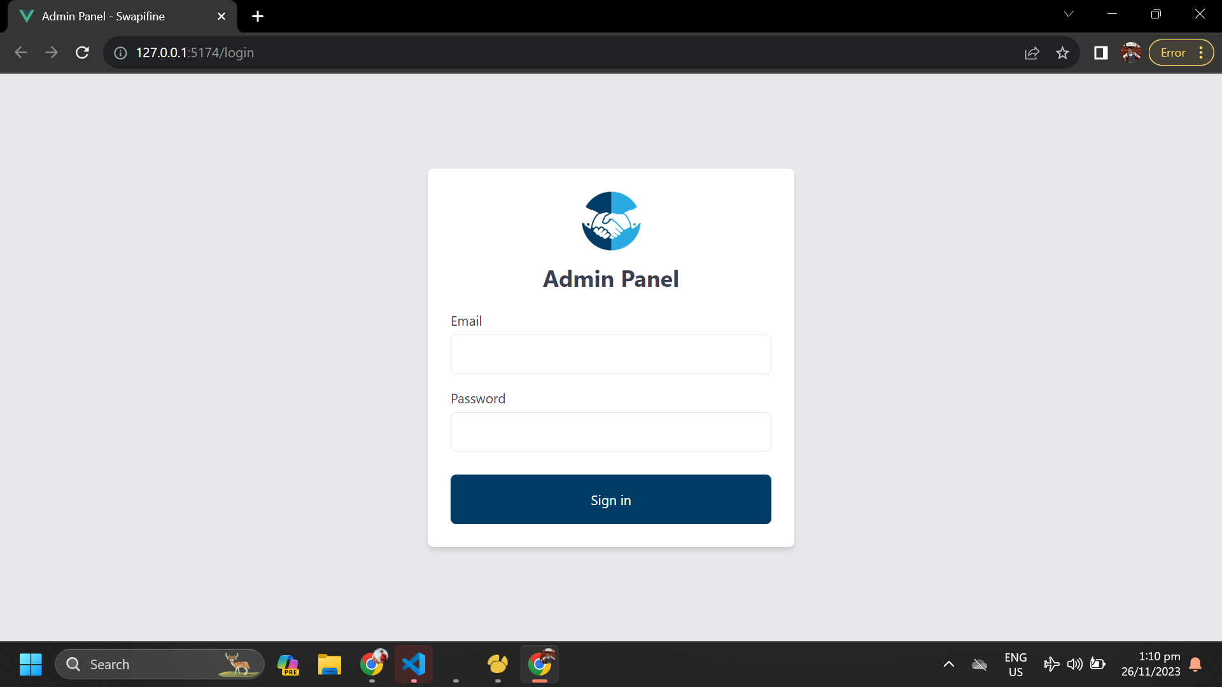

*Figure 16*

**Admin - Dashboard:**  Allows administrators to oversee and supervise the platform efficiently.

*Figure 17*

**Admin - Categories:** It facilitates efficient space for edit and creates new categories.

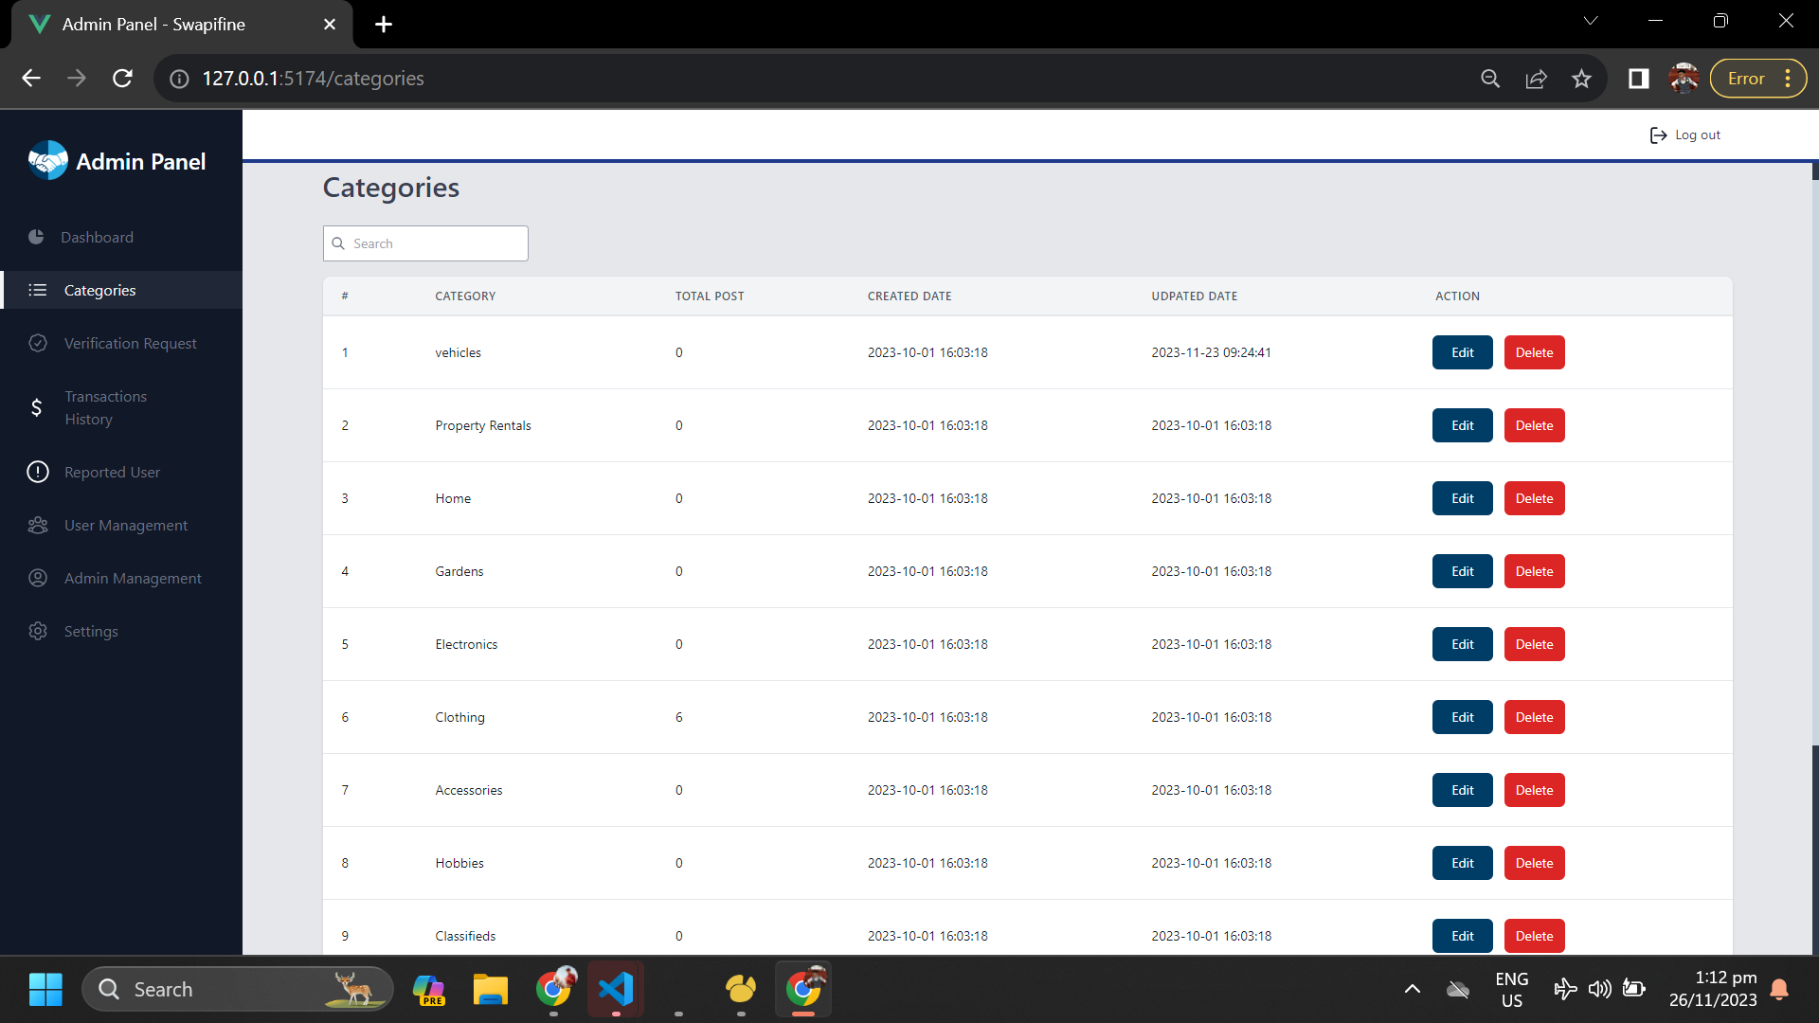

*Figure 18*

**Admin Verification Request:** Presents organized information for those users who seek verification within the platform. It allows the administrator to take action by changing the status of their request and view verification details.

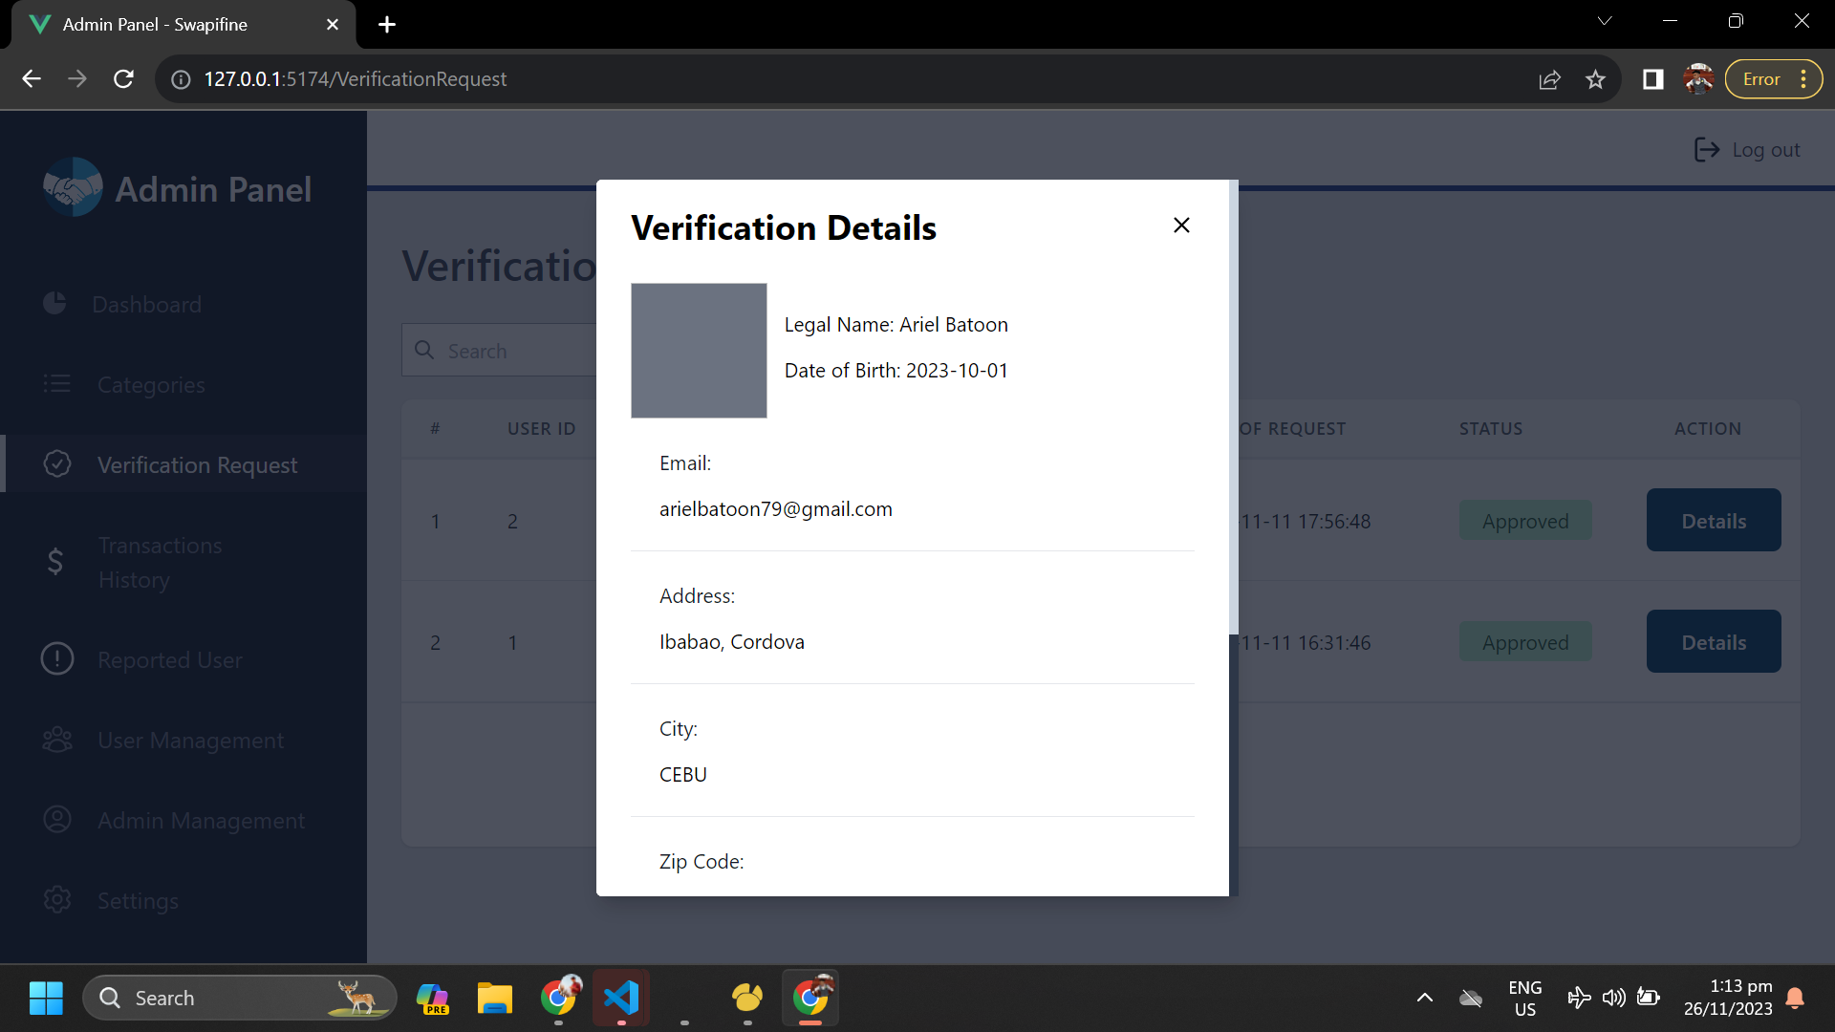

*Figure 19*

**Admin Withdrawal Request:** Presents management of withdrawal requests for users. It allows the administrator to view withdrawal details.

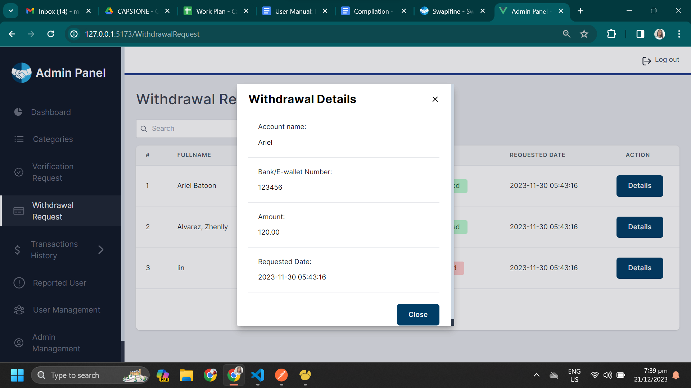

*Figure 20*

**Admin - Transaction History- User Order:** The administrator has control over this area for keeping track of transaction activities from user orders.

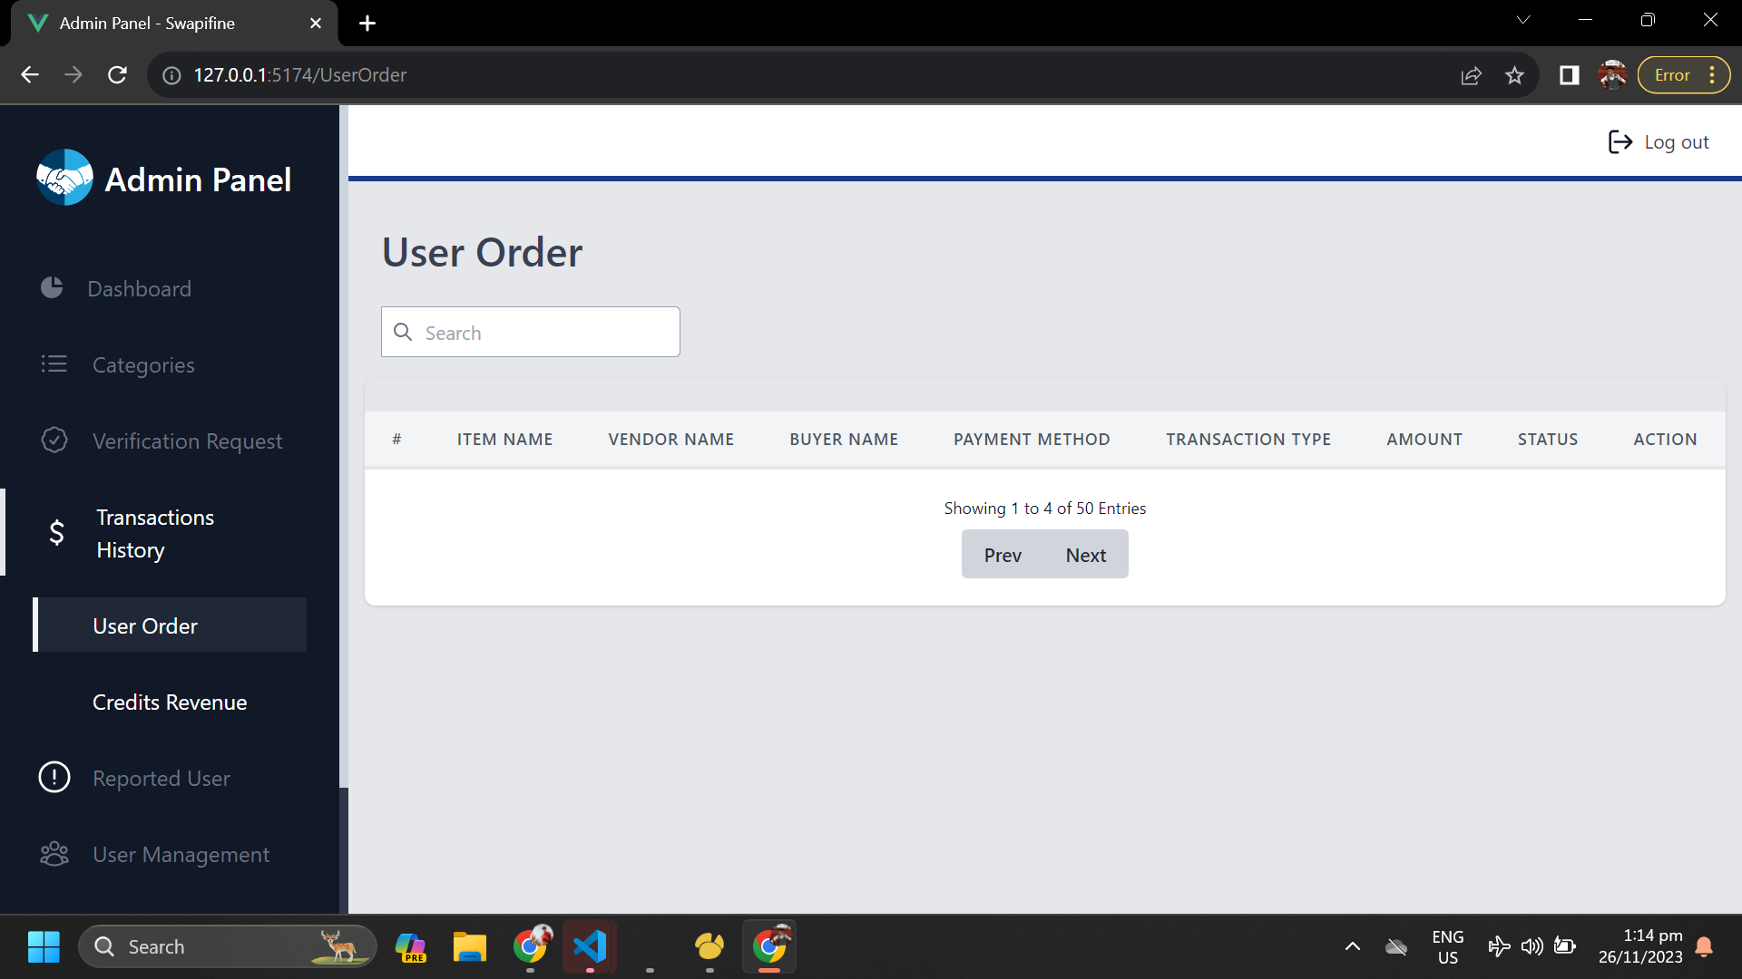

*Figure 21*

**Admin - Credits Revenue:** Is organized to give administrators insights into the revenue generated within the application. It will present the details of the revenue gathered.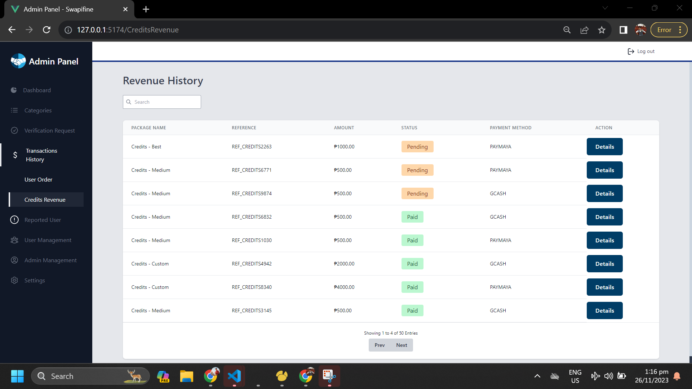

*Figure 22*

**Admin - Reported User:** Allows the administrator to monitor and manage reported users. It will present detailed information for the reported user.

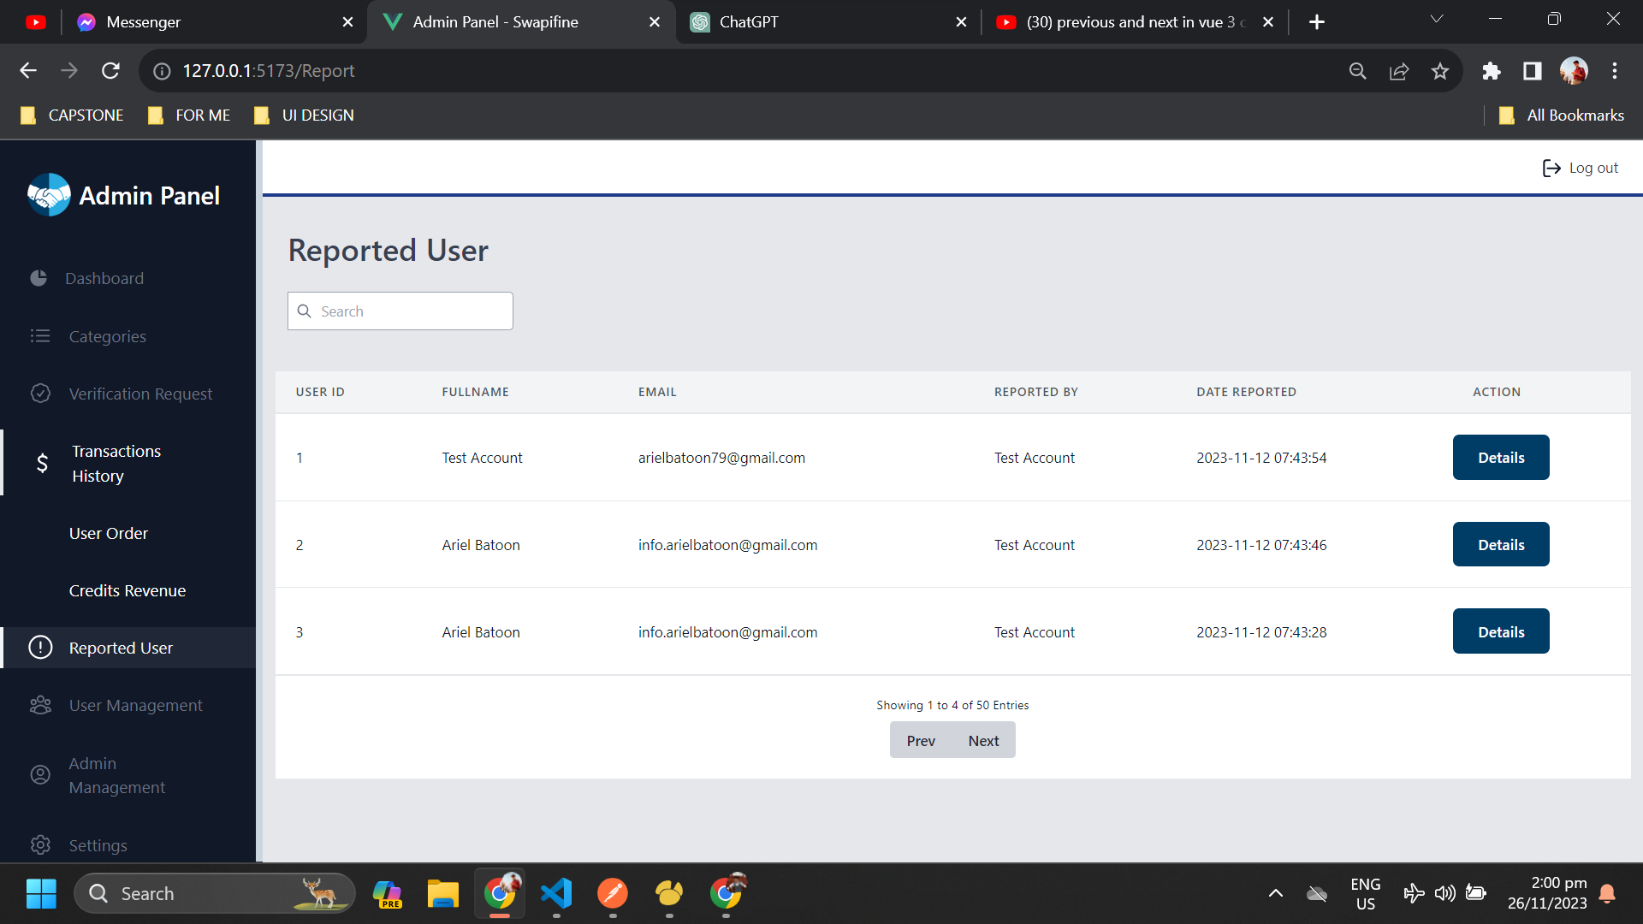

*Figure 23*

**Admin - User Management:** Allows the administrator to monitor and manage the user’s account. The administrator has control to edit or delete the user’s account. 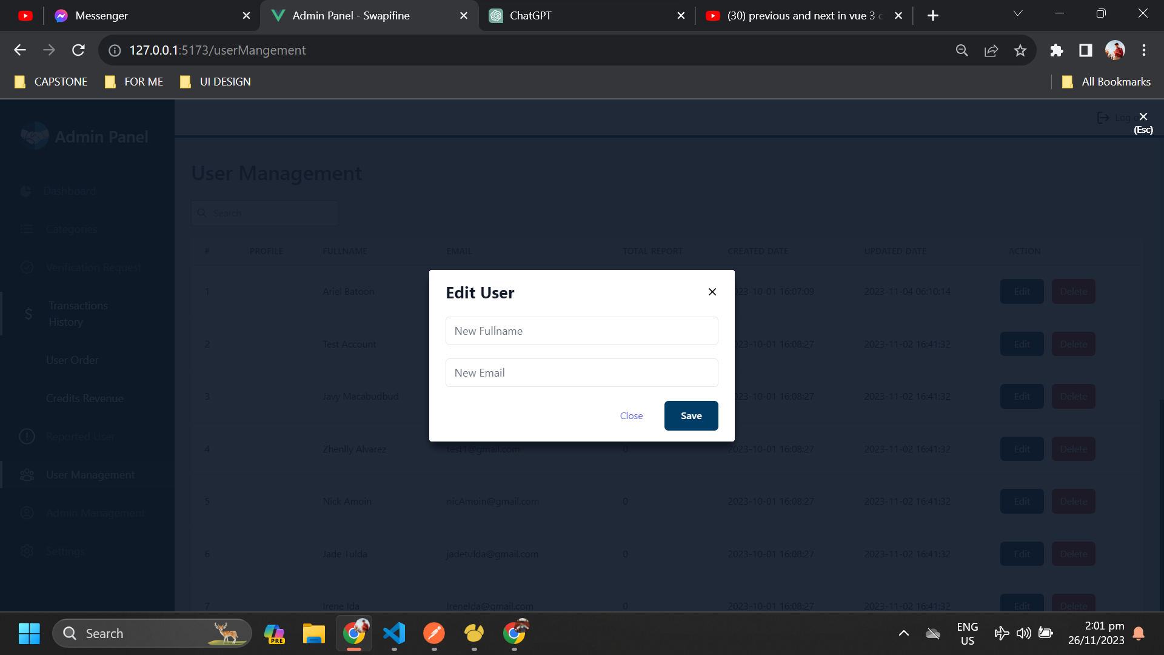

*Figure 24*

**Admin Management:**  Equips administrators with the necessary tools to oversee the accounts, roles, and permissions of other administrators within the system.

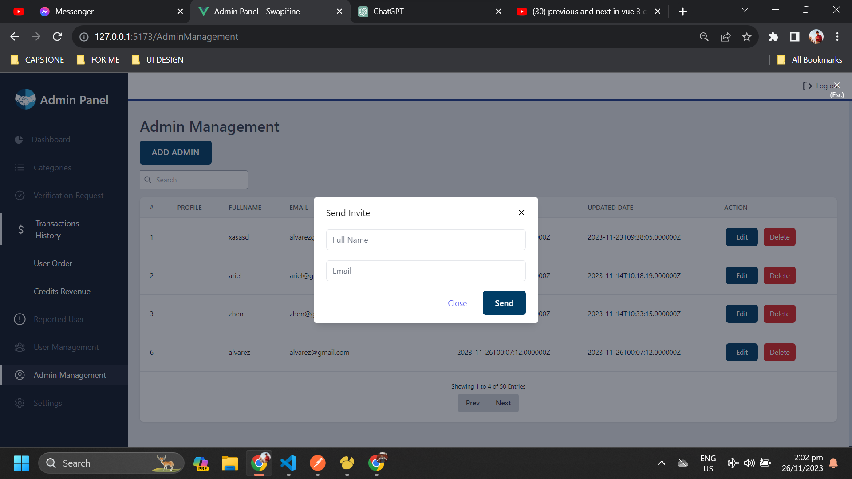

*Figure 25*

**Admin - Settings:** It can change the information required for the account. For security, the administrator can change the password anytime.

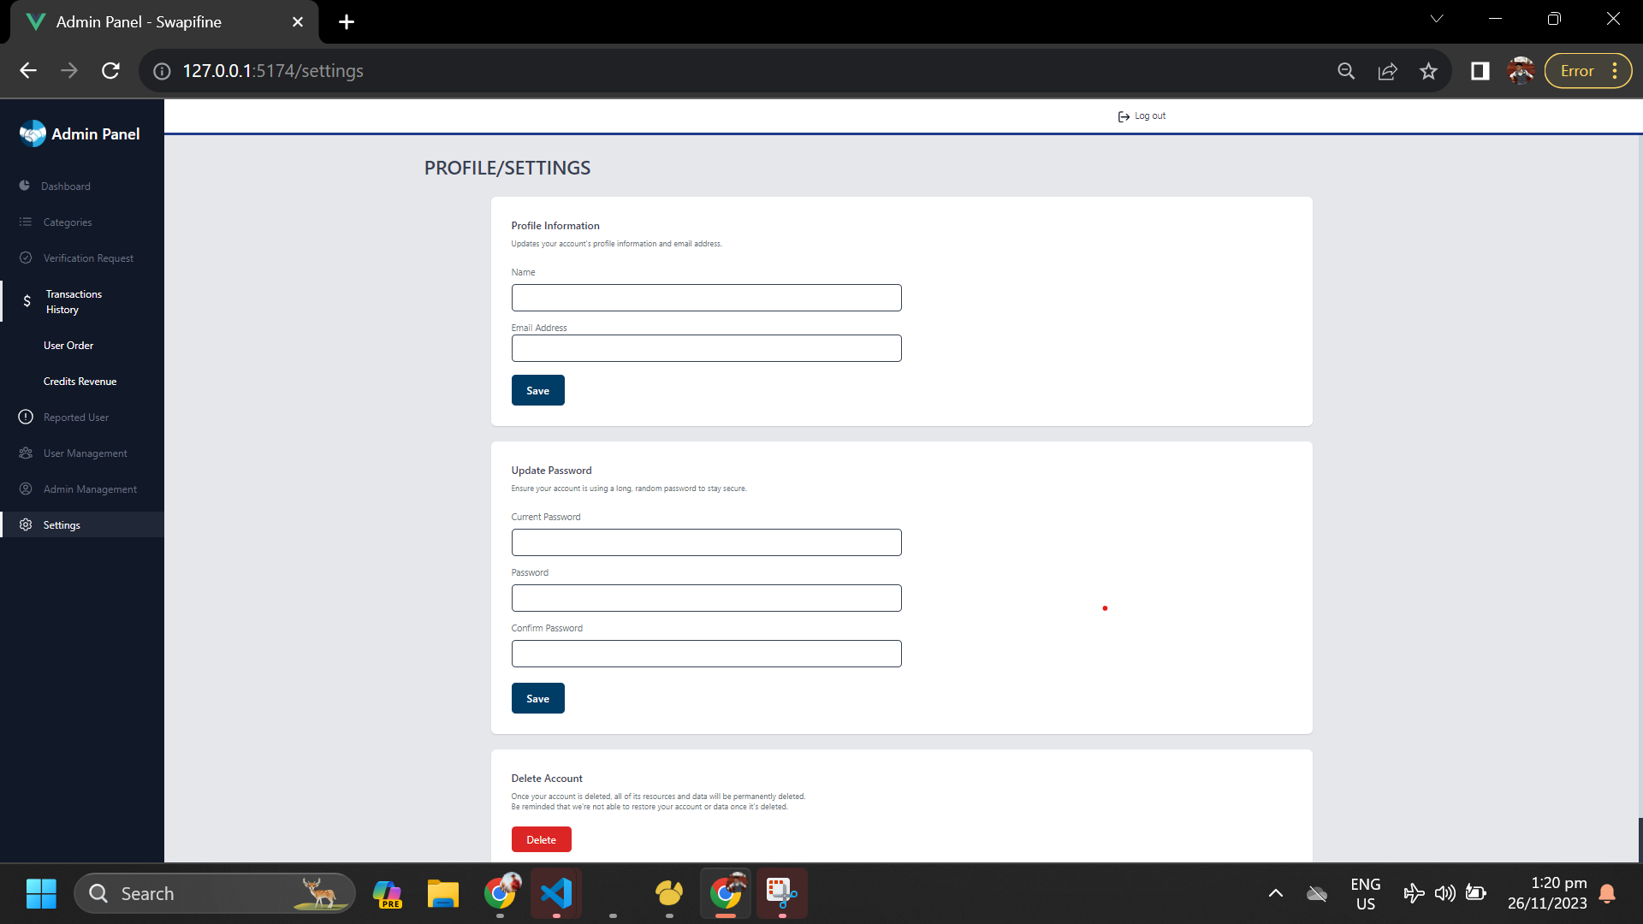

*Figure 26*

# **Requirement Matrix**

Table 15

| **Requirement ID** | **Requirement Description** | **Priority** | **Use Case** | **Component** | **Test Case** |
| --- | --- | --- | --- | --- | --- |
| **REQ-001** | Users can signup and login to their account using manual credentials | High | UC-032 - UC-033 | Authentication | TC-001 - TC-002 |
| **REQ-002** | Enable users to reset and make new password | High | UC-034 | Forgot Password | TC-003 |
| **REQ-003** | Users can explore post items | High | UC-035 | Browse | TC-004 |
| **REQ-004** | The user can post item | High | UC-036 | Post Item | TC-005 |
| **REQ-005** | Users can access the post items and send offers | High | UC-037 | View Item Details | TC-006 |
| **REQ-006** | Able to purchase credits | High | UC-038 | Credits  System | TC-007 |
| **REQ-007** | view list of orders | High | UC-039 | Order Lists | TC-008 |
| **REQ-008** | Users can able to track their orders | High | UC-040 | Order Tracking | TC-009 |
| **REQ-009** | Sets their current location | High | UC-041 | Location | TC-010 |
| **REQ-010** | For categorizing items and filtering | High | UC-042 | Category Filtering | TC-011 |
| **REQ-011** | Users able to search specific post item | High | UC-043 | Search Filtering | TC-012 |
| **REQ-012** | Users can received notification | High | UC-044 | Notifications | TC-013 |
| **REQ-013** | Can view all messages | High | UC-045 | Messages List: | TC-014 |
| **REQ-014** | Users can interact with other users | High | UC-046 | Chat-To-Chat | TC-015 |
| **REQ-015** | View list of items | High | UC-047 | My Items | TC-016 |
| **REQ-016** | List of favorites post | High | UC-047 | Wishlist | TC-017 |
| **REQ-017** | Rates received from buyers | High | UC-047 | Ratings | TC-018 |
| **REQ-018** | User can verify their account | High | UC-048 | Verification | TC-019 |
| **REQ-019** | User can withdraw their credits or money | High | UC-049 | Withdrawal | TC-020 |
| **REQ-020** | Users can view and edit their profiles information | High | UC-050 | Settings | TC-021 |
| **REQ-021** | Admin can login to the application | High | UC-051 | Admin-Login | TC-022 |
| **REQ-022** | Admin can view and access the overall system’s information. | High | UC-052 | Admin-Dashboard | TC-023 |
| **REQ-023** | Admin can view, edit, and access the categories list | High | UC-053 | Admin-Categories | TC-024 |
| **REQ-024** | Admin can access the users verification request | High | UC-054 | Admin-Verification Requests | TC-025 |
| **REQ-025** | Admin can manage the withdrawal request of users received from the users. | High | UC-055 | Admin- Withdrawal Request | TC-026 |
| **REQ-026** | Admin can view and access the user orders and credits revenue received from the users. | High | UC-056 | Admin-Transaction | TC-027 |
| **REQ-027** | Admin can view the list and details of reported user | High | UC-057 | Admin-Reported User | TC-028 |
| **REQ-028** | Admin can view the list of the users using the swapifine’s application, | High | UC-058 | Admin-User Management | TC-029 |
| **REQ-029** | Admin can access the list and add new admin users. | High | UC-059 | Admin-Admin Management | TC-030 |
| **REQ-030** | Admin can edit their profile. | High | UC-060 | Admin- Settings | TC-031 |



**CORDOVA PUBLIC COLLEGE**

GABI, CORDOVA, CEBU, PHILIPPINES

COLLEGE OF COMPUTER STUDIES

**Software Test Document**

*for*

Community Resource Exchange (Swapifine)

CPC-BSIT-CAPSTONE-STD-1st SEM 2022-2023-SWAPIFINE

Documents for IT Project

Of

Ariel Batoon

John Zhenlly Alvarez

Javy Macabudbud

**Change History**

| **Version** | **Date** | **Author** | **Changes** |
| --- | --- | --- | --- |
| 0.1 | November 09, 2023 | Javy Macabudbud | Adding reported user for the features to be tested |
| 0.2 | November 21, 2023 | Javy Macabudbud | Initial Testing for some features |
| 0.3 | November 23, 2023 | Javy Macabudbud | Updating the Incident Report |
| 0.4 | December 01, 2023 | Javy Macabudbud | Adding the withdrawal and Admin: Withdrawal Request in features to be tested and in test case |

**Preface**

The Software Test Document encompasses the comprehensive testing and approach undertaken by the team members for the application known as Community Resource Exchange (Swapifine). Its primary aim is to ensure the smooth and effective operation of every feature.

The tester's responsibilities include formulating a test plan that clearly outlines the objectives, strategies, and outlines needed to execute a well-structured testing procedure. Furthermore, it entails the creation of detailed test cases that describe the system's behavior and pinpoint potential errors and issues. Additionally, the document facilitates the provision of feedback and recommendations for enhancing the user experience.

In summary, this document will serve as a manual for conducting performance tests on all the application's functionalities and conducting a security assessment to uncover vulnerabilities, ensuring it is free from defects.

**Table of Contents**

**Change History 3**

**Preface 4**

**Table of Contents 5**

**List of Tables 7**

**1.** **Introduction 9**

1.1. System Overview 9

1.2. Test Approach 9

1.3. Definitions and Acronyms 10

**2.** **Test Plan 11**

2.1 Features to be Tested 11

2.2 Testing Tools and Environment 11

**3.** **Test Cases 12**

3. n Case-n 12

*3. n.1 Purpose* [*1*](https://docs.google.com/document/d/1GckRsobDw2HgH1p_32cmCGUW3CZ_7wDYxEGyaTXb73Q/edit#heading=h.44sinio)2

*3. n.2 Inputs* [*1*](https://docs.google.com/document/d/1GckRsobDw2HgH1p_32cmCGUW3CZ_7wDYxEGyaTXb73Q/edit#heading=h.2jxsxqh)2

*3. n.3 Expected Outputs & Pass/Fail Criteria* [*1*](https://docs.google.com/document/d/1GckRsobDw2HgH1p_32cmCGUW3CZ_7wDYxEGyaTXb73Q/edit#heading=h.z337ya)6

*3. n.4 Test Procedure 23*

**Appendix (Test Logs) 34**

A.1 Log for Test n 34

A.2 Test Results 34

A.3 Incident Report 36

**List of Tables**

Table 1 Inputs

Table 2 Expected Outputs & Pass/Fail Criteria

Table 3 Authentication: Register

Table 4 Authentication: Login

Table 5 Forgot Password

Table 6 Browse

Table 7 Post Item

Table 8 Item Details

Table 9 Credits System

Table 10 Order Lists

Table 11 Order Tracking

Table 12 Location

Table 13 Category Filtering

Table 14 Search Filtering

Table 15 Notifications

Table 16 Messages Lists

Table 17 Chat-to-Chat

Table 18 My Items

Table 19 Wishlists

Table 20 Ratings

Table 21 Verification

Table 22 Withdrawal

Table 23 Settings

Table 24 Admin Authentication

Table 25 Admin Dashboard

Table 26 Admin Categories

Table 27 Admin Verification Requests

Table 28 Admin Withdrawal Requests

Table 29 Admin Transactions History

Table 30 Admin Reported User

Table 31 Admin User Management

Table 32 Admin Management

Table 33 Admin Settings

# **Introduction**

The Community Resource Exchange is a platform designed for buying, selling, and swapping items and services. Its primary goal is to offer the community a convenient and secure online marketplace for discovering and trading a variety of items.

The development team is committed to ensuring that every user enjoys a superb experience when using the application. They strive to provide a straightforward and user-friendly interface that accommodates various user identities. The team rigorously tests all functionalities to determine the system's success rate, ensuring it operates smoothly and adheres to standard requirements.

Moreover, this system not only facilitates transactions between users but also fosters sustainability. It caters to a broad audience, making it easier for individuals to sell and swap resources, thereby promoting a sense of community and environmental responsibility.

## ***System Overview***

The system platform comprises various components, such as user authentication, inventory management, payment processing, and order fulfillment. The marketplace software interacts with these components to facilitate seamless buying, selling, and trading of goods and services.

## ***Test Approach***

The test approach being used by the team developers is the following;

**Unit Testing:** Performed by the developers to examine the code of every component in the system.

**Integration Testing:** Once done in the unit testing, the tester is required to test the performance of the individual unit when it is combined.

**System Testing:** This test approach ensures that the overall performance of the system is working well without errors and issues.

## ***Definitions and Acronyms***

This clause of the STD shall define, or provide references to, documents containing the definition of all terms and acronyms required to properly understand the STD.

CPC – Cordova Public College

Swapifine – Swap and Refine

STD – Software Test Document

# **Test Plan**

## ***2.1 Features to be Tested***

* Authentication (Sign Up, Login, Auth, Email Verification)
* Forgot Password
* Item Post
* Browse Item Post
* View Item Details
* Category Filtering
* Search Filtering
* Credits System
* Order Lists
* Order Tracking
* Location
* Notifications
* Messages List
* Chat-To-Chat
* My Items
* Favorites
* Ratings
* Vendor Identity Verification System
* Withdrawal
* Settings
* Admin Authentication (Login)
* Dashboard
* Manage Categories
* Verification Requests
* Withdrawal Requests
* Transactions
* Reported User
* User Management
* Admin Management
* Settings

## ***2.2 Testing Tools and Environment***

To conduct testing on the project, developers utilize Laravel's built-in support. They leverage the "artisan" command as well as the console log to identify and diagnose any system errors.

# **Test Cases**

## ***3. n Case-n***

### ***3. n.1 Purpose***

The primary purpose of conducting a test case is to assess whether a specific functionality behaves as intended and whether the application aligns with the proposed features. Test cases play a pivotal role in the development process as they are instrumental in ensuring the Swapifine’s reliability. They allow testers to identify errors in the early stages of development, which is critical for quality assurance.

Furthermore, test cases ensure that the software's behavior aligns with the defined requirements and specifications. The results of these tests furnish the development team with valuable insights into the application's performance and functionality, helping to ascertain its overall quality. A well-tested and functioning application contributes to a positive user experience, making it an essential component of software development.

### ***3. n.2 Inputs***

*Table 1*

| **Test Case ID** | **Test Case Description** | **Expected Outcome** | **Remarks** |
| --- | --- | --- | --- |
| TC-001 | Authentication: Sign Up | The user needs to verify their account. Once done, the user should be redirected to the home page after creating their account. | Pass |
| TC-002 | Authentication: Log In | The user can fill in the input fields. After successfully login, the user will be redirected to the Home page. | Pass |
| TC-003 | Forgot Password | After a user inputs their email account they can receive a verification code to be used to change their password. Then they will be back to the login page. | Pass |
| TC-004 | Browse | Users can view the list of post items and the categories list. All the buttons and search filtering are responsive. | Pass |
| TC-005 | Post Item | Users can fill in the forms and be able to insert an image. | Pass |
| TC-006 | Item Details | Users can view the details of the item posted. | Pass |
| TC-007 | Credits System | The payment method should be functional. Users can choose the options for the credit system. They are successfully processed with a confirmation. | Pass |
| TC-008 | Order Lists | Users can view the order list and its details. | Pass |
| TC-009 | Order Tracking | Users should be able to keep track of their parcels. It shows the order status and the total payment. | Pass |
| TC-010 | Location | A geographic location map should appear and the user can filter their exact location. | Pass |
| TC-011 | Category Filtering | Once a user clicks the icon of the category they will be redirected to its content which is the list of items in that category. | Pass |
| TC-012 | Search Filtering | Users can search filters. Able to delete the recent searches. | Pass |
| TC-013 | Notifications | Users are able to view all the notifications and filter to unread. | Pass |
| TC-014 | Messages List | The user should be able to receive messages and offers sent from other users. The status such as active or active a few minutes ago is functional. | Pass |
| TC-015 | Chat-To-Chat | Users should be able to interact with other users in negotiating or trading items within the application. | Pass |
| TC-016 | ViewStore: My Items | Users can view and browse the items they posted. | Pass |
| TC-017 | ViewStore: Favorites | The post items that users like are posted here with the number of stars they received. | Pass |
| TC-018 | ViewStore: Ratings | All of the feedback and ratings are visible on this page. It has a timestamp when it was sent. | Pass |
| TC-019 | Verification | Users should have the capability to input their fundamental information, make selections from dropdown menus, and browse files from their local storage. Successfully processed with a confirmation. | Pass |
| TC-020 | Withdrawal | Users are able to go through the process of withdrawing their credits or money. | Pass |
| TC-021 | Settings | Users can access their settings and the buttons inside it. They are capable of editing their account and changing their password. | Pass |
| TC-022 | Admin- Authentication | After the administrator successfully logs in they will be directed to the admin dashboard. | Pass |
| TC-023 | Admin-Dashboard | Total Users, total revenues, charts, and other information can be accessed and viewed by the admin. | Pass |
| TC-024 | Admin-Categories | The admin possesses the ability to perform search filtering, view the list of categories, and make modifications to it. | Pass |
| TC-025 | Admin-Verification Requests | The admin should be able to view the list of users’ verification requests. Can change the status of the request. | Pass |
| TC-026 | Admin-Withdrawal Requests | The admin should be able to view the list of users’ withdrawal requests. Can change the status of the request. | Pass |
| TC-027 | Admin-User Transactions | The admin should be able to view the transactions made by the users. They can change the status of the user order and take action for credit revenue. | Pass |
| TC-028 | Admin-Reported User | A list of reported users will appear with detailed information | Pass |
| TC-029 | Admin-User Management | The administrator should be able to manage the user's account. They are capable of editing and deleting users. | Pass |
| TC-030 | Admin-Admin Management | A list of administrators should be visible and can add another admin account. | Pass |
| TC-031 | Admin-Admin Settings | Admin can edit their profiles. | Pass |

### ***3.n.3 Expected Outputs & Pass/Fail Criteria***

*Table 2*

| **Test Case ID** | **Test Case Description** | **Test Data** | **Expected Outcome** | **Pass Criteria** | **Fail Criteria** |
| --- | --- | --- | --- | --- | --- |
| TC-001 | Authentication: Sign Up | Valid Gmail account and unique password | Users should be redirected to the login page after creating their account. | creating their account. | Users are unable to create their account and are not redirected to the login page. |
| TC-002 | Authentication: Login | Email and Password | After successful login, the user will be redirected to the Home page. | Successfully log in to the home page. | If the user can’t be redirected to the home page. |
| TC-003 | Forgot Password | Unique password and accessible email | After a user input their email account they can receive a verification code to be used to change their password. Then they will be back to the login page. | Able to receive an OTP verification from the email. | Unable to receive OTP verification code |
| TC-004 | Browse | Scrollable with post items and categories | Users can view the list of post items and the categories list. All the buttons and search filtering are responsive. | Users can view the list of post items and the categories list. | Users are unable to view the list of post items and the categories list. |
| TC-005 | Post Item | Valid Item details | Users can fill in the forms and be able to insert an image. | Users can access the form. | Users are unable to access the form. |
| TC-006 | View Item Details | Viewable item details | Users can view the details of the item posted. | Users can view the details of the item posted. | Users are unable to view the details of the item posted. |
| TC-007 | Credits System | Valid Payment details | The payment method should be functional. Users can choose the options for the credit system. They are successfully processed with a confirmation. | Successfully processed with a confirmation. | Successfully processed without a confirmation. |
| TC-008 | Order Lists | List of orders | Users are able to view the order list and its details. | Users are able to view the order list. | Can’t view the order lists. |
| TC-009 | Order Tracking | Correct order ID and calculation of bill | Users should be able to keep track of their parcel. It shows the order status and the total payment. | Users can check their total bill and trace their parcel. | Users are unable to track their orders. |
| TC-010 | Location | Accurate geographic location | A geographic location map should appear and the user can filter their exact location. | Users select their accurate location address. | Users are unable to find their address. |
| TC-011 | Category Filtering | Category Filtering | Once a user clicks the icon of the category they will be redirected to its content which is the list of items in that category. | Users have the option to view category items and apply precise category filters to refine their choices. | Users are unable to access the category. |
| TC-012 | Search Filtering | Search Filtering | Users can search filters. Able to delete the recent searches. | Users can perform searches with filtering options. | Users can’t perform the search filtering. |
| TC-013 | Notifications | List of Notifications | Users can view all the notifications and filter to unread. | Users can receive notifications. | Users are unable to receive notifications. |
| TC-014 | Messages List | Messages | The user should be able to receive messages and send offers from other users. The status such as active or active a few minutes ago is functional. | Users should be able to receive messages and can send offers. | Users can’t receive messages and send offers. |
| TC-015 | Chat-To-  Chat | Real-Time Messaging | Users should be able to interact with other users in negotiating or trading items within the application. | Users can interact with each other to negotiate or trade items within the application. | Users are unable to message and make negotiations. |
| TC-016 | My Items | View Items | Users can view and browse the items they posted. | Users can access their post items. | Users are unable to view the items. |
| TC-017 | Favorites | Access Favorite Items | The post items that users like are posted here with many stars they received. | Users can access their favorite items with many stars received. | No favorite items are visible. |
| TC-018 | Rating | Description and Timestamp | All of the feedback and ratings are visible on this page. It has a timestamp when it was sent. | Users can receive feedback and ratings. | Unable to receive ratings and feedback. |
| TC-019 | Verification | Valid Personal Information | Users should have the capability to input their fundamental information, make selections from dropdown menus, and browse files from their local storage. Successfully processed with a confirmation. | Valid information and receive a confirmation message. | Users are unable to proceed with the verification process. |
| TC-020 | Withdrawal | Process transaction | Users should be able to input the information needed to proceed with withdrawing. The system should be able to update account balance after the user withdraws. | Can input user information and update account balance. Successfully processed with a confirmation. | Users undergo technical issues. Users can’t proceed with the withdrawal process. |
| TC-021 | Settings | Accessible Settings | Users can access their settings and the buttons inside it. They are capable of editing their account and changing their password. | Users can access their settings and are capable of editing their accounts and changing their passwords. | Users are unable to access their settings and can’t edit their accounts and change their passwords. |
| TC-022 | Admin-Authentication | Valid Admin account | After the administrator successfully logs in they will be directed to the admin dashboard. | Admins can log in to the admin dashboard. | Admins are unable to log in to the admin dashboard. |
| TC-023 | Admin-Dashboard | Viewable dashboard | Total Users, total revenues, charts, and other information can be accessed and viewed by the admin. | Administrators can access the information in the dashboard. | Unorganized dashboard. |
| TC-024 | Admin-Categories | Search filtering, edit, and delete | The admin possesses the ability to perform search filtering, view the list of categories, and make modifications to it. | The admins can search, filter, edit, and delete the category. | They can’t perform the search, edit and delete. |
| TC-025 | Admin-Verification Requests | Verification Request list | The admin should be able to view the list of users’ verification requests. Can change the status of the request. | Admins can edit the status of a user's request. | Admins can’t change the status of the request. |
| TC-026 | Admin- Withdrawal Requests | Withdrawal Request list | The admin should be able to view the list of users’ withdrawal requests. Can view the details. | Admins can edit the status of a user's request. | Admins can’t change the status of the request and no update of user’s account balance |
| TC-027 | Admin- User Transactions | View Transaction list | The admin should be able to view the transactions made by the users. They can change the status of the transaction. | Admin can view the user transaction with accurate information | Admins are unable to view the user transaction. |
| TC-028 | Admin-Credits Revenue | Revenue list | A list of users' invoices is viewable in this area. | Admins can access the revenue list. | Admins can’t access the revenue list. |
| TC-029 | Admin-User Management | User’s List | The administrator should be able to manage the user's account. They are capable of editing and deleting users. | Admins can edit and delete a user's account. | Can’t access and manage the user's account. |
| TC-030 | Admin-Admin Management | Add and manage admin details | A list of administrators should be visible and can add another admin account. | Administrators can create new admin accounts and can also perform editing and deletion of admin accounts. | “Add Admin”, “edit”, and The “delete” button is not accessible |
| TC-031 | Admin-Admin Settings | Edit Profiles | Admin can edit their profiles. | Admins can edit their profiles | Admins unable to edit their profiles. |

### ***3.n.4 Test Procedure***

1. **Authentication: Register**

*Table 3*

| **Test** | **Result** | **Remarks** |
| --- | --- | --- |
| Text fields are empty then click the button | Error: Please fill out this field | Passed |
| Password field is empty | Use passwords saved in your Google account | Passed |
| The input password is excessively short | Passwords are too short or below 6 characters. | Passed |
| Password mismatch | Password does not match | Passed |
| Text fields are not empty then click the Sign up | Received Verification Email | Passed |

1. **Authentication: Login**

*Table 4*

| **Test** | **Result** | **Remarks** |
| --- | --- | --- |
| Text fields are empty then click the button | Error: Please fill out this field | Passed |
| Password field is empty | Use passwords saved in your Google account | Passed |
| Incorrect data input | Invalid Email or Password | Passed |
| Text fields are not empty then click the button | Redirect Home page | Passed |

1. **Forgot Password**

*Table 5*

| **Test** | **Result** | **Remarks** |
| --- | --- | --- |
| Text fields is/are empty then click the button | Can’t proceed with changing the password |  |
| Text fields are not empty then click the button | Receive OTP code and  Alert: Password Change! |  |

1. **Browse**

*Table 6*

| **Test** | **Result** | **Remarks** |
| --- | --- | --- |
| Scrollable page with items posted | Viewable posts | Passed |

1. **Post Item**

*Table 7*

| **Test** | **Result** | **Remarks** |
| --- | --- | --- |
| More than 10 item images added | A limit of 10 images will be displayed | Passed |
| Text fields are empty then click the button | Error: Please fill out this field | Passed |
| Text fields are not empty then click the button | Alert: Posted Item Successfully! | Passed |

1. **Item Details**

*Table 8*

| **Test** | **Result** | **Remarks** |
| --- | --- | --- |
| Inquire button is functional | Redirect to message inbox | Passed |
| Add to Wishlist Button is functional | The heart icon should be replaced with a shaded version | Passed |

1. **Credits System**

*Table 9*

| **Test** | **Result** | **Remarks** |
| --- | --- | --- |
| Option field is empty then click the button | Error: Please fill out this field | Passed |
| Option field is not empty then click the button | Alert: Added to Checkout | Passed |

1. **Order Lists**

*Table 10*

| **Test** | **Result** | **Remarks** |
| --- | --- | --- |
| Clickable open inbox button | Redirect to inbox | Passed |

1. **Order Tracking**

*Table 11*

| **Test** | **Result** | **Remarks** |
| --- | --- | --- |
| Follow a step-by-step procedure | Able to track the order progress | Passed |

1. **Location**

*Table 12*

| **Test** | **Result** | **Remarks** |
| --- | --- | --- |
| Text field is not empty then click the save changes button | Alert: Successfully set the location! | Passed |
| Map | Filter Location | Passed |

1. **Category Filtering**

*Table 13*

| **Test** | **Result** | **Remarks** |
| --- | --- | --- |
| Functional categories buttons | Redirect to the chosen category |  |
| Option fields are not empty then click the button | Display only the selected posted item | Passed |
| Clear Filter | No filtered results | Passed |

1. **Search Filtering**

*Table 14*

| **Test** | **Result** | **Remarks** |
| --- | --- | --- |
| Text fields are empty then click the button | Error: Please fill out this field |  |
| Text fields are not empty then click the button | Display search results |  |

1. **Notifications**

*Table 15*

| **Test** | **Result** | **Remarks** |
| --- | --- | --- |
| Listed notifications | Display a message |  |

1. **Messages List**

*Table 16*

| **Test** | **Result** | **Remarks** |
| --- | --- | --- |
| Search Message | Filter user message |  |

1. **Chat-To-Chat**

*Table 17*

| **Test** | **Result** | **Remarks** |
| --- | --- | --- |
| Type a message then click the send button | Display the message | Passed |
| Add image | Display the image |  |
| Once Transaction has already been completed | Alert: Already have an open transaction | Passed |
| Item Details Button | Redirect to item details page | Passed |

1. **My Items**

*Table 18*

| **Test** | **Result** | **Remarks** |
| --- | --- | --- |
| Visible posted items | Redirect to the posted item | Passed |

1. **Wishlist**

*Table 19*

| **Test** | **Result** | **Remarks** |
| --- | --- | --- |
| Visible liked items | Display items images | Passed |

1. **Ratings**

*Table 20*

| **Test** | **Result** | **Remarks** |
| --- | --- | --- |
| Visible rated items | Display ratings and comments provided by buyers |  |

1. **Verification**

*Table 21*

| **Test** | **Result** | **Remarks** |
| --- | --- | --- |
| Text field is functional | Display text and options field. Able to add image |  |

1. **Withdrawal**

*Table 22*

| **Test** | **Result** | **Remarks** |
| --- | --- | --- |
| Text field is functional | Display text and options field |  |

1. **Settings**

*Table 23*

| **Test** | **Result** | **Remarks** |
| --- | --- | --- |
| Text fields are empty then click the button | Error: Please fill out this field | Passed |

1. **Admin Authentication**

*Table 24*

| **Test** | **Result** | **Remarks** |
| --- | --- | --- |
| Text fields are empty then click the button | Error: Failed to login | Passed |
| Text fields are not empty then click the Login | Alert: Successfully login | Passed |

1. **Admin Dashboard**

*Table 25*

| **Test** | **Result** | **Remarks** |
| --- | --- | --- |
| Visible Table and data | Display valuable data | Passed |

1. **Admin Categories**

*Table 26*

| **Test** | **Result** | **Remarks** |
| --- | --- | --- |
| Edit: Text field is empty then click the save button | Error: Failed to update | Passed |
| Edit: Text fields is not empty then click save | Alert: Successfully updated | Passed |
| Delete Category | Alert: Successfully deleted | Passed |
| Search Filtering | display filtered results | Passed |

1. **Admin Verification Requests**

*Table 27*

| **Test** | **Result** | **Remarks** |
| --- | --- | --- |
| View Details - Approved | Display modal of Verification details with only close button | Passed |
| View Details - Pending | Display modal of Verification details with reject and approve button to choose | Passed |
| Search Filtering | display filtered results | Passed |

1. **Admin Withdrawal Requests**

*Table 28*

| **Test** | **Result** | **Remarks** |
| --- | --- | --- |
| View Details - Approved | Display model of Withdrawal details with only close button | Passed |
| View Details - Pending | Display modal of Withdrawal details with reject and approve button to choose | Passed |
| Search Filtering | display filtered results | Passed |

1. **Admin Transactions History**

*Table 29*

| **Test** | **Result** | **Remarks** |
| --- | --- | --- |
| View Details | Display modal of Transaction Details | Passed |
| Search Filtering | display filtered results | Passed |

1. **Admin Reported User**

*Table 30*

| **Test** | **Result** | **Remarks** |
| --- | --- | --- |
| View Details | Display modal of Reported Details | Passed |

1. **Admin User Management**

*Table 31*

| **Test** | **Result** | **Remarks** |
| --- | --- | --- |
| Edit: Text fields are empty then click the save button | Error: Failed to update | Passed |
| Edit: Text fields are not empty then click save | Alert: Successfully updated | Passed |
| Same email with other users | Error: Failed to update | Passed |
| Delete Category | Alert: Successfully deleted | Passed |

1. **Admin Management**

*Table 32*

| **Test** | **Result** | **Remarks** |
| --- | --- | --- |
| Add Admin: Text fields are empty then click the send button | Error: Failed to invite | Passed |
| Add Admin: Text fields are not empty then click the send button | Alert: Successfully invited | Passed |
| Add admin: With same email | Error: Failed to invite | Passed |
| Edit: Text fields are empty then click the save button | Error: Failed to update | Passed |
| Edit: Text fields are not empty then click save | Alert: Successfully updated | Passed |
| Same email with other admin | Error: Failed to update | Passed |
| Delete Category | Alert: Successfully deleted | Passed |

1. **Admin Settings**

*Table 33*

| **Test** | **Result** | **Remarks** |
| --- | --- | --- |
| Text fields are empty then click the save button | Error: Error updating Profile Information | Passed |
| Text fields are not empty then click the save button | Alert: Successfully updated Profile Information | Passed |
| Incorrect password | Error: Failed to update Password | Passed |
| Delete Button | Alert: Successfully deleted account | Passed |

# **4. Appendix (Test Logs)**

## ***4.1 Log for Test n***

Thoroughly document the entire testing process to ensure the reliability of the information. Test each function according to the software requirements for the application with precise attention to detail. Also, provide comprehensive test procedures for every individual test case.

## ***4.2 Test Results***

To check if the outcomes match what the development team wants, just look at how well each part works. This is evident when all requirements perform as expected and fulfill their intended purposes.

## ***4.3 Incident Report***

### ***4.3.1 Purpose***

To provide documents that record any incident occurring during the testing phase. To ensure the quality of Swapifine and aid in identifying issues, proposing a solution, and enhancing the overall testing process.

### ***4.3.2 Outline***

A test incident report shall have the following structure:

a) Test incident report identifier;

b) Summary;

c) Incident description;

d) Impact.

### ***4.3.2.A Test incident report identifier***

Community Resource Exchange(Swapifine)-001

### ***A.3.2.B Summary***

While testing the Community Resource Exchange (Swapifine), some incidents were encountered, particularly concerning posting items and setting locations. These incidents had an effect on the functionality and user experience of the system.

### ***A.3.2.C Incident description***

***1. Incident: Post Item Failure***

Description: The system is unable to generate the limit of image quantity in the view store page.

Steps to Reproduce: Enter a maximum of ten images.

Expected Behavior: The number of images for posted items should not exceed the specified maximum quantity.

Observed Behavior: The total number of images surpasses the specified requirements.

***2. Incident: Set Location Failure***

Description: Users encounter issues while setting its location.

Steps to Reproduce: Input user address.

Expected Behavior: Users should be able to set their location for personal information and order-related activities.

Observed Behavior: The map functionalities do not yield any geographic results.

**Resolution:** The QA tester has reported the incidents to the developers for error correction. The team is collaboratively working to ensure high quality and address the identified issues.

**Validation:** Right after the implementation of appropriate solutions, the development team will retest the affected functionalities to ensure that posting items and setting locations function properly.

### ***A.3.2.D Impact***

***Incident: Post Item Failure***

Impact: The failure of the "Post Item" functionality reduces the user experience during the posting process. As a result, users are unable to fully utilize the system's features. This situation could result in user dissatisfaction, frustration, and a lack of trust in the application.

***Incident: Set Location Failure***

Impact: Errors in setting the location are an important obstacle for users attempting to post items, as setting the location is required for posting. Furthermore, accurate location information is necessary for ordering. These issues can cause user dissatisfaction with the system, potentially causing users to disregard the application's intended purpose.

In summary, the impacts of these incidents include a decrease in potential users, user dissatisfaction, and a decrease in overall quality, all of which hinder the achievement of Community Resource Exchange (Swapifine) objectives. A quick resolution is required to ensure a smooth and satisfying user experience.

**USER MANUAL**

**Table of Contents**

1. Introduction

1.1 Overview

1.2 Purpose

1.3 Key Features

1.4 System Requirements

2. Getting Started

2.1 Account Registration

2.2 User Profile Setup

2.3 Navigating the Swapifine

2.4 Searching for Items

2.5 Adding Item to Wishlist

2.6 Set location

3. Buying and Selling

3.1 Making a Purchase

3.2 Checkout Process

3.3 Order Tracking

3.4 Ratings and Review

3.5 Selling or Swapping Item

3.6 Managing Listings

4. Account Management

4.1 Account Settings

4.2 Security

4.3 Payment Methods

4.4 Notifications

5. Communication

5.1 Messaging Other Users

6. Safety and Security

6.1 User Verification

6.2 Reporting User

7. Mobile Application (if applicable)

7.1 Download and Installation

7.2 Mobile Features

**1. Introduction**

**1.1 Overview**

Welcome to Swapifine, a dynamic online platform connecting buyers and sellers. This platform uses desktop computers and mobile devices to make it easy for users to browse and find specific items, with sellers handling shipping to purchasers.

**1.2 Purpose**

This instructional guide serves as your key resource for effectively utilizing and navigating the Swapifine web application. By following to the outlined steps, users will be able to discover and make the most of the features provided by Swapifine.

**1.3 Key Features**

* Set Location
* Post Item
* Notification
* Credits System
* Order Tracking
* Category Filtering
* Chat-To-Chat
* Wishlist
* Ratings
* Verification
* Withdrawal

**1.4 System Requirements**

The system must be accessible on both desktop and mobile devices, and an internet connection is necessary to utilize this web application.

**2. Getting Started**

**2.1 Account Registration**

To use Swapifine, start by creating a user account. Follow the on-screen instructions to provide the necessary details.

**2.2 User Profile Setup**

Enhance your profile by adding a profile picture, bio, and other relevant information.

**2.3 Navigating the Marketplace**

Explore categories, featured listings, and trending items to familiarize yourself with the platform.

**2.4 Searching for Items**

Use the search bar and select filters to find specific items and resources or browse through categories.

**2.5 Adding Item to Wishlist**

When you find an item you like, add it to your wishlist by clicking the heart icon.

**2.5 Set location**

Before you can post an item, you must first set your location to determine the distances to other users.

**3. Buying and Selling**

**3.1 Making a Purchase/Transaction**

Navigate through the posted items and select the item you wish to purchase or swap. Then, click the "Inquire" button. You will be redirected to the chat to initiate a transaction with the vendor.

**3.2 Checkout Process**

Review your order, confirm details, and proceed to payment. To view your checkouts just click the icon above.

**3.3 Order Tracking**

Track and manage your past and current orders. Click the icon “Track order at the header part so that you can track your order. There is a step-by-step process to undergo before you receive your item.

**3.4 Ratings and Review**

After receiving your ordered item, you can now provide a review and rate the vendor based on their credibility.

**3.5 Selling or Swapping Item**

Add an item to sell or swap, it's better to have an image for transparency. Set the value, details, and item preference. To have a successful transaction, utilize the chat-to-chat feature.

**3.6 Managing Listings**

Edit or remove product listings as needed.

**4. Account Management**

**4.1 Account Settings**

You can find the setting in the header with its icon. Customize your account preferences. You can also delete your account permanently.

**4.2 Security**

Ensure your account security with password management. You can change your password in “Settings”

**4.3 Payment Methods**

You can select payment methods when you checkout, purchase package credits system and withdraw.

**4.4 Notifications**

Manage notifications for updates and messages.

**5. Communication**

**5.1 Messaging Other Users**

Interact with buyers or sellers using the platform's chat-to-chat feature.

**6. Safety and Security**

**6.1 User Verification**

Complete necessary verification steps to enhance trust on the platform. Vendors are required to verify their accounts for reliability.

**6.2 Reporting User**

Report any suspicious or inappropriate behavior of users for a safer community. You can report the user in the chat.

**7. Mobile Application**

**7.1 Download and Installation**

Download and install the Swapifine mobile app by navigating through the three dots you can find in the upper part of your mobile screen.



**7.2 Mobile Features**

Explore features specific to the mobile application.

**CURRICULUM VITAE**



**Name: Ariel Batoon**

**Address: Sun-ok Ibabao, Cordova, Cebu**

**Contact number: 09310367164**

**Email:** [**info.arielbatoon@gmail.com**](mailto:info.arielbatoon@gmail.com)

**Educational Background**

Elementary: Ibabao Elementary School

High School: Babag National High School

College: Cordova Public College

**Skills**

Experienced in C/C# and OOP Java

Proficiency in HTML5, CSS3

JavaScript, ES6, JQuery, Ajax

TailwindCSS, Bootstrap

SASS + BEM Methodology

Experienced of using ReactJS and VueJS

Can code PHP and MySQL

Understanding of RESTful APIs

Knowledgeable of Git and GitHub

Experienced in WordPress CMS



**Name: John Zhenlly**

**Address: Deca Home 1 Mactan LLC**

**Contact number: 09079077532**

**Email:** [**alvarezjohn0126@gmail.com**](mailto:alvarezjohn0126@gmail.com)

**Educational Background**

Elementary: Calatrava II Central School

High School: Colegio De Sto.tomas Recoletos

College: Cordova Public College

**Skills**

Web Development

Knowledgeable of Git and GitHub

Javascript

VueJS

Proficiency in HTML5, CSS3

TailwindCSS, Bootstrap

Knowledge in Microsoft Office



**Name: Javy Macabudbud**

**Address: Catarman, Cordova, Cebu**

**Contact number: 09475454100**

**Email:** [**macabudbudjavy@gmail.com**](mailto:macabudbudjavy@gmail.com)

**Educational Background**

Elementary: Catarman Elementary School

High School: Cordova Catholic Cooperative School

College: Cordova Public College

**Skills**

Web Development

Knowledge in Microsoft Office

QA Tester